Practical Advice on Jail Diversion:
Ten Years of Learnings on Jail Diversion from the CMHS National GAINS Center

CMHS National GAINS Center
CMHS GAINS TAPA Center for Jail Diversion
Delmar, NY

Recommended citation: CMHS National GAINS Center. (2007). Practical advice on jail diversion: Ten years of learnings on jail diversion from the CMHS National GAINS Center. Delmar, NY: Author.
This publication is based on content produced by the CMHS National GAINS Center and the CMHS GAINS Technical Assistance and Policy Analysis (TAPA) Center for Jail Diversion, with support from the Substance Abuse and Mental Health Services Administration (SAMHSA) Center for Mental Health Services (CMHS). The material contained in this publication does not necessarily represent the position of the SAMHSA Center for Mental Health Services.
Susan Milstrey Wells was contracted to write this publication. The CMHS National GAINS Center acknowledges the members of the review panel, program and evaluation staff of the 32 grantees of the CMHS Targeted Capacity Expansion for Jail Diversion Programs initiative, the communities that provided feedback, and the individuals and programs that shared expertise and materials for the project.
This publication is available from the CMHS National GAINS Center website at http://www.gainscenter.samhsa.gov. You can contact the Center at (800) 311-4246 or gains@prainc.com.
Contents

Message from the GAINS Center Director iv
User Guide 4
SECTION 1: Why Develop a Jail Diversion Program? 10
SECTION 2: What Is Jail Diversion Really? 15
SECTION 3: Making Jail Diversion Happen in Your Community 22
SECTION 4: Getting Started 29
SECTION 5: Putting the “Action” in Your Action Plan 51
SECTION 6: Planning for Sustainability 78
SECTION 7: Data 101 85
Moving Forward 98
APPENDIX A: Resources 99
APPENDIX B: Program Examples 125
APPENDIX C: Glossary 133
References 138
Message from the GAINS Center Director
Since 1995, the CMHS National GAINS Center, under Federal support from the Substance Abuse and Mental Health Services Administration, has provided direct technical assistance to upwards of 175 U.S. communities and indirect support to hundreds of others around the issues of developing appropriate and comprehensive services for justice-involved persons with mental illness, the vast majority of whom have co-occurring substance use disorders.
In the process of providing these supports we have learned much about how to keep people with mental illness out of jail that are there because there are not community-based treatment alternatives, i.e. diversion. Our intent in this document is to collect as much of our learning as we can.
In down to earth terms, we trust you will find guidance here to implement the political will that exists in so many communities around this country who just need some explicit direction to do the right things. As you use this document, please also use our Web site to give us feedback that could improve it as we make future revisions.
Henry J. Steadman, Ph.D.
User Guide
Responding to fragmentation in service delivery for people with serious mental illness, the President’s New Freedom Commission on Mental Health has called for nothing short of fundamental transformation of the mental health care delivery system in the United States. Perhaps nowhere is service system fragmentation and its devastating impact on individuals more evident than in the lack of coordination between the criminal justice and mental health systems.
- People with mental illness and substance use disorders are greatly overrepresented in the criminal justice system compared to their prevalence in the general population.
- These individuals cycle in and out of the mental health, substance abuse, and criminal justice systems, often receiving little, if any, treatment.
- People with mental illness are costly and time consuming for law enforcement officers and local jails. Courts become backlogged trying to deal with the influx of these complex cases.
- People whose mental illness is untreated may act in ways that the general public considers to be frightening or threatening. However, when effective treatment and support services are available and used, people with mental disorders present no greater risk to the community than other people.
Over the last two decades, jail diversion programs have been developed with the goal of reducing or eliminating the time people with mental and substance use disorders spend in jail by redirecting them from the criminal justice system to community-based treatment and supports. Groups that plan jail diversion programs develop and build on broad-based community consensus and collaboration to integrate services and systems designed to improve the lives of people with mental disorders and enhance public safety.
Jail diversion programs are designed to bridge the gap in fragmented systems and break the cycle of recidivism for people with serious mental illness and co-occurring substance use disorders. As such, they reflect a holistic, systemic approach to mental health service delivery that will allow most people with mental disorders to live, work, learn, and participate fully and safely in their communities.
Who Should Read This Publication
The Federal Substance Abuse and Mental Health Services Administration (SAMHSA) in the U.S. Department of Health and Human Services (HHS) has sponsored development of this publication to serve as a guide for interested community members who want to know how to design, plan, implement, and evaluate a successful jail diversion program. Whether you’re a case manager in a community mental health center, a substance abuse counselor, a jail mental health practitioner, a cop who walks a beat, a prosecuting attorney, a local judge, a consumer, or a family member, you’ll want to read this publication if you are leading development of a jail diversion program in your community or hope to do so. You’ll gain a better understanding of what jail diversion really is, why it makes sense, and how to adopt or adapt a program for your community. See the section below for a more detailed look at what you’ll find in these pages and how to make the best use of it.
It was beyond the scope of this publication to go into depth about the structure and processes of the mental health and criminal justice systems. For this, two comprehensive publications are available from SAMHSA’s CMHS National GAINS Center:
Overview of the Mental Health Service System for Criminal Justice Professionals is available at www.gainscenter.samhsa.gov/pdfs/jail_diversion/MassaroII.pdf.
Working with People with Mental Illness Involved in the Criminal Justice System is available at www.gainscenter.samhsa.gov/pdfs/jail_diversion/Massaro.pdf.
You can also order copies by contacting the CMHS National GAINS Center at (800) 311-GAIN or the Technical Assistance and Policy Analysis (TAPA) Center for Jail Diversion at (866) 518-TAPA.
How to Get the Most Out of This Guide
There is no one correct way to use this publication, there is no specific order in which you have to read it. Where you start and what you get out of it will depend on where you are in the process of implementing a jail diversion program for people with mental and substance use disorders. For example:
- If you’re just beginning to think about jail diversion but not ready to start, you can use this guide as a springboard for discussion. Share it with your colleagues or others you think will have a vested interest in jail diversion and talk about it informally or at initial meetings of your stakeholder group.
- When you’re ready to begin, you can use this publication as a checklist of the activities you need to consider. You won’t necessarily do everything suggested in each section, and you’ll most likely implement these steps in the order that makes the most sense for your community. For example, though many jurisdictions begin jail diversion programs with no dedicated funding, you may find that the decision makers in your community will require a source of funds before you begin accepting consumers.
- Finally, it’s not too late to use this guide even if you’ve already begun implementing a jail diversion program. Use it with your planning group to determine how much progress you’ve made and whether you need to revisit some of your decisions, such as determining what type of criminal charges you’ll accept and what level of services your consumers need.
Here’s what you’ll find in the pages that follow:
- Section 1: Why Develop a Jail Diversion Program? In this section, you’ll learn about the scope of the problem, how it affects the key players—including people with mental and substance use disorders, the mental health and criminal justice systems, and the community—and why jail diversion makes sense from public health and public safety perspectives.
- Begin with this section, and read the next two as well, if you’re at the very earliest stages of thinking about jail diversion in your community.
- Section 2: What Is Jail Diversion Really? In this section, you’ll learn exactly what jail diversion is, the characteristics of the major types of jail diversion programs, and the five basic tasks and the six factors for success that are essential regardless of the particular model you choose.
- This section is a good primer for your planning group; you may want to extract it and take it to your first stakeholder meeting.
  - Section 3: Making Jail Diversion Happen in Your Community. In this section, you’ll learn why some individuals and groups initially may be opposed to adopting a jail diversion program in your community and how you can respond when they ask, “What’s in it for me?”
- You have to be able to address stakeholders’ concerns if you hope to move forward.
  - Section 4: Getting Started. In this section, you’ll learn why collaboration among the criminal justice, mental health, and substance abuse systems is not as difficult as it first seems; how to develop consensus and create a strategic plan; and where to find the resources you need to begin.
- Start here if your community is committed to developing a jail diversion program and you are ready to begin. Pay special attention to the importance of identifying your consumers and mapping the service system.
  - Section 5: Putting the “Action” in Your Action Plan. In this section, you’ll learn how to implement your action plan by developing formal agreements and sharing information; providing a set of mental health, housing, and support services for your consumers; creating key positions and training the staff who fill them; and devising and implementing a marketing strategy.
    - One the most important topics in this section is how to staff your program, including the development of boundary spanners and the vital roles your practitioners and case managers will play.
- Section 6: Sustaining Your Program. In this section, you’ll learn why it’s important to think about sustainability from day one, what types of services you need to sustain, and how to approach potential funders and use creative strategies to support vital services.
- Ideally, you thought about how to keep your program going even before you began. Review this section for further ideas on how to find funding and use technical assistance.
- Section 7: Data 101. In this section, you’ll learn why it is in your best interests to collect data, what types of data you need to gather, and how to use data to answer some key questions about the success of your program.
  - Whether you are just beginning or your program is well underway, this is a “must read” section; data will help inform your work and secure your program.
Each of these sections is divided into three parts:
- The Problem sets the stage for each section.
- What You Need to Know reviews relevant research and literature that lends support to the recommended strategies.
- What You Need to Do gets to the heart of the matter. Here is where you’ll learn the mechanics of designing your jail diversion program, implementing your action plan, and gathering the data you need to support your program’s future.
Throughout the text, you’ll find additional resources: They include:
- Shaded boxes with program profiles, helpful tips, and consumer success stories. The success stories serve as good examples of the type you’ll want to develop and showcase. If you’re not quite certain what a jail diversion staff person really does, see three “A Day in the Life” profiles scattered throughout the text.
- Clear boxes that highlight the types of implementation barriers you’re likely to encounter and some possible solutions you can try. Look for this symbol ➔ to point you to the information you need.
Finally, in addition to these substantive sections, this publication contains several appendices with important ancillary materials:
- Resources. Here you’ll find a compilation of relevant Web sites, key literature, and tools, such as the Brief Jail Mental Health Screen, that you can adopt or adapt. You’ll see references to this material throughout the text. Please note that inclusion of specific publications or Web sites does not imply the endorsement of SAMHSA, HHS, or any agency of the Federal government.
- Program Examples. This section includes a number of brief examples of how pre- and post-booking jail diversion programs have been implemented in communities around the country. If you’d like further details, contact the individual listed at the end of each profile.
- Glossary. Mental health and criminal justice professionals speak very different languages, which can hamper collaborative efforts. This section defines key terms unique to mental health, criminal justice, and substance abuse treatment that you’ll encounter in planning your jail diversion program.
We invite your comments on the material presented. This publication is designed to be a living document; future iterations will build on what we learn from sharing this information with you.
SECTION 1: Why Develop a Jail Diversion Program?
On the face of it, diverting people with serious mental illness and co-occurring substance use disorders from the criminal justice system seems like “the right thing to do.” This is especially true when the behaviors that bring people to the attention of law enforcement are the result of untreated mental illness. But in today’s economic and political climate, this rationale often is not enough. In this section, you’ll learn about the scope of the problem, how it affects the key players—including people with mental illness and substance use disorders, the mental health and criminal justice systems, and the community—and why jail diversion makes sense from more than just a humanitarian perspective.
The Problem
Significant numbers of people with serious mental illness and co-occurring substance use disorders are threatened with arrest or placed in jail, often for minor offenses, many of which are the result of or associated with untreated mental illness. This phenomenon disrupts jail operations, clogs court dockets, and impedes recovery from mental illness and substance use disorders.
What You Need to Know
The Scope of the Problem
Each year, 14 million people are arrested and booked into jails. An estimated 1,100,000 people—8 percent of annual jail bookings—have current symptoms of serious mental illness, and of these, approximately three-quarters have co-occurring substance use disorders. (Bureau of Justice Statistics, 2006; The National GAINS Center, 2004; Steadman & Naples, 2005; New Freedom Commission, 2004).
People with mental illness in jails are likely to be poor and uninsured and more than half are members of minority groups. They cycle in and out of the mental health, substance abuse, and criminal justice systems, receiving inadequate or inappropriate treatment, if they receive treatment at all. Many become homeless and end up on the streets, where they engage in survival activities (e.g., panhandling, public urination, theft of services) that get them into trouble. In other cases, people whose mental illness is untreated may act in ways that the general public considers to be frightening or threatening, resulting in a call to law enforcement.
Often as a result of circumstances beyond their control, people with mental illness are more likely to be arrested; to be detained because they cannot post even very low bail; to be charged with more serious crimes; to have stiffer penalties imposed; to spend two to five times longer in jail; and to be involved in more fights, infractions, and sanctions (Massaro, 2004). Further, people with serious mental illness and co-occurring substance use disorders are at increased risk of returning to jail on a probation violation, as compared to probationers without a mental illness. Behaviors either directly or indirectly related to their mental illness or substance use disorder (e.g., substance abuse, failure to keep appointments or a job) and the increased scrutiny that people with mental illness may receive from their probation officers or treatment providers might be to blame (Skeem & Louden, 2006) for this elevated risk of technical violation.
Frequently, people who are caught in the “revolving door” of corrections, mental health treatment, and homelessness are thought of as “bad clients” or “treatment resistant,” when in reality, they are the casualty of “client resistant services” (H. J. Steadman, personal conversation, March 6, 2006).
Indeed, numerous clinical, system, and individual barriers combine to make it difficult even for the most functional and motivated people with mental illness and co-occurring substance use disorders to get help. These barriers include:
- Lack of funding for mental health services
- Lengthy waits for treatment and services
- Lack of adequate housing
- Fragmentation among mental health, substance abuse treatment, housing, social services, and health care providers
- Lack of culturally competent service delivery and trauma-informed care
- A gap between what is known to be effective for treatment of mental illness, based on the best scientific evidence, and services delivered at the community level
- Previous negative experiences in both the mental health and substance abuse treatment systems
- Stigma and discrimination
How Individuals and Agencies Are Affected
When people with serious mental illness and co-occurring substance use disorders are inappropriately arrested or incarcerated, outcomes are often ineffective and can result in tragedy.
- Law enforcement officers spend an inordinate amount of time on calls involving people with mental illness. Frequently, police officers transport people to mental health centers or hospitals only to learn that staff are unable to admit the individual. Arrest is often the only option when officers lack knowledge of alternatives or cannot gain access to them. Further, if people with mental illness feel threatened, they may lash out at police. Encounters between law enforcement and people with mental illness sometimes end in violence, endangering the safety of people with mental illness, officers, and the community (Council of State Governments, 2002; Reuland, 2004; Munetz & Griffin, 2006).
- People with mental illness are costly and time consuming inmates for local jails. They may require extra security if they are on suicide watch, resulting in overtime costs. Inmates with mental illness may have to be in special housing units with 24-hour medical staff, and they might be taking expensive medications. Often, they’re disruptive, which impacts jail operations and staff morale.
- Some people with mental illness do well with structure, but for others, jail is a high-stress environment that may exacerbate their symptoms. Pretrial facilities that are loud, uncomfortable, and often dangerous tend to aggravate symptoms of untreated mental illness. Inmates with mental illness become vulnerable to assault and are at risk of harming themselves or others. An increase in symptoms may delay legal proceedings, causing further decompensation (Bush, 2002; Council of State Governments, 2002).
- Courts become backlogged, unable to process quickly the increasing number of cases involving people with mental illness.
- Mental health providers lose touch with consumers who cycle in and out of the justice system, disrupting ongoing treatment and derailing progress toward recovery.
- Members of the community lose confidence in the ability of the justice system to keep them safe and to serve their relatives and friends with mental illness fairly and appropriately.
What Jail Diversion Has to Offer
“Mary” was one of the first clients to be admitted to an innovative jail diversion program for women. She was 4 months pregnant, had been drinking and using crack regularly, and had no prenatal care. She was living with an abusive boyfriend and was arrested for prostitution, but this wasn’t her first brush with the law; court personnel knew her by name. Mary’s first words when she met the program worker were “I need help.”
Mary agreed to the conditions of the program and she began participating in trauma education and recovery groups. On her own, she attended 12-step groups in her neighborhood; she was clearly invested in her recovery. Intensive case management staff linked Mary to prenatal care, physical exams, basic needs, medical insurance, and housing alternatives. They also helped her when she relapsed after a close friend was murdered.
During her recovery, Mary found out that she had cervical cancer and she was diagnosed with hepatitis C. She was homeless after she left her boyfriend’s apartment in attempts to stop being mistreated. Despite all her struggles, she continued thriving. Mary has been sober for more than 8 months and has a beautiful, healthy infant. Mary’s court case was dismissed after 6 months. She is planning to work and continue to provide the best care for her young son.
Over the past two decades, jail diversion programs have been offered as a viable and humane solution to the criminalization and inappropriate detention of people with mental illness. There are a number of reasons why communities have embraced jail diversion, but chief among them is this: for most people, jail diversion works.
Research indicates that jail diversion results in positive outcomes for people with mental illness, systems, and communities. In particular, jail diversion:
- Reduces time spent in jail for people with mental illness and co-occurring substance use disorders
- Links these people to community-based services
- Results in lower criminal justice costs
- Does not increase public safety risk (TAPA Center, 2004; Steadman & Naples, 2005).
Because people with mental illness who are diverted spend less time in jail and more time in community-based services, treatment costs increase during the first 12 to 18 months of a jail diversion program. This is particularly true for people who have not received treatment previously or who have been disconnected from treatment for some time. As people become stabilized in treatment and services, these costs decrease, representing a cost savings to the community as a whole.
Indeed, as the Criminal Justice/Mental Health Consensus Project points out, “…jail, prison, and hospital beds are among the most expensive resources available to the criminal justice and public health systems…when it comes to people with mental illness and the criminal justice system, policymakers simply can’t afford not to do business differently (Council of State Governments, 2002, p. 13, emphasis added).
Mental health recovery is a journey of healing and transformation enabling a person with a mental health problem to live a meaningful life in a community of his or her choice while striving to achieve his or her full potential.
—National Consensus Statement on Mental Health Recovery, 2006

Saving money may be one of the most compelling reasons for policymakers and funding agencies to support jail diversion, but it is by no means the only significant outcome. Mental health recovery is both a reason to commit to jail diversion and one of its most important results. The good news is people with mental and substance use disorders can and do recover.
Recovery is more than the current catchphrase in mental health. It is the fundamental concept on which a transformed mental health system is based. In a transformed mental health system, people with mental illness receive evidence-based treatment and services in the amount and type they need, provided in ways that are accessible and acceptable to them, and that are designed to promote self-direction, choice, empowerment, peer support, and respect. While arrest and incarceration interrupt and impede an individual’s recovery, people who receive appropriate mental health treatment in the community are more likely to have a better long-term prognosis. They become productive members of their community, which decreases their chances of returning to jail.
What You Can Do
Despite a pressing need to address the increasing numbers of people with mental illness who are inappropriately involved with the criminal justice system, and though empirical evidence shows positive outcomes for jail diversion, these programs can be a difficult sell in many communities and among key constituent groups. It’s natural for those with a stake in the process—individuals and groups referred to as “stakeholders” in the balance of this document—to question what they have to gain by participating. Further, they may be confused about what jail diversion really is.
If you’re leading the jail diversion effort in your community, you need to be able to address these issues. The next two sections will help you do that. Section 2 defines diversion and examines different models. Following that, Section 3 highlights specific concerns stakeholders may have and provides answers to the all important question, “What’s in it for me?”
SECTION 2: What Is Jail Diversion Really?

Jail diversion is not as simple a concept as it first appears and, as a result, it can be misinterpreted or misconstrued as crisis services or transition planning. There are two general categories of jail diversion programs defined by the point in criminal justice processing where diversion occurs—pre-booking or post-booking—and post-booking programs are further divided into jail-based and court-based models. In this section, you’ll learn exactly what jail diversion is, the characteristics of the major types of jail diversion programs, and the five basic tasks and the six factors for success that are essential regardless of the particular model you choose.
The Problem
Jail diversion may be a much touted but little understood response to the problems of people with serious mental illness and co-occurring substance use disorders in contact with the criminal justice system. In particular, key stakeholders may focus too much on what type of program to adopt or adapt and not enough on the key features that will ensure their success.
What You Need to Know
Defining Jail Diversion: What It Is and What It Isn’t
A jail diversion program is one that identifies people with serious mental illness and co-occurring substance use disorders in contact with the justice system and redirects them from jail by providing linkages to community-based treatment and support services. In essence, jail diversion is the avoidance or radical reduction in jail time achieved by linkage to community-based services (see the jail diversion logic model on the next page).
This definition implies two areas of intervention—first is the means by which the individual is identified at some point in the arrest process and diverted into treatment and services. Second is the system of community-based mental health, substance abuse, housing, and other social services to which the person is connected (Draine & Solomon, 1999).
It’s important to differentiate jail diversion from mental health crisis services and transition planning. As opposed to crisis services, jail diversion focuses on access to treatment as an alternative to arrest or incarceration. The emphasis of a jail diversion program is not on getting consumers away from one system and into another, but on “integrating the two systems to better serve the interests of clients in common” (Draine & Solomon, 1999, p. 60).
Jail Diversion Logic Model
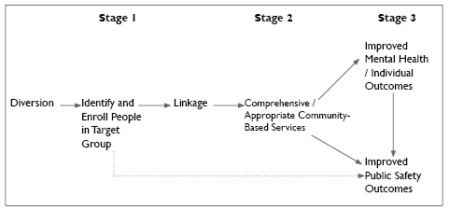
Likewise, jail diversion is not the same as transition or discharge planning. Transition planning activities should be part of usual criminal justice processing and occur only when the detainee would ordinarily leave the jail. By contrast, jail diversion is a special, targeted program designed to eliminate or reduce the amount of time an individual with mental and substance use disorders spends in jail, to the benefit of the inmate, the correctional staff, and the community.
Finally, jail diversion doesn’t end when the inmate leaves the jail. Diversion programs for people with mental illness will not work without coordination of appropriate services (Steadman, Morris, & Dennis, 1995). The types of services required for successful diversion programs are discussed in Section 5 of this publication.
Types of Jail Diversion
Diversion programs can be divided into pre-booking and post-booking models, and post-booking programs can be either jail-based or court-based. Court-based programs can be further separated into specialty (e.g., mental health and drug courts) and regular dispositional courts. Each of these is described in brief below.
Pre-booking Diversion
Pre-booking diversion occurs at the point of contact with law enforcement officers and relies heavily on effective interactions between police and community mental health and substance abuse services. Specially trained officers who encounter a person exhibiting symptoms of a mental disorder are allowed to use their discretion to determine the necessity of arrest (Lattimore et al., 2003). The most recognized pre-booking program is the Crisis Intervention Team (CIT) as developed in Memphis, TN.
The Memphis CIT is considered a police-based specialized police response. A second type of pre-booking diversion is called a police-based specialized mental health response, in which police departments hire mental health consultants to provide on-site and telephone consultation to officers. For example, in Birmingham, AL, a Community Services Officer program—civilian police employees with professional training in social work or related fields—helped police officers in mental health emergencies by providing crisis intervention and some follow-up assistance.
A third pre-booking strategy is referred to as a mental health-based specialized mental health response, which often includes a mobile crisis team that responds when requested by police. All three types of programs reduce arrest rates for people with mental illness, and each has its benefits and drawbacks. CIT is marked by a rapid response time and the lowest arrest rate, while mental health professionals who respond with police are particularly adept at resolving mental health disturbance calls on the scene. The sometimes slow response time for a mental health crisis team makes this option less likely to be used by patrol officers (Steadman et al., 2000; Munetz & Griffin, 2006).
A Day in the Life of a CIT Officer
Officer Gonzalez is assigned to the patrol division of her agency. She may work any shift and might have a partner, but she is just as likely to work alone. She takes any call a regular patrol officer handles and also responds to calls about people with mental illness in crisis. The detail shows that she is a CIT officer so the dispatcher can find her easily when the need arises.
Since she completed 40 hours of CIT training, Officer Gonzalez has been receiving approximately three times as many crisis calls. Many of the people she helps are familiar to her. She’s probably built some rapport with the person in crisis and his or her family, which helps the situation go more smoothly. She has ready access to less-lethal weaponry, such as a stun gun, but is trained to be judicious in its use.
After de-escalating the immediate crisis, Officer Gonzalez takes the person to a psychiatric emergency services facility or hospital. Most likely this will be a voluntary admittance.
Officer Gonzalez doesn’t receive extra compensation, which causes some of her fellow officers to wonder why she does this work. This doesn’t distract her from doing her job. Most likely, Officer Gonzalez will rise through the ranks faster than her non-CIT colleagues and will be a lifelong supporter of programs that teach law enforcement officers to deal respectfully with people who have mental illness.
In addition to her work on the force, Officer Gonzalez takes refresher and advanced CIT courses every year and attends special functions sponsored by such groups as the National Alliance on Mental Illness (NAMI), local mental health and substance abuse authorities, and other community agencies that want to recognize her dedication and that of her fellow CIT officers.
Successful pre-booking programs are characterized by specialized training for police officers and a 24-hour crisis drop-off center with a no-refusal policy that is available to receive people brought in by the police. A central drop-off site provides police with a single point of entry into the mental health system, though some larger or more rural communities adapt this model to work with multiple facilities. Regardless of the configuration, without some type of triage facility that is prepared to accept police referrals, Reno police officer Patrick O’Bryan noted, “CIT will be a service to nowhere.”
It’s important to point out that not all encounters with police that result in a referral to treatment can be considered pre-booking diversion. Diversion is what happens when charges could have been filed. In many cases police intervene with people in a mental health crisis (e.g., a suicide attempt) that does not involve commission of an offense. In other cases, the specialized police response is believed to have prevented the commission of an offense. These are important roles for police in contact with people who have mental disorders, but they do not constitute jail diversion (Reuland & Cheney, 2005).
Post-booking Diversion
Post-booking diversion is the most prevalent type of diversion program in the United States. As of mid-2007, there were approximately 500 jail diversion programs in the country, and 65 percent were post-booking programs. Post-booking programs identify and divert people with mental illness after they have been arrested and at or after booking. Nearly all post-booking diversion programs include some type of monitoring of compliance with treatment, though the level of supervision and the active involvement of the court vary from jurisdiction to jurisdiction.
A post-booking program at either the arraignment court or the jail is one that:
- Screens people potentially eligible for diversion for the presence of mental illness;
- Evaluates their eligibility for diversion;
- Negotiates with prosecutors, defense attorneys, community-based mental health providers, and the courts to produce a disposition outside the jail in lieu of prosecution or as a condition of a reduction in charges; and
- Links people to an individualized array of community-based services.
Court-based programs can occur at any stage in the criminal justice process prior to sentencing and may be decentralized—with diversion staff working in multiple courts with multiple judges—or centralized in a specialty court such as a mental health or co-occurring disorders court. Specialty courts are marked by the use of one primary judge, a courtroom team approach, separate court calendar, court supervision, and interaction with the mental health treatment system (Lattimore et al., 2003; Broner et al., 2004; Steadman, Davidson, & Brown, 2001).
Specialty courts such as mental health courts are based on the concept of “therapeutic jurisprudence.” To produce a beneficial outcome, many of the courts use dismissal of charges after successful completion of the mental health court program as an incentive to participate in community treatment and avoid re-offenses. Though based on the drug court model, mental health courts operate somewhat idiosyncratically; currently there is no one definitive mental health court model (Steadman, Davidson, & Brown, 2001).
Some mental health courts only accept people who have committed low-level offenses, though increasingly, many mental health courts are accepting felony cases. Courts that accept offenders with more serious charges often require defendants to enter a plea and to be supervised by criminal justice personnel, and they are more likely than mental health courts that do not accept felonies to use jail as a sanction for noncompliance with court-approved diversion plans (Griffin, Steadman, & Petrila, 2002; Redlich et al., 2005).
Non-specialty court models address a number of barriers to the development of mental health courts. In particular (Clark, 2004):
- In some communities, the size or configuration of the court system may not make such dockets feasible or practical, particularly because of the need to dedicate substantial judicial resources to actively supervising cases.
- Many mental health advocates are cautious about these courts, believing that they create additional stigma for people with mental illness or abridge defendants’ rights.
- Some observers fear that mental health courts may have the unintended consequence of making a limited set of mental health services available on a priority basis to those who have been arrested rather than expanding community-based treatment to serve all people with mental illness and co-occurring substance use disorders. This argument has been made against jail diversion programs in general.
- Even where mental health courts exist, not all defendants with mental illness are appropriate candidates for these courts.
There is no one right way to create a jail diversion program; each program will be unique to the needs of the community.

While similar in purpose to many mental health court models, non-specialty court approaches that rely on deferred prosecution or conditional release strategies do not require dedicated court resources and can apply to a broader group of offenders with mental illness, including those with extensive criminal histories or violence associated with their charges (Bush, 2002).
Jail-based programs are operated by pretrial service personnel or by specialized jail personnel, often for defendants who have more serious charges or more severe mental health problems, or who have not been identified earlier in the process. For example, in Hawaii, staff of Oahu Intake Services screened new detainees in jail and referred those with symptoms of mental illness to the diversion team. The team negotiated with the judge, prosecutor, and public defender to arrange for diversion into community-based mental health treatment (Lattimore et al., 2003).
What You Can Do
While all diversion programs engage in some form of identification and linkage, there is no definitive model for organizing a jail diversion program. Jail diversion programs will be unique to the community and the services they provide will be tailored to the consumer. In fact, jail diversion programs in your community may differ even from those in the neighboring city or town because your jurisdictions will vary in the size and structure of the criminal justice system, the resources available to the mental health and substance abuse treatment systems, and the political and social climate in which you work. The model you choose will be based on these factors and it may seem at times that there is a dizzying array of options from which to choose.
As you begin planning, remember the old adage to “keep it simple.” Listed below are the five basic tasks involved in any jail diversion program and the six key features that will make them successful. Think of these as what you are going to do and how to make it work.
Five Basic Tasks
Regardless of the type of diversion program you select, you are going to be required to do some or all of the following:
- Know who you are looking for: Determine your eligibility criteria.
- Find them: Screen and assess the people you believe are eligible.
- Engage them: Develop trusting relationships with consumers and plan for services they want and will accept.
- Cut a deal: Negotiate the terms and conditions of the jail diversion plan with the key players in your system, including law enforcement, defense attorneys, prosecutors, judges, mental health and substance abuse treatment providers, and consumers.
- Make it stick: Link consumers to the treatment and supports they need to recover from mental and substance use disorders and remain stably housed in the community.
Six Factors for Success
Across all types of approaches, the following six key features have emerged as essential for creating an effective jail diversion program (Steadman, Morris, & Dennis, 1995). These elements are crucial in linking the criminal justice and community treatment systems:
- Interagency collaboration: Services should be integrated at the community level, including involvement of social services, housing, mental health, health, local corrections (institutional and community), criminal justice, workforce development, Medicaid, and substance abuse agencies.
- Active involvement: Stakeholders must hold regular meetings for service coordination and information sharing and establish formal agreements, such as written Memoranda of Understanding (MOUs).
- Boundary Spanner: Programs require staff that bridge the mental health, criminal justice, and substance abuse systems and manage cross-system staff interactions.
- Leadership: You need a strong leader to network and coordinate activities.
- Early identification: People should be screened at the earliest point possible (ideally, in the first 24–48 hours of detention) for mental health treatment needs and to determine whether they meet the criteria for diversion.
- A specialized case management program: An effective case management program is one of the most important components of successful diversion. Case managers should have adequate knowledge and experience with mental health and criminal justice systems.
Further discussion of these key components can be found in sections 4–6 of this publication.
SECTION 3: Making Jail Diversion Happen in Your Community
Regardless of whether you approach jail diversion as a way to save costs or save lives, you may encounter resistance among the very people and systems such programs are designed to help. Some resistance is understandable, but much of it stems from misinformation or misinterpretation of what a jail diversion program involves. In this section, you’ll learn why some individuals and groups initially may be opposed to adopting a jail diversion program in your community and how you can respond when they ask, “What’s in it for me?”
The Problem
Despite what seem like clear benefits, some individuals and groups initially may resist adopting a jail diversion program for people with serious mental illness and co-occurring substance use disorders. This makes it more difficult to gather stakeholders, reach consensus, and develop a strategic plan.
What You Need to Know
Each group that will be party to jail diversion efforts will likely have some concerns you need to address. They include those noted below.
Responsibility for Criminal Behavior
Criminal justice professionals may think the person is not being held accountable for his or her actions. In particular, police officers may feel that a specialized jail diversion approach is inconsistent with traditional policing, which focuses on putting people in jail. While law enforcement professionals may think the person is getting out of punishment, mental health providers may see the same process as helping people get into treatment.
One way to reconcile this difference is to focus on avoiding incarceration rather than avoiding punishment (Draine & Solomon, 1999, p. 59, emphasis added). Treatment and accountability are not mutually exclusive; many people enrolled in a jail diversion program will spend more time in community treatment, often under the supervision of the court, than they would have spent in jail.
Further, in no case is anyone who advocates for a jail diversion program for people with serious mental illness suggesting that people who commit serious crimes or crimes unrelated to their mental illness should be exempted from appropriate punishment. Munetz & Griffin (2006) make this clear:
People with mental illness who commit crimes with criminal intent that are unrelated to symptomatic mental illness should be held accountable for their actions, as anyone else would be. However, people with mental illness should not be arrested or incarcerated simply because of their mental disorder or lack of access to appropriate treatment—nor should such people be detained in jails or prisons longer than others simply because of their illness (p. 544).
Fears about the Forensic Consumer
Mental health providers may be reluctant to work with people diverted from the justice system for several reasons. The first is their fear that offenders with mental illness have a higher potential for violence, which they don’t (see section below). However, people with mental illness may have previous problems, such as an arson charge, that make it challenging to find an appropriate array of services for them. Also, many people who are diverted have co-occurring substance use disorders and mental health professionals may not be trained in treatment of co-occurring disorders or have access to an integrated treatment program.
In addition, mental health professionals may believe that people in contact with the justice system are difficult to engage in services and resistant to treatment. In fact, most people are amenable to treatment given the right combination of services delivered in the right way (Massaro, 2005). Engagement into services can be difficult, though much has been learned about the importance of respectful, trauma-sensitive, culturally competent, and peer-supported techniques that make services attractive and appropriate for people with serious mental illness and co-occurring substance use disorders.
Interventions specific to a criminal justice population are also being developed. For example, many former inmates have acquired beliefs and behaviors that, while adaptive in jail or prison, get in their way of succeeding in a mental health program and in the community. The Bronx Psychiatric Center has developed a half-day training workshop for providers to help them understand how these behaviors are traditionally misinterpreted in mental health treatment settings and a group therapy program for former inmates that helps them make a successful transition to the community. For more information about the SPECTRM (Sensitizing Providers to the Effects of Correctional Incarceration on Treatment and Risk Management) program, contact Merrill Rotter, M.D., at mrotter@omh.state.ny.us.
Finally, regardless of any real or unfounded concerns they may have, mental health providers face the very real problem of limited resources. Jail diversion consumers, some of whom may not have been enrolled in services previously, are an added burden on an already strained system. When jail diversion staff help consumers access such mainstream benefits as Supplemental Security Income (SSI) and Medicaid, it reduces the need for agencies to provide uncompensated care. See Section 5 for more information on this topic.
The Risk of Violence
Public perception of the risk of violence among people with serious mental illness is skewed by media stereotypes in news coverage, movies, and novels. When effective treatment and support services are available and used, people with mental illness pose no greater threat to the community than other people and may in fact be the victims rather than the perpetrators of violence. Co-occurring substance abuse represents a much greater risk for violence than does mental illness alone (Steadman et al., 1998; Massaro, 2004; Dvoskin & Steadman, 1994).
Even when people with mental illness do have violent charges, most can be successfully diverted with no additional risk to public safety. A study of federally funded jail diversion programs found no empirical evidence showing more negative outcomes for people with violent charges who are diverted from jail to treatment in the community (Naples & Steadman, 2003). This issue is important when determining a target population for jail diversion, an issue that will be discussed further in Section 4.
Concerns About Coercion
Though all jail diversion programs are voluntary, people with mental illness in contact with the justice system, particularly those who have had previous negative experiences in the mental health system, may feel they will be forced to participate in treatment that is not in their best interests. Some may believe they are better off spending a few days in jail than 6 months or more in treatment.
Sensitizing Providers to the Effects of Correctional Incarceration on Treatment and Risk Management (SPECTRM)
Survival adaptations made by individuals with mental illness in correctional environments often conflict with the expectations of therapeutic environments and reduce the likelihood of successful community adjustment following release. For example, survival adaptations such as distrust of others result in a lack of engagement in treatment settings. Further complicating matters, mental health providers often mistake these survival adaptations for treatment resistance, lack of motivation, evidence of character pathology, or signs of mental illness.
To address these issues, the SPECTRM provider training reviews potential behaviors considered adaptive in jail and prison and uses a cultural competence approach to address them. By training treatment providers about the incarceration experience and showing them how behaviors adapted in correctional settings are misinterpreted in community treatment settings, providers are better able to understand their clients and engage them in treatment.
To learn more about the SPECTRM training, contact Dr. Merrill Rotter (Bronx Psychiatric Center, Bronx, NY / Albert Einstein College of Medicine, Yeshiva University, Bronx, NY 10461) at Brdomrr@omh.state.ny.us.
Adapted from Sensitizing Providers to the Effects of Incarceration on Treatment and Risk Management (SPECTRM): Expanding the Mental Health Workforce Response to Justice-Involved Persons with Mental Illness (CMHS National GAINS Center, 2007). Available from http://www.gainscenter.samhsa.gov/html/resources/publications.asp#reentry
Further, though it may make sense for a person to accept mental health treatment as part of a plea agreement, jail diversion programs that require offenders to enter a guilty plea in order to participate must be certain the person makes this decision with the aid of competent defense counsel. A person should never be asked to forfeit significant constitutional rights to enter a jail diversion program, cautions public defender Stephen C. Bush, J.D., Coordinator of Mental Health Systems for the Shelby County (TN) Public Defender’s Office.
“Sam” was a gentleman in his late forties. He was divorced, unemployed, homeless, and suffered from bipolar disorder and an addiction to prescription pain medication. Sam was arrested for trespassing—he had been sleeping in the shed in his ex-wife’s backyard, something he had done many times before—and was booked into the county jail.
Sam was interviewed in jail by a practitioner for the local jail diversion program and, based on his history and willingness to try to improve his life, was recommended for and accepted into the program. Sam worked very hard during his involvement with the program to turn his life around. He was diligent in attending his scheduled appointments with his intensive case manager, his therapist, and his psychiatrist. Sam participated in treatment and fine tuned his job skills.
Eventually, Sam transitioned out of the program, maintained himself in treatment, and continued therapy with his psychiatrist. He also found stable housing. Early on, Sam was allowed to work community service hours in lieu of sitting out his fine and court costs in jail. Sam’s job was working in the front office of the local arena football team. The experience went so well for both Sam and the team that he was hired on full-time at the conclusion of his community service hours.
While consumers may fear forced treatment, mental health advocates and family members may worry that the inherently coercive nature of the criminal justice system might endanger people or compromise the positive strides the mental health system has made in reducing coercion in treatment and services. It is up to professionals in both the criminal justice and mental health systems to arrange for or provide services that are appropriate, respectful, and useful to help people see the potential for long-term benefit, including the likelihood of reduced contact with the justice system.
Political and Financial Liability
Elected officials whose support is critical to the success of a jail diversion program may fear a high-profile failure, though in reality the community will be safer when people with mental illness are in services and, often, under court supervision. They also worry about the costs of implementing new programs, particularly when any savings are not likely to be realized for several years.
What You Can Do
One of the most important tasks you will accomplish in planning your jail diversion program will be gathering your key stakeholders (see Section 4) and helping them achieve consensus. This will be easier when each of the individuals and groups you approach are very clear about how such a program would benefit them.
Here are some reasons you can give them. Each of these benefits speaks to the problems that various stakeholders experience when services and systems are unresponsive to the needs of people with serious mental illness and co-occurring substance use disorders. In addition, you may want to consult the Resources and Program Examples sections of this document to have ready evidence in hand to show that, in fact, for most people, jail diversion works.
The Criminal Justice System
For the criminal justice system in general, partnerships to create jail diversion programs can help alleviate:
- Low staff morale and high turnover
- The cost of providing expensive medication and treatment services within the jail
- Expensive overtime pay
- Limited space for more serious felons
- Burgeoning court dockets
For people enrolled in the Clark County (WA) Mental Health Court, arrests were reduced from an average of 2 in the year prior to enrollment to 0.48 in the year following enrollment (Herinckx et al, 2005).
For law enforcement, in particular, a diversion program that helps address the needs of people with mental illness in crisis can reduce:
- Injuries to police officers and to people with mental illness
- The amount of time officers spend accompanying people with mental illness while they are evaluated for treatment admission
A one-stop medical and psychiatric crisis center in Bexar County, TX, has reduced significantly the waiting time for officers in the county’s pre-booking diversion program to about 15-20 minutes.
The Mental Health System
For mental health providers, programs that divert people with mental illness from inappropriate arrest and incarceration to community treatment can help:
- Minimize the impact of treatment interruption for those who are consumers of the system
- Provide outreach to those who are disengaged from services
- Present opportunities for greater stability and fewer crises
- Offer an additional source of motivation to participate in treatment
The community-based mental health services offered through the Clark County (WA) Mental Health Court resulted in a 75 percent reduction in inpatient treatment days for people enrolled in the program (Herinckx et al, 2005).
Individuals with Mental Illness
For people with serious mental illness in contact with the justice system, a diversion program can help them:
- Avoid jail time
- Reconnect to supports and services
- Focus on recovery
- Avoid recidivism
The Nathaniel Project in New York, NY, for felony defendants on Rikers Island, had an 80 percent participant retention rate over 2 years with 100 percent of participants engaged in treatment (The National GAINS Center, 2002).
Family Members
Family members are supportive of diversion efforts that help their relative:
- Stay out of jail
- Get access to the treatment, services, and housing they need
- Reconnect to family and other social supports
- Recover from mental illness and substance use disorders
In Milwaukee, WI, when an individual with mental illness is diverted by the city’s Crisis Intervention Team, a member of NAMI-Greater Milwaukee follows up with family members in order to gather their perspectives on the situation.
Policymakers and Funders
For elected and appointed officials, as well as key leaders in the mental health and criminal justice systems, reasons to support jail diversion include the need to (Council of State Governments, 2002):
- Enhance public safety
- Use criminal justice resources more efficiently
- Reduce taxpayer expenditures
- Increase public confidence in the justice system
- Gain access to resources
Through the support of County Criminal Court Judge Steven Leifman, Miami-Dade County received voter approval for a $23 million bond to develop a facility for jail inmates with mental illness.
You may not be able to quell initial fears even with the best information about how successful jail diversion is in other communities. Some people will only be convinced of the value of jail diversion when you are able to connect people in contact with the justice system in your own community to treatment, housing, and supports. The next two sections will help you develop and implement a plan to do so.
SECTION 4: Getting Started

Planning for and designing a jail diversion program may seem like a daunting task. You have to convene key stakeholders, map the service system, and secure funding, responsibilities that are not part of your everyday routine. During the start-up phase, it’s particularly helpful to keep your goals in mind—your hard work will help improve the lives of people with serious mental illness and co-occurring substance use disorders, enhance public safety, and use criminal justice and mental health resources more effectively. In this section, you’ll learn why collaboration between the criminal justice, mental health, and substance abuse systems is not as difficult as it first seems; how to develop consensus and create a strategic plan; and where to find the resources you need to begin.
The Problem
People with serious mental illness and co-occurring substance use disorders come into contact with the criminal justice system for a number of reasons, not the least of which is the fact that services designed to help them are fragmented, uncoordinated, and underfunded. The mental health, substance abuse, and criminal justice systems have their own histories, languages, values, concerns, and protocols. This leads to inefficient and ineffective services and results in failed systems, wasted resources, and lost lives (Council of State Governments, 2002).
“You can start a jail diversion program with one public defender and one mental health boundary spanner. It’s all about relationships.”
—Stephen C. Bush, J.D., Coordinator of Mental Health Systems for the Shelby County (TN) Public Defender’s Office

What You Need to Know
People with mental illness and substance use disorders in contact with the criminal justice system need multiple services, including housing, health care, mental health services, substance abuse treatment, income supports and entitlements, life skills training, education, and employment. These services typically are provided by multiple agencies in different systems, leaving individuals to coordinate their own care. They may receive duplicate services at multiple agencies or no services at all. Both practically and clinically, coordinating the services they need to recover from their illness and remain stably housed in the community simply makes sense (SAMHSA, 2003; Council of State Governments, 2002).
The solution to fragmentation is to integrate services and systems by promoting collaboration. Community collaboration and integration help increase retention in services and stability in the community for people with mental illness and substance use disorders and decrease public safety risk and criminal justice costs. What does it mean to integrate services and systems?
Integrated services are designed to maximize an individual’s use of existing resources through such techniques as case management. In contrast, integrated systems are designed to change service delivery for a defined population and involve fundamental changes in the way agencies share information, resources, and consumers. As such, systems integration goes beyond service integration. It does not require the creation of a single system, but it does demand an interconnected network of organizations that can complement each other by coordinating their assessments, treatment services, administration, management information systems, and staff training (Dennis, Cocozza, & Steadman, 1999; The National GAINS Center, 1999a).
Both services and systems integration are important for creation of an effective jail diversion program. In fact, systems integration cannot succeed without an emphasis on integrated services, as well. Successful jail diversion programs have a boundary spanner who helps coordinate and integrate the activities of the mental health, substance abuse, and criminal justice systems and specialized case managers who help people with mental illness and substance use disorders gain access to the full range of services to which they are entitled. Creation of these positions and the important roles they play will be expanded on in Section 5 of this publication.
Despite distinct advantages to both systems and consumers, the barriers to integrating service systems are both broad and deep. As one observer notes, “While everybody is in favor of coordination, nobody wants to be coordinated” (Feldman, 1976). Barriers to effective collaboration include:
- Funding “silos” make communication about cross-systems efforts more challenging.
- Limited resources create a competitive and/or protective environment.
- Regulations concerning confidentiality create both real and perceived hurdles.
- The mental health, substance abuse, and criminal justice systems have their own, separate treatment philosophies, administrative policies, and funding streams.
- Lack of political will and public support can stymie even the most dedicated efforts.
However, the mental health, substance abuse, and criminal justice systems share common issues that can be leveraged for collaboration. These include public safety, responsibility, and accountability. Further, though the work of systems integration may be difficult and take years to accomplish fully, it often begins with a simple step. As the Criminal Justice/Mental Health Consensus Project points out:
The single, most significant common denominator shared among communities that have successfully improved the criminal justice and mental health systems’ response to people with mental illness is that each started with some degree of cooperation between at least two key stakeholders—one from the criminal justice system and the other from the mental health system (Council of State Governments, 2002, p. 14, emphasis added).
Creating and sustaining these relationships will be critical as you follow the steps outlined below for creating systems change.
What You Can Do
Each community will develop a tailored jail diversion program. However, regardless of the specifics in any community, there are common steps on the road to success.
To develop the infrastructure for jail diversion, you need to:
- Designate a lead person
- Gather your key stakeholders
- Really do strategic planning (see box)
- Secure funding
- Communicate regularly
Designate a Lead Person
You need someone to lead the charge. Sometimes this person is referred to as a “change agent.” He or she needs to be a strong leader with good communication skills and an understanding of the systems and the informal networks involved. This may be a prosecutor, public defender, judge, jail medical staff, or a political champion. For example, in Miami, County Criminal Court Judge Steven Leifman of the 11th Judicial Circuit convened a group of interested parties to discuss jail overcrowding. Judges can be particularly effective at motivating distinct agencies and systems to see the shared responsibilities they have for improving outcomes for people with mental illness in the justice system. Indeed, support from critical community leaders is often the key to crystallizing your drive and vision into concrete programs (The National GAINS Center, 1999a).
Gather Your Key Stakeholders
Stakeholders are “individuals and organizations in the community who have a vested interest in mental health services or the criminal justice system, or who would be affected, whether positively or negatively, by the implementation of a diversion program” (National Mental Health Association, 2003, p. 1). You’ll need their active involvement, because you can’t do this alone. As the Criminal Justice/Mental Health Consensus Project points out, “a community partnership becomes a single voice that demands attention and appeals convincingly for assistance needed to solve the problem” (Council of State Governments, 2002, pp. 9-10). The specific stakeholders will be unique to your community, but typically they will include:
- Police
- Jail administrators
- Corrections officers
- Jail mental health and health service providers
- District attorneys and prosecutors
- Public defenders
- Local judges and magistrates
- Probation officers
- Community mental health and substance abuse treatment providers/administrators
- Housing and social service providers
- Elected officials (mayor, county commissioners, legislators, etc.)
- The State Medicaid director or his/her designee
- Consumers and consumer advocacy groups
- Family members
Implementation Barrier: You encounter opposition from key stakeholders.
Potential Solutions:
- Involve representatives from all affected stakeholders in planning the project.
- Make sure that all members of the planning group feel valued.
- Provide consumer or peer advocates with stipends and transportation assistance.
- Make use of local data demonstrating the extent of the problem.
- Address stakeholder concerns when defining target populations and eligibility criteria.
- Meet your stakeholders “where they are.”
You may also want to have the following important constituents represented:
- Workforce development agencies
- Education and training providers
“Marge” was arrested and jailed for a first offense of driving under the influence, but initially she wanted nothing to do with addressing her substance abuse problem; she just “wanted out” of jail. Staff of the local mental health jail diversion program met with Marge in jail and provided her with education about substance abuse and about its relationship to her depression and anxiety disorder. When Marge was ready to get the help she needed, the mental health court liaison/boundary spanner and the case manager advocated on her behalf with her attorney and the judge. Once treatment linkages were made, Marge was given a suspended sentence and released into the program.

After her release, Marge participated in medication management and support groups at a local mental health center and she attended regular Alcoholics Anonymous meetings. She became involved in her family church, which provided additional support, and she met regularly with her case manager.

When Marge accepted a job in another town 5 months later, the case manager and boundary spanner worked with her probation officer to have her supervision transferred, and the case manager provided referrals to community mental health centers in her area so she could continue with her treatment. At last report, Marge was still sober and making positive changes in her life.
- Victim advocates
- Agencies that provide services for parents with children, including Women, Infants and Children (WIC), child protective services, childcare providers, etc.
Also, be certain to include representatives of other diversion programs that may be operating in your community. Your goal should be to enhance the services each program provides. For example, Shelby County, TN, has three levels of intervention to divert people with mental illness from the criminal justice system, beginning with the well-known Memphis Crisis Intervention Team. Each of the three distinct programs, which are designed to identify and divert people at different stages of the justice system, is supported by the Mayor’s Jail Diversion Committee.
Make Sure You Have the Right People
Even if you have representatives of all the agencies listed above, you may not have the people you need to make things happen. Some questions to consider when forming a coalition include (National Mental Health Association, 2003, pp. 1–2):
- What types of expertise will the coalition need and who would best offer each type of expertise [e.g., knowledge about research and data, diversion programs, public education campaigns, potential funding sources, etc.]?
- Who can make or influence important decisions in the community?
- Do these people have resources and time to commit to the coalition?
- From whom does the community need buy-in to make this project successful
Of particular importance, each organization should be represented by the chief executive or his or her designee, for two reasons: First, they have the authority to commit the resources of their organization, and second, their involvement signals to their subordinates and to other stakeholders that their agency is committed to the initiative (Council of State Governments, 2002).
At the same time, it’s equally important to get low-level buy-in from the earliest stages (Reuland, 2004). For example, in a pre-booking program, it’s the patrol officers on the street who will be implementing jail diversion activities discussed and decided upon by the coalition. In addition, if you’re having trouble convincing the head of your law enforcement agency about the wisdom of beginning a jail diversion program, you may be able to find informal leaders on the front line of service who can help break through organizational resistance.
Consumer Advocates: Essential to the Success of Every Jail Diversion Program
Consumer advocates are important representatives on a jail diversion program’s stakeholder group and as providers of services to consumers enrolled in the program. The roles and responsibilities of consumer advocates vary with each program. One example of the responsibilities of a consumer advocate comes from the jail diversion program in Dubuque, IA.
- Assists in the transition of individuals from the criminal justice system to community-based services
- Serves as a consumer liaison between involved agencies and service providers
- Responsible for support groups outside of offices of service providers
- Provides referrals to non-clinical community-based services
- Advocates for program participants with regard to services
- Works with families of program participants
- Maintains records of interactions with program participants
- Serves on stakeholder group of the jail diversion program
- Conducts information sessions with community groups
(Dubuque Jail Diversion Program, 2004)
Some of these individuals may already be meeting together as part of existing groups, such as local homeless coalitions, so they will be easy to identify and contact. In other cases, you may have to make “cold calls,” introducing yourself to local human services organizations or law enforcement agencies. If this is the case, it may be helpful to take someone with you who is known to and respected by the organization whose support and expertise you need. For example, in Philadelphia, well-known homeless services provider Sister Mary Scullion was well received by the local police department when discussions began about developing a CIT program.
Consumers and consumer advocates—particularly people with mental illness and co-occurring substance use disorders who have experienced justice involvement—should have an early and continuing role in the coalition because they are invaluable in defining problems and identifying solutions. However, the stigma attached to both mental illness and substance use disorders and to justice involvement may make it challenging to locate and involve consumers, especially if other stakeholders are not attuned to recovery as a viable outcome for people with mental illness, substance use disorders, and justice involvement.
In addition, though the consumer movement in mental health is fairly well organized and increasingly respected, some criminal justice stakeholders may be reluctant to elicit or heed advice from people they have seen only in times of crisis. Finally, it is important to remember that consumers don’t speak with one voice. Some may be opposed to jail diversion if they equate it with “coerced treatment.” Educating all constituents, including consumers, about the value of jail diversion is one of the tasks for your stakeholder group.
Get Your Stakeholders to the Table
Once you identify who needs to be part of your coalition, you have to bring them together. Benefits likely to appeal to key leaders in the mental health and criminal justice system include the following (Council of State Governments, 2002, p. 17):
- Improving the lives of people with mental illness and reducing the frequency of their contact with the criminal justice system
- Enhancing public safety
- Using criminal justice resources more efficiently
- Improving the safety of line staff and the environment in which they work
- Reducing taxpayer expenditures
- Increasing public confidence in the justice system
- Gaining access to resources
- Enlisting allies capable of attracting support from policymakers previously unmoved by the need to bolster the mental health system
Sometimes a high profile incident or damaging story in the media serves to motivate a core group of prospective partners. For example, following the deaths of two men with mental illness in recent contact with the police, the Rochester Police Department formed the Emotionally Disturbed Persons Response Team (EDPRT).
A new funding opportunity, particularly one that requires collaborative efforts, often helps bring stakeholders together. Likewise, legislation can prompt joint ventures through the establishment of task forces (Council of State Governments, 2002).
Compelling data also may promote interest in a jail diversion program. Though there may be barriers to collecting and reporting such data, you don’t need a university cost study to prove the case for jail diversion. In Reno, NV, patrol officers Steve Johns and Patrick O’Bryan conducted their own informal survey of how much it cost to care for several people who were in and out of emergency rooms, substance abuse treatment, and the local jail. In one case, which has now been well publicized as the story of “Million-Dollar Murray,” Johns and O’Bryan discovered that the City of Reno spent $1 million over 10 years to not provide adequate treatment for one individual, who later died on the streets (Gladwell, 2006). See more about how to collect and present such data in Section 7.
Assess Your Current Level of Collaboration
Some of the stakeholders in your group may already be collaborating with one another. For example, mental health providers and local law enforcement officers may hold informal meetings to discuss areas of mutual concern. But others will be new to the idea of a criminal justice/mental health collaboration. To help stakeholder groups determine their current level of collaboration, the Criminal Justice/Mental Health Consensus Project has developed a collaboration assessment tool available at http://consensusproject.org/assessment. Your answers will help reveal:
- The process by which agencies involved in the initiative define, identify, track, share, and evaluate information on the target population within and across agencies.
- The process by which different systems work together to define common goals, identify mechanisms to achieve those goals, support their service providers, and evaluate and refine their initiative to ensure positive outcomes.
- The process by which service providers from different systems coordinate—and potentially integrate—treatment and services for a shared population in order to achieve system goals.
- The process by which agencies involved in the initiative identify and secure resources (e.g., staffing, funding) that sustain the initiative and advance its goals.
This information will help guide your planning activities, particularly as you begin to map the system and identify gaps in services (see discussion of these topics later in this section).
Plan and Run Effective Meetings
Every one of your planning group members is a busy person with competing priorities, so it may be challenging to find a time and place where all of your diverse constituents can meet. You might want to plan a breakfast or lunch meeting, with food provided by the host agency. Alternating meeting sites among various organizations—e.g., the police department one time and the local mental health center the next—helps group members become familiar with the various settings in which people are seen. Choosing a site that would create the greatest sense of importance, such as the courthouse or the district attorney’s office, might help increase buy-in from the stakeholders whose influence will be critical. You also may want to plan a field trip or two; visits to the local jail can be enlightening for human services personnel and law enforcement officers can benefit from talking to consumers at a local mental health center (see more in “Create a Shared Vision” below).
Implementation Barrier: Stakeholders think jail diversion will solve all problems.
Potential Solutions:
- Use data to keep expectations grounded.
- Don’t oversell jail diversion.
- Set realistic goals and objectives.
To keep your meetings focused, be certain to have a written agenda and stick to the time frames you establish. If you’re new at this, you can find helpful tips and techniques for planning and running effective meetings at www.effectivemeetings.com.
Really Do Strategic Planning
This is where the rubber meets the road. Strategic planning is important for two reasons. First, it is the most direct way to ensure involvement from all the individuals and groups who need to buy into your efforts to plan a jail diversion program. Second, and equally important, good strategic planning models the type of collaboration and cooperation you need to successfully improve services for people with mental illness and substance use disorders involved in the justice system and enhance public safety.
Start small, but carry a big vision.

Create a Shared Vision
Planning a jail diversion program begins with reaching agreement on desired outcomes or goals. Eventually, everyone in your group needs to be on the same page, but they won’t start out there. The opening dialogue may be uncomfortable and time-consuming, but everyone needs a chance to be heard.
Resist the tendency to engage in “finger pointing” by emphasizing a problem-solving (rather than a position-taking) approach, which focuses on the interests or concerns that underlie the stakeholders’ positions on issues. Inevitably, at early meetings, there will be some tensions often associated with particular cases that need to be resolved. To shift the dynamics to more creative problem solving (Fisher, Ury, & Patton, 1991; see also www.resolv.org):
- Discuss and address interests. Interests are less rigid than positions.
- Understand the role of interpersonal dynamics in negotiations and help people move on (separate the people from the problem).
- Generate a wide range of options, minimizing judgments at first.
- Agree on criteria by which to generate options for resolution.
“Listen to differences and drill down to the common issues. The ‘right thing to do’ is not compelling. Reframe the issue so it resonates with everybody.”
—Michele Saunders, LCSW, Executive Director of Florida Partners in Crisis

A key part of reaching consensus about the need for a jail diversion program and what its outcomes should be will be to educate each other about the services you provide and the constraints you face. This is where the field trips mentioned above can be useful. If you’re in the mental health or substance abuse treatment system, you need to learn about the unique challenges faced by criminal justice agencies in working with people who have mental illness and substance use disorders. On the criminal justice side, you may lack knowledge about how people with mental illness who have access to appropriate services can live in and contribute to the life of the community. You might want to invite key members of your group to spend a day following the footsteps of someone with co-occurring disorders who is trying to navigate the system. Public education and advocacy are vital tools to reach community consensus (The National GAINS Center, 1999a; National Mental Health Association, 2003).
When developing your goals, keep in mind that they should remain broad enough to encourage general buy-in, but narrow enough to keep your target in mind. For example, some broad goals for those considering a pre-booking program may be (Reuland, 2004, pp. 25-27):
- Improved services to people with mental illness
- Improved efficiency and effectiveness of law enforcement response
- Diversion from the criminal justice system
- Reductions in officer and civilian injuries
- Improved officer knowledge about mental illness
- Effective partnerships with the mental health community
The goals then become your vision, which must be refined into a simple concept that captures the complex issues at hand.
For example, in Miami, diversion and linkages to comprehensive care make jail the last resort. The goal of jail diversion activities in Montgomery County, VA, is to narrow the door into the criminal justice system and open the door to treatment.
Really Do Strategic Planning
1. Create a shared vision
2. Define the target group
3. Examine available models
4. Map the system
5. Identify gaps
6. Determine where to invest scarce resources
7. Create an action plan
Finally, remember that your vision and the goals they embody must embrace a set of values that are critical to successful community integration of people with serious mental illness and co-occurring substance use disorders in contact with the justice system. Any program you develop must be consumer focused, gender sensitive, culturally appropriate, strengths based, and include peer support. These are more than politically correct terms. They are the foundation on which individuals with mental illness and substance use disorders are able to recover their health and their place in the community, thereby avoiding future contact with the criminal justice system. These values are particularly important given the prevalence of trauma, including physical and sexual abuse, among the individuals you will be serving. More information about trauma-informed services can be found in Section 5 of this publication.
Define the Target Group
This is big! This step can’t be overstated. You need to determine who you are going to serve, how many of these people there are, and what services they require. This is critical because if you choose your criteria too narrowly, you may find you don’t have enough people for your jail diversion program.
Often, because it’s safer politically, communities begin by serving people with serious mental illness who have committed non-violent or low-level offenses, typically misdemeanors. You may find your group wants to further restrict participants by eliminating from consideration, for example, people charged with operating a motor vehicle while intoxicated or those who have a violent offense in their past.
Sometimes this strategy is effective if it allows you to build on early successes. Stakeholders in Lancaster County, NE, initially decided the jail diversion program should only accept people charged with nonviolent misdemeanors. Based on a positive track record, this program is now working with people charged with higher level misdemeanors and lower level felonies.
“You get more bang for the buck if you serve the people who consume the most resources.”
—Stephen C. Bush, J.D., Shelby County, TN

Nonetheless, you may want to come equipped at your initial coalition meetings with research and tools that show what you have to gain by serving people with more serious offenses. When stakeholders in Chester County, PA, pilot tested a Jail Diversion Cost Simulation Model, developed by Human Services Research Institute of Cambridge, MA, in collaboration with the TAPA Center for Jail Diversion, they discovered that diverting people with the lowest level offenses did not result in a cost savings. However, other iterations of the simulation model that did include at least the lowest level felony offenders resulted in significant cost savings for Chester County over a 2-year period. See the box on the next page for a more complete description of the resource simulation model.
Further, research supported by the Massachusetts Mental Health Diversion & Intervention Program and the National Institute of Mental Health, which tracked nearly 14,000 mental health service recipients for 10 years, indicates that only choosing those individuals with mental illness who commit misdemeanors would miss a significant number of people who could potentially be helped by a jail diversion program. For more information on this study, contact Principal Investigator William H. Fisher, Ph.D., at bill.fisher@umassmed.edu.
Implementation Barrier: You have difficulty identifying potential consumers.
Potential Solutions:
- Improve screening and assessment procedures within the jail.
- Increase the number of referral sources.
- Consider accepting referrals from probation.
- Expand eligibility criteria to fill gaps not served by other diversion efforts.
One additional group you may want to work with is probation violators, who represent a significant percentage of the population in local jails. By working with local probation departments and officers to identify and divert individuals with mental illness at risk of re-incarceration due to a technical violation of probation, jail diversion programs and mental health courts can have a meaningful impact on the number of unnecessary incarcerations; this frees beds for those individuals who do pose a risk to public safety. For example, the Women’s Support Program operating in New Britain and Bristol, CT, has forged a successful relationship with the local probation department, which has resulted in the program receiving a significant number of referrals from their partners at probation.
Determine the Services Your Target Group Requires
Once you decide who you are going to serve and how many people are in this group, you’ll need to determine the types and amount of services they require. The service packages you plan to offer should be based on the functional level of the people you intend to serve. Most jail diversion consumers, who have been unconnected to treatment and services for some time, will require a greater intensity of services at the outset. As a person’s functional level improves, he or she needs a less intense set of services.
The Jail Diversion Cost Simulation Model: Determining Effectiveness, Costs, and Potential Cost Savings
The Jail Diversion Cost Simulation Model developed by Human Services Research Institute (HSRI) is a computerized simulation that projects the effectiveness, costs, and potential cost savings of implementing jail or prison diversion programs for offenders with mental illness and co-occurring substance use disorders. Using information about the people you plan to divert and the services you have available, the model helps your stakeholder group consider what services to provide, what they will cost, and what you can save. Here’s what you’ll need to put into the model:
- Number of cases you can divert per month by mental health status and criminal justice charges
- Mental health and substance abuse services that the diverted group should receive in the community
- Costs of services in the mental health system
- Criminal justice costs associated with each offense
- Estimated outcomes of service packages
You can gather these data from published reports, databases of State and local behavioral health and criminal justice systems, and assessments by expert providers. HSRI can provide technical assistance to help you identify, collect, and interpret these data.
For each jail diversion strategy being considered, the model will produce estimates of consumer benefits, community outcomes, and mental health and criminal justice system costs that, in turn, reveal the fiscal implications of implementing a particular strategy. You can see the impact of different service packages and of choosing different groups to divert. Further, the model predicts individual-level savings by allowing you to compare the costs of a group of people who are diverted to a similar group who are not diverted. It also figures current and future public-level savings that help you determine whether you can close or reduce staff at institutions or avoid building additional facilities.
For more information on the resource simulation model, contact David Hughes at HSRI, (617) 844-2500, ext. 2527, hughes@hsri.org.
In general, the cost simulation model profiled above indicates that a basic level of necessary services, such as housing, Assertive Community Treatment (ACT), and substance abuse treatment, must be provided before jail diversion can be expected to improve consumer outcomes. Improved outcomes can lead to lower costs. If you provide fewer or less intense services at the outset, people who are more seriously impaired will take longer to improve, and you run the risk that they will relapse, thereby requiring more expensive emergency intervention and resulting in higher recidivism rates.
In addition to determining the type and intensity of services your consumers require, you need to plan for how long they will be in your program. If you establish a 90-day program but find that your consumers require twice that long to become stable in the community, you will have a backlog that will make it difficult for you to accept new consumers. Once you begin collecting data (see Section 7), you may have to revise your projected timeline based on actual results. Developing a flow chart of where consumers are at various points in the program may be helpful.
Using Data to Identify Your Target Group
- It is essential to use data to define your target group.
- Match jail intake data with existing treatment records or new clinical data to determine the size of the target group, taking into account the charge criteria agreed upon by the community, prosecutor, and the courts, as well as the clinical criteria.
- Quite often the initial decisions on the target group result in too few people being eligible for diversion to make any impact on jail census.
- It is necessary to determine how many of the prospective target group actually come into the jail over a specific time period.
- With these results brought back to the planning group, final decisions that may result in a more powerful jail diversion program can be negotiated.
Finally, if you are working with women, you need to be aware that most incarcerated women have, at the time of their arrest, one or more children in their custody. In 1998, more than 1.3 million minor children had mothers who were in the care, custody, or control of Federal, State, or local corrections agencies (Greenfeld & Snell, 1999). Jail diversion programs serving women with minor children will have to help consumers plan for childcare and related services so they can keep appointments and feel comfortable meeting program requirements. Those who have children in foster care may need reunification assistance. Agencies that provide these services should be included in your stakeholder group. The CMHS National GAINS Center has an excellent set of resources on the special needs of women in the justice system that is available at www.gainscenter.samhsa.gov. Click on the “Publications” link on the “Resources” tab.
Implementation Barrier: System fragmentation makes collaboration difficult.
Potential Solutions:
- Use a system mapping exercise to engage in systems-level strategic planning.
- Appoint an interagency task force to guide program development and implementation.
Sequential Intercept Model

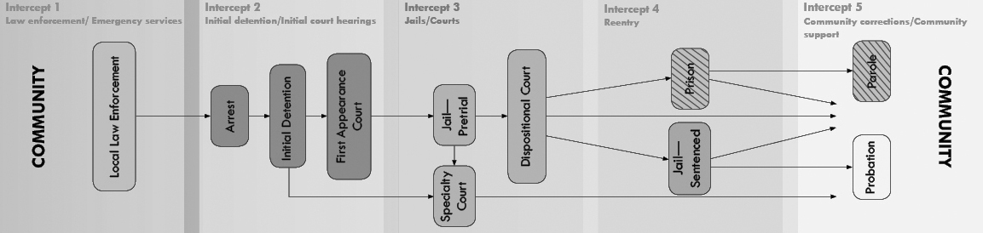
Examine Available Models
To further educate your planning group about jail diversion, you’ll want to examine models that have been developed and tested in other communities. Though the program you create will be unique to the needs, resources, and political climate in your jurisdiction, there is no need to reinvent the wheel. Many planning groups send key members to visit programs in communities that are similar to their own. For example, the Lancaster County, NE, Mental Health Jail Diversion Project used Federal technical assistance funds to send two county commissioners to visit a similar program in Portland, ME. Most police agencies that are considering creating a pre-booking diversion program begin by examining model approaches that have already been developed, particularly the Memphis CIT program (Reuland, 2004).
As you review other program models, you’ll need to consider how they could be adapted to fit your local context and constraints. Items to consider include, but are not limited to, the following:
- How will you determine legal and clinical criteria?
- How, where, and when will you assess potential consumers?
- How long will they spend in your program?
- How will you supervise consumers, and who will be responsible for doing so?
- What consequences will you impose for noncompliance?
- How will consumers transition from criminal justice-based programs to community services?
- What will be the disposition of the case when consumers complete the program? What will happen if they don’t?
The answers to many of these questions will depend on how your system is structured, who the key players are, and at what points in the system your consumers interface with various agencies and individuals. This is where mapping the system can help. The section that follows describes this process in more detail.
Map the System
If your community is like most, the structure of the mental health, substance abuse, and criminal justice systems, and the points at which they intersect, are sufficiently complex that no one person in your planning group sees the system as a whole. When you examine the pathways through which a person with mental illness and substance use disorders in contact with the justice system has to travel to get treatment and services, you begin to understand how people with multiple and complex needs fall through the cracks of fragmented systems of care.
System mapping may be an unfamiliar term, but it’s a simple idea. It’s a tool for identifying gaps and needs in the system and for doing prioritized action planning. The goal of a system mapping exercise is both simple and profound: to transform fragmented services into a system that makes sense to the people and the professionals who use it. This is a dynamic and interactive process, and you may choose to contract with an outside facilitator to help negotiate the competing priorities that will emerge. See the box in this section for a description of one such service.
At its core, system mapping uses what is called the “sequential intercept model” to determine the key points at which people with mental illness and substance use disorders may be diverted and the critical strategies that can be employed at each juncture. The five intercept points are:
- Law enforcement and emergency services
- Initial detention and initial hearings
- Jails, courts, forensic evaluations, and forensic commitments
- Reentry from jails, State prisons, and forensic hospitalization
- Community corrections and community support services
The sequential intercept model can help you decide where to begin your intervention. For example, pre-booking diversion programs represent the first point of intervention; mental health courts are an example of an intervention at the third intercept point. Ideally, most people will be intercepted at early points. Using this model, communities can develop targeted strategies that evolve over time to divert people with mental illness and substance use disorders from the justice system and link them to community treatment (Munetz & Griffin, 2006).
ACTION: A Set of Tools to Facilitate Systems Change
The members of your stakeholder group will approach development of a jail diversion program with different experiences, perspectives, and expectations. Few, if any, will know how the entire system works. As one individual who participated in a cross-systems mapping exercise noted, “We found that many people had contact with the same individual with no coordination of services.”
To facilitate systems change, Policy Research Associates, Inc., which operates the CMHS National GAINS Center, has developed a set of training and technical assistance system change products called ACTION: Transforming Services for Persons with Mental Illness in Contact with the Criminal Justice System.
ACTION is a dynamic approach setting communities on a trajectory of change through interactive, cross-system collaboration. It convenes key community decision makers, professionals, and consumers for cross-training, cross-systems mapping and facilitated action planning.
■ Partnership Building & Collaboration: Cross-systems training to help build partnerships and prepare communities to assess current services in the community
■ Cross-Systems Mapping: Strategic planning workshop to map out current local services and identify gaps and opportunities
■ Taking Action for Change: Facilitated action planning workshop to embark on systems change
ACTION products are tailored to site-specific needs, include examples and vignettes from evidence-based programs across the nation, and help communities reach across diverse viewpoints to develop a unified plan of action. For more information about ACTION products and services, contact Policy Research Associates at (518) 439-7415 or training@prainc.com.

Sequential Intercept Model
Identify Gaps
As you map your service system, you’ll begin to identify where gaps in services exist. Based on knowing who you want to serve and the services they require, you’ll need to determine whether these services exist in sufficient quantity, and, if so, whether the agencies that provide them are prepared to work with your consumers. You might want to use a tool such as the Community Needs Assessment developed by the National Consumer-Supporter Technical Assistance Center (NCSTAC), funded by the Federal Substance Abuse and Mental Health Services Administration. The NCSTAC tool guides the collection of both quantitative and qualitative data designed to help communities determine the current strengths and service gaps in the system, with an emphasis on recovery-oriented mental health services. A companion document, Assessing Communities for Systems Transformation, is also available. Visit the NCSTAC Web site at www.ncstac.org and click on the “Resource Library” link.
When you identify where the gaps are, you have to decide how to fill them. The solution for each community will be different. Depending on how you structure and finance your jail diversion program, you may choose to add a service that doesn’t currently exist, or adapt one—such as an Assertive Community Treatment (ACT) team—to serve the needs of your consumers.
In many communities, the mental health and substance abuse systems are underfunded and oversubscribed and affordable housing resources are scarce. Finding appropriate treatment and housing for your consumers may be difficult, which is why your program’s boundary spanner and case managers are critical for success. The boundary spanner can reach across agencies to develop solutions that may require little new funding or expansion of services. Individual case managers can help broker limited resources for their consumers. Where such services don’t exist or have waiting lists, the case managers can provide them. In Lancaster County, NE, lack of substance abuse treatment, in particular, necessitated development of an intensive case management model. While waiting for substance abuse treatment slots to open, the intensive case managers provide jail diversion consumers with individual and group therapy and offer opportunities for peer support. More information about how to access mental health services on behalf of jail diversion consumers can be found in Section 5 of this publication.
Determine Where to Invest Scarce Resources
It’s no secret that few communities planning jail diversion programs will have all the resources they need to accomplish everything they want to do. This is where all the steps you’ve taken to this point are so important. To estimate the cost of needed services and begin to locate funding for your jail diversion program, you’ll need to be equipped with the information you’ve gathered, including:
- Who you want to serve
- How many potential consumers you have
- The types and level of services they need
- The features of existing models you plan to adopt or adapt
- Where you want to begin to intervene
- What types of services you have and which ones you lack
- How you plan to fill any service gaps
In the section below titled “Secure Funding,” we outline some suggestions for seeking new funding or making innovative use of the resources you already have.
Create an Action Plan
If you’ve followed all the strategic planning steps to this point, you’ve learned much about how your system operates, what type of jail diversion program you want to develop, and what you hope to accomplish. Now it’s time to make your plans concrete by creating an action plan that is designed to ensure continued collaboration and progress toward achieving goals. Your stakeholder group should collectively determine action items, identify who is responsible for overseeing the progress or completion of each item, and report on progress at subsequent meetings (National Mental Health Association, 2003).
Your action plan should be designed to do the following, as highlighted more fully in Section 5:
- Designate specific responsibilities among participating agencies for each point in your diversion pathway. Memoranda of understanding (MOUs) or interagency agreements are good ways to do this.
- Share information about the consumers you have in common and about their treatment and service needs. You’ll have to do this within the bounds of confidentiality, but there are effective ways to do so.
- Plan for services that will help your consumers achieve psychiatric and residential stability and avoid recidivism. Services packages will be unique to each consumer, but there are a common set of services—including housing, treatment, and supports—that most consumers will require.
- Identify key positions for the diversion program and cross-train your staff. These positions include the all-important boundary spanner and specialized case managers. In keeping with the need to be culturally relevant to your program’s consumers, you’ll want to pay special attention to recruiting staff who reflect the cultural and racial diversity of the people you intend to serve.
- Devise a marketing strategy to share the good news about your program’s successes and to head off any potential negative publicity.
Secure Funding
In an era of scarce resources, finding the money for your jail diversion program requires creativity, perseverance, and ongoing advocacy. Taxpayers in your community may be more supportive of spending limited public resources to build and fill more jails rather than creating community-based treatment and supports for people with mental and substance use disorders in contact with the justice system. Further, categorical funding that targets dollars to specific populations, providers, and programs makes it difficult to fund the integrated services that mark a successful jail diversion program. Finally, the emergence of managed behavioral health care in the public sector holds out both promise and peril for people with multiple and complex needs.
There are, however, several key strategies highlighted below that have proven successful in helping communities overcome these barriers. Additional resources are outlined in Section 6.
Custom Blend Funding Sources
No single system can pay for the multitude of services needed by people with mental illness and substance use disorders in contact with the criminal justice system. Since you need to integrate several types of services in order to provide comprehensive treatment, you should identify a mix of funding sources that respond to the specific needs of your consumers and reflect the way services are funded and delivered in your community. By blending funds, you will be less susceptible to reductions in any one funding stream and your funding package will mirror the diversity of the services you provide.
Blending funds may require you to shift attitudes among many of your key stakeholders from one of “my funds” and “your funds” and “my customers” and “your customers” to one of “our funds” and “our customers.” Potential funders, in particular, may be nervous about co-mingling historically separate funding streams. If legislation is required to create the mix of funding you need, you’ll want to be certain to involve key lawmakers in your planning process.
Whatever you do, heed the caution of others who have created jail diversion programs and don’t retrofit your plan to a specific funding source. Rather, decide on the services you need to provide and find a way to pay for them. For example, the Tulsa County (OK) Jail Diversion Program is funded by the county, the Oklahoma Indigent Health Care System, and the Oklahoma Department of Corrections Community Sentencing Program. Programs that secure funds from several sources and blend them according to the specific needs of their localities have the best chance of carrying pilot programs into the mainstream and ultimately achieving their goals.
Reorganize Existing Funds
Blending Funds to Pay for Diversion in Seattle
With the support of its Systems Integration Advisory Council (SIAC) and many local stakeholders and advocates, King County (Seattle, WA) was able to blend funds and resources from five systems to support a pre-booking diversion program for people with mental illness and co-occurring substance use disorders. A subgroup of the SIAC recommended adoption of a Crisis Triage Unit (CTU) to divert nonviolent misdemeanants with co-occurring disorders from the county jail to treatment in the community. Here’s how the project was funded:
■ Harborview Medical Center, the county hospital, provided space for the CTU within a locked area of the hospital’s Emergency Services Department. The hospital’s community mental health program provided 24-hour psychiatric coverage, augmented by nursing, social work, and triage staff.
■ The county mental health and substance abuse systems provided funds to support a large portion of the CTU staff enhancement, as well as support services that include service linkage staff, crisis respite beds, dedicated capacity at the detoxification unit, fast track access to substance abuse residential treatment, and next day appointments for mental health and substance abuse services.
■ The developmental disabilities system provided part-time support staff.
■ The City of Seattle Human Services Department funded emergency respite beds for individuals who appeared eligible but were not yet enrolled in the county’s mental health managed care system.
The package of funds supporting the CTU totaled $2.4 million, but no single player contributed more than about $800,000. Together, the blending of these resources created a holistic service continuum that transcended the categorical restrictions carried by many of the funds provided and made the CTU possible. See a fact sheet on the CMHS National GAINS Center Web site at www.gainscenter.samhsa.gov/pdfs/jail_diversion/Blending_Funds.pdf for more information about this innovative use of blended funds.

From Albuquerque to Miami to Augusta, ME, communities around the country have begun their jail diversion efforts with no money specifically targeted to their activities. Though you may eventually need new money to expand or enhance your program, it’s important to look at how existing funds in the mental health, substance abuse, and criminal justice systems can be reorganized to better serve the consumers you have in common.
You can be creative with small amounts of money and with funds that are already available. Consider sharing staff, space, equipment, or expertise, for example. You might piece together full-time positions with multiple agencies, eachto people with mental illness (Council of State Governments, 2002; Reuland, 2004).
In a related vein, you may be able to “find” money by redirecting savings from your jail diversion program or a related initiative. When King County (Seattle), WA, initiated a managed care program, it redirected funds previously spent on institutional and other high-cost care into services for those diverted from the criminal justice system. In addition, the managed care entity is required to treat jail diversion consumers and report its performance in doing so (Bazelon Center, n.d.; Council of State Governments, 2002). When you attach funding to outcomes, you can ensure that your consumers will be served.
Use Best Practices
Evidence-based and promising practices are not only the most effective way to ensure recovery for your jail diversion consumers; because many of these services are reimbursable under your State’s Medicaid program, they can generate Federal matching funds. Best practices that are eligible for Federal match include the following (Bazelon Center, n.d.):
- Psychiatric rehabilitation (building social skills and skills for daily living)
- Assertive Community Treatment (ACT)
- Integrated treatment for co-occurring disorders
- Supported employment
- Disability management
- Family psychoeducation
- Peer services
Communicate Regularly
You’ve reached consensus on a vision, developed a plan, and located funding for your jail diversion program. However, the work of creating a jail diversion program doesn’t end when your plan is complete and you begin accepting consumers. You have to communicate regularly with representatives from all key agencies through continued group meetings. This may occur naturally if some of your stakeholders are involved in the jail diversion program itself. For example, in Shelby County, TN, a roundtable that includes key partners—pretrial services, jail medical staff, provider agencies, and boundary spanners—meets to plan service packages for people who are eligible for diversion.
Every time your stakeholder group meets, it should set goals for the next meeting, such as assigning members to make telephone calls to recruit support. These small steps help your group learn to work as a team to build on initial successes and to monitor progress toward long-term goals (National Mental Health Association, 2003). Indeed, all the good work you’ve done to date now becomes the foundation for what you need to do to implement your action plan successfully. Such important steps as moving from informal to formal arrangements, ensuring access to services, creating boundary spanner positions, and cross-training your staff are discussed in Section 5.
SECTION 5: Putting the “Action” in Your Action Plan
Developing an action plan to guide jail diversion activities requires reaching broad community consensus, examining available models, and selecting a program to adapt based on common goals, available resources, and political and popular support in your community. But planning for change isn’t enough; you must put your plan into action. In this section, you’ll learn how to implement your action plan by developing formal agreements and sharing information; providing a set of mental health, housing, and support services for consumers; creating key positions and training the staff who fill them; and devising and implementing a marketing strategy.
The Problem
There are a host of difficulties that can derail your best intentions to implement a jail diversion program if you are not prepared to address them. Popular and charismatic leaders may retire or move away, creating a vacuum in leadership. Staff may be ill prepared to work across systems and with consumers who have multiple and complex problems. A negative news story about a jail diversion consumer can bring unwanted attention to your program from lawmakers, funders, and a skeptical public.
What You Need to Know
The goal of a well developed jail diversion action plan is to integrate the services of three distinct systems with often conflicting values and modes of operation: mental health, substance abuse, and criminal justice. This takes creativity, flexibility, and patience. True systems integration is an ideal state and one you may not achieve fully, but you can tell you’re making progress by the degree to which you proceed along a continuum that includes the following stages (Konrad, 1996; The National GAINS Center, 1999a):
- Information sharing and communication: At the beginning, key personnel from mental health, substance abuse treatment, law enforcement, and corrections may have an informal arrangement to share information about programs, services, and target populations. They may exchange brochures, share newsletters, and hold joint staff meetings.
- Cooperation and coordination: Though still informal, mental health/criminal justice partners at this stage may establish reciprocal program referral and follow-up processes or mutual agreements to provide priority response to each other’s target populations.
- Collaboration: Collaborative efforts are usually formalized and may include written agreements, formalized operational procedures, joint funding, cross-training of staff, and shared management information systems.
- Integration: A fully integrated system features joint planning, training, decision-making, information systems, purchasing, screening and referral, care planning, service delivery, monitoring, and feedback (Leutz, 1999).
Typically, arrangements between agencies become more formal as they progress through these stages. The steps highlighted in this section will point you in the direction of moving from cooperative ventures to true partnerships.
Implementation Barrier: Your program’s key champion retires or moves away.
Potential Solution:
- Develop formal agreements, such as an MOU, to solidify agreements and define staff roles.
What You Need to Do
Jail diversion efforts in your community might begin with something as simple as an informal agreement between a law enforcement officer and a mental health crisis counselor to coordinate their activities on behalf of people with mental illness and substance use disorders who risk arrest and incarceration. However, to reach beyond informal, handshake agreements and create the more formal structures that will ensure lasting system change for people with mental illness and substance use disorders involved in the criminal justice system, you will need to:
- Develop formal agreements
- Share information
- Plan for services
- Identify key positions
- Cross-train and support your staff
- Devise a marketing strategy
Develop Formal Agreements
You can begin jail diversion activities with little more than verbal agreements to coordinate services on behalf of people with mental illness in the justice system. But at some point you’ll want to formalize your efforts so they outlive the personalities and relationships on which they are founded.
Memoranda of understanding are formal agreements between public service agencies that can facilitate service delivery through cooperative efforts (Massaro, 2005). A memorandum of understanding (MOU) or interagency agreement is a good way to formalize what the partners in your collaboration have agreed to do. Elements of a successful MOU include (Council of State Governments, 2002, p. 202):
- A well-defined target population
- An overarching purpose that underlies the agreement
- Discussion of any relevant legislation or regulations
- Elaboration of specific goals, both shared and germane to a particular partner
- Definition of any new responsibilities
- Time lines for the implementation of new initiatives and for review of the implementation process
Other key elements include the terms of agreement, procedures for communication and information sharing, primary and secondary contacts for each agency, and signatures. In Miami, the stakeholder group developed a written cooperative agreement that spells out the process for the city’s pre-booking and post-booking diversion efforts. The Hawaii jail diversion program drafted a program manual that outlines rules and responsibilities for individuals and for participating agencies. See the Resources section of this publication for a sample MOU.
Implementation Barrier: Stakeholders raise concerns about sharing information.
Potential Solution:
- Access training on what information sharing HIPAA prohibits and allows.
Share Information
To plan effective services for people with multiple and complex needs, you’ll need to be able to share information about the treatment and services they require. Information-sharing restrictions may appear to be a significant barrier to collaboration, but there are several steps you can take to overcome this potential obstacle.
First, learn everything you can about local, State, and Federal laws that govern exchange of information between mental health providers and law enforcement. Your agency’s legal department may be a good place to start.
In general, though State statutes are not entirely consistent, they typically require that the consumer provide written consent if information is to be shared beyond the immediate clinical team providing services. The Federal Health Insurance Portability and Accountability Act (HIPAA) makes some exceptions for the exchange of information with correctional facilities or law enforcement; however, local or State regulations may be stricter than HIPAA requirements. Finally, Federal statute governing information related to substance abuse treatment is stricter than provisions covering mental illness treatment records. A comprehensive set of resources on HIPAA, including a checklist to help you get started, is available at www.hipaa.org.
Second, establish a subcommittee of your stakeholder group to review or develop policies that facilitate information sharing, including the development of a standardized release of information form that meets all Federal, State, and local requirements. A written consent form should indicate, at a minimum, the purposes for which the requested information may be used, the period for which consent is valid, and the parties with whom it may be shared. This can be an important way to build trust with consumers and between providers. A sample release of information form is included in the Resources section of this publication.
Third, consider the use of some form of advance planning that allows consumers to decide in advance of a crisis whether and how much information should be divulged and to whom. The concept of a psychiatric advance directive is gaining recognition in the mental health system and is particularly relevant for individuals who have previously been in contact with the criminal justice system or whose behaviors put them at significant risk. The Bazelon Center for Mental Health Law at www.bazelon.org is a good source of information on psychiatric advance directives.
Another resource is the section on developing crisis plans in Mary Ellen Copeland’s Wellness Recovery Action Plan (WRAP) curriculum. Created by consumers for consumers, WRAP is a systematic approach for monitoring, reducing, and eliminating uncomfortable or dangerous physical symptoms and emotional feelings, some of which may increase risk for contact with law enforcement. WRAP can also be an important adjunct to the delivery of best practices designed to promote recovery (Copeland, 2000; www.mentalhealthrecovery.com).
Plan for Services
There is probably nothing else you will do to implement a successful jail diversion program that is more important, and more difficult, than ensuring access to a full range of comprehensive and coordinated treatment, housing, and services for people with mental illness and substance use disorders in contact with the justice system. Indeed, as Munetz and Griffin (2006) note, “An accessible, comprehensive, effective mental health treatment system focused on the needs of individuals with serious and persistent mental disorders is undoubtedly the most effective means of preventing the criminalization of people with mental illness” (p. 545). Unfortunately, few communities in the United States have this level of services. Without adequate and appropriate services to which people can be referred, jail diversion will be an exercise in futility.
Regardless of whether your organization has the immediate ability to increase or enhance the level of community-based mental health and substance abuse treatment services available to jail diversion consumers, you must become knowledgeable about the services that are available; how services are organized, delivered, and financed; and what services are deemed to be most effective. Only then can you successfully advocate for the type and level of services your consumers need to recover from their illness and avoid recidivism.
The HIPAA Privacy Rule: What It Means for Information Sharing
The Health Information Portability and Accountability Act (HIPAA) was signed into law in 1996. The portion of the law governing the protection and disclosure of health information, known as the Privacy Rule, took effect in 2003. The Privacy Rule only applies to covered entities (health plans, health care clearinghouses, health care providers, and in some cases, business associates). It does not apply to the courts, law enforcement, or community corrections. In the case of correctional facilities, information can be disclosed if an individual is in custody and the records are required for the purposes of treatment or for the safety of other inmates and staff.
■ When is disclosure permitted without an individual’s consent? For reasons related to the provision of health care (treatment, payment, and health care operations), court proceedings, law enforcement purposes, where there is a threat to health and safety, or where State laws mandate disclosure.
■ When to obtain consent. Where disclosure is permitted without consent, HIPAA mandates only the minimally necessary health information be released. In most instances, HIPAA is less restrictive than State laws or Federal law covering the release of substance use treatment records. However, as health care confidentiality and privacy are important values, and are often protected by State laws, seeking consent from individuals is important.
More resources on information sharing:
■ Dispelling the Myths about Information Sharing between the Mental Health and Criminal Justice System issue brief: http://www.gainscenter.samhsa.gov/html/resources/publications.asp#services
■ Dispelling the Myths about Sharing Data between Mental Health and Criminal Justice Systems net/teleconference: http://www.gainscenter.samhsa.gov/html/resources/presentations.asp
Adapted from Dispelling the Myths about Information Sharing between the Mental Health and Criminal Justice System by John Petrila, JD, LLM, and available from the CMHS National GAINS Center website.

Understand the Mental Health System
As you examine the structure of the mental health system in your community, focus not only on what currently exists, but, more important, on what an ideal system would look like if all the pieces were in place. This may be more difficult than it sounds, because as the Criminal Justice/Mental Health Consensus Project points out, “‘System,’ indeed, may be a misnomer for what is often a patchwork of programs, services, and complex funding sources” (Council of State Governments, 2002, p. 17).
Though it is beyond the scope of this publication to explore in detail the changing context of care for people with serious mental illness, several key facts are worth noting:
- The full range of services and supports that people with the most serious mental illness need to live successfully in the community doesn’t exist in many localities today. In particular, lack of intensive outreach, limited treatment for co-occurring mental illness and substance use disorders, and inadequate and inappropriate housing result in people with serious mental illness receiving fragmented and uncoordinated treatment, housing, and support services, if they receive them at all.
- Unlike the criminal justice system, which has a fairly straightforward structure, the mental health system draws revenue from a “dizzying variety of sources.” These include Medicaid, Medicare, State general revenue funds, local matches, the Community Mental Health Services Block Grant, and fees paid by consumers (Council of State Governments, 2002, p. 16). Each of these funding sources has its own eligibility rules, required services, and reporting mechanisms.
- There is a significant gap between research and practice, which means that the best, science-based treatments for serious mental illness aren’t being delivered at the community level (Institute of Medicine, 2006).
- There is a growing body of evidence that evidence-based practices (see box in this section) improve outcomes for both the consumer and the system. If they were implemented more broadly, it is likely that fewer people with mental illness would become involved in the criminal justice system (Council of State Governments, 2002).
Use Best Practices
Your challenge as key stakeholders planning a jail diversion program for people with mental illness and substance use disorders is to ensure that evidence-based practices become more broadly available and to incorporate them into the service packages you plan for your consumers. You also need to understand the potential limitations of using evidence-based practices with a criminal justice population.
One of the most essential services you need to provide for people in contact with the justice system is integrated treatment for serious mental illness and co-occurring substance use disorders. Frequently, people are excluded from mental health treatment because of their substance use disorder and from substance abuse treatment because of their mental illness, meaning they may receive treatment for only one, or for neither, disorder.
There is a significant body of research which shows that treating mental and substance use disorders simultaneously and in one setting reduces alcohol and drug use, the severity of mental health symptoms, and homelessness. For individuals with co-occurring disorders, integrated treatment appears seamless, with a consistent approach, philosophy, and set of recommendations (Drake et al., 2001, 1998). At least one model of integrated treatment, the modified therapeutic community (MTC), has demonstrated lower rates of reincarceration and a reduction in criminal activity for MTC participants (Sacks et al., 2004).
Evidence-based practices are “interventions for which there is consistent scientific evidence showing that they improve client outcomes”
—Drake et al., 2001.
Evidence-Based Practices: Shaping Mental Health Services toward Recovery
The following six services are designated as evidence-based practices for people with serious mental illness, including those who have co-occurring disorders (Massaro, 2005; see also www.samhsa.gov):
Illness management and recovery teaches each person to understand his or her mental illness. It helps individuals to identify and use those elements of treatment and rehabilitation they have found to be most effective.
Medication management approaches encourage the use of medications with proven efficacy, which should be accompanied by proper medication management skills to increase independence in managing medications.
Family psychoeducation services are educational programs for families to learn about mental illnesses, how to respond to people experiencing symptoms, and how to support recovery.
Assertive Community Treatment (ACT) is a service delivery approach that uses a team of professionals, often assisted by paraprofessionals and consumers, that is available on a 24-hour basis to deliver comprehensive and coordinated, intensive treatment and support services. These services often target individuals at high risk for homelessness, hospitalization, or incarceration.
Supported employment is a service that helps people with mental illnesses find and keep competitive employment. Agencies work with employers and consumers to provide the necessary supports that enable people to face the challenges of employment without compromising their recovery.
Integrated treatment for co-occurring mental illness and substance use disorders involves treatment for both disorders at the same time and in one setting.
The Federal Substance Abuse and Mental Health Services Administration (SAMHSA), part of the U.S. Department of Health and Human Services, has published a set of six Evidence-Based Practice Implementation Resource Kits to encourage the use of evidence-based practices (EBPs) in mental health (see box). The kits include a user’s guide, information sheets for all stakeholder groups, tips for implementing the practice with fidelity to the model, and a workbook or manual for practitioners. Complete versions of the publications can be downloaded from the SAMHSA Web site at www.mentalhealth.samhsa.gov/cmhs/communitysupport/publications/about.asp. In addition, fact sheets on EBPs as they relate to individuals in contact with the justice system are available on the CMHS National GAINS Center Web site at www.gainscenter.samsha.gov. These fact sheets contain important caveats for the use of EBPs with people who are involved in the criminal justice system.
For example, a number of jail diversion programs have modified Assertive Community Treatment (ACT) to serve the needs of individuals in contact with the justice system, sometimes referring to this adaptation as a forensic ACT or FACT team.
ACT teams feature a multidisciplinary group of mental health, substance abuse, and social service specialists who provide, or arrange for, each individual’s clinical, housing, and rehabilitation needs. Staff-to-consumer ratios are low (typically 10 to 1) and services are available around the clock. ACT teams, when compared to other forms of case management, have proven effective in reducing psychiatric hospitalizations and improving housing stability for people with the most serious disorders (Morrissey & Meyer, 2005).
Forensic ACT teams partner with criminal justice agencies with the goal of preventing arrest and incarceration. Compared to regular ACT programs, FACT teams typically: 1) require that all consumers admitted to the team have criminal justice histories; 2) accept the majority of their referrals from criminal justice agencies; and 3) place a greater emphasis on developing supervised residential treatment for high-risk consumers, particularly those with co-occurring substance use disorders (Lamberti, Weisman, & Faden, 2004).
Though ACT is in many ways thought of as the “gold standard” for people with severe disorders who are unlikely to engage in traditional approaches, researchers caution that there is not yet enough evidence to suggest that specialized FACT teams can achieve their stated goals of preventing arrest and incarceration. Other forms of intensive case management may be equally suited to the needs of jail diversion consumers and less expensive to implement.
Using a Mobile Treatment Team Based on the ACT Model to Prevent Jail and Hospital Recidivism
Project Link in Monroe County (Rochester), NY, is a university-led consortium of five community agencies that is designed to prevent repeated incarceration and hospitalization of people with serious mental illnesses and to promote their reintegration into the community. The majority of Project Link’s clients have been charged with a felony or have a past felony conviction, most of them violent felonies involving physical assault. They have severe mental illness and co-occurring substance use disorders, and one-third are homeless.
To meet the needs of their multiply disabled clients, the consortium links the health care, social service, and criminal justice systems and features a mobile treatment team, a dual diagnosis treatment residence, and multicultural staff. Clients who need the most intensive treatment and support are served by a mobile treatment team based on the ACT model. The team, which includes a part-time forensic psychiatrist and a full-time psychiatric nurse practitioner, ensures the delivery of comprehensive health services around the clock. Team members provide both crisis stabilization and referral and intensive treatment. Because of their high level of impairment, many clients remain with the team for about two years.
Project Link has had a significant impact in decreasing the number of incarcerations and average days spent in jail; the average hospital days and number of hospitalizations have also declined. In 1999, Project Link received a Gold Achievement Award from the American Psychiatric Association. For more information, see http://psychservices.psychiatryonline.org/cgi/reprint/50/11/1477.
For example, the Lancaster County (NE) Mental Health Jail Diversion Project uses an intensive case management team but refers consumers to community agencies for such services as psychiatric and nursing care that might be provided by members of a more resource-intensive ACT team. Also, individuals who are accepted into the jail diversion program must have some degree of stability; typically ACT teams work with a highly disabled population. This approach allows the Lancaster County program to incorporate the full support philosophy and team approach of an ACT model with lower costs.
Incorporate Promising Practices
Best practices are necessary but not sufficient to ensure full community integration for people with mental illness and substance use disorders in contact with the justice system. Promising practices exist in a number of areas, including supportive housing, consumer-operated mental health services, and trauma-informed services. Brief descriptions of these services follow, along with resources for more information.
Supportive housing is generally defined as a broad range of housing options linked to a variety of supportive services. Services, which include case management, mental health and substance abuse treatment, and employment assistance, typically are voluntary and are designed to help individuals maintain residential stability. “Housing First,” a type of supportive housing, often is touted as a way to take people with the most severe mental illness and substance use disorders directly from the streets or from jails and prisons and place them into permanent housing. New York City’s Pathways to Housing program is one of the most well-known examples of this approach (see www.endhomelessness.org/best/pathways.htm).
The Corporation for Supportive Housing (www.csh.org) is an excellent resource for information on how to develop, fund, and evaluate supportive housing options. In your local community, be certain to involve the homeless coalition or city homeless services coordinator and the housing authority on your planning group. These individuals may have information on affordable housing resources available to your consumers, many of whom have experienced homelessness. For more information on Federal affordable housing programs, see the list of resources on the Technical Assistance Collaborative Web site at www.tacinc.org/HH/Program_Policy/Programs_Policy.htm.
Implementation Barrier: You have difficulty placing your consumers in housing.
Potential Solutions:
- Include homeless coalitions and housing authorities on your planning group.
- Consider establishing scattered-site housing if the community opposes a group facility.
- Provide follow-up to consumers in housing to ease landlords’ fears.
Unfortunately, housing availability and affordability remain significant roadblocks in many communities for people of limited means. Many individuals with serious mental illness who are unable to work rely on Supplemental Security Income (SSI), but in 2004, the average rent of a one-bedroom apartment was 109 percent of SSI (O’Hara & Cooper, 2005).
Further, Federal housing policy makes it difficult for ex-offenders, particularly those with drug-related offenses, to secure public housing assistance. Federally assisted housing programs, including public housing authorities and Section 8 providers, are permitted, and in some cases required, to deny housing to individuals with certain criminal histories (Council of State Governments, 2002). For a discussion of eligibility for Federal housing for people who have been incarcerated, see the New Freedom Commission’s Subcommittee on Criminal Justice report at www.mentalhealthcommission.gov/papers/CJ_ADACompliant.pdf.
Consumer-operated services are programs run by people who have experienced serious mental illness, homelessness, and recovery from substance use disorders, as well as those who have been involved in the justice system. They include drop-in centers, recovery support programs, case management programs, outreach programs, businesses, employment and housing programs, and crisis services. Many of these services are more “user friendly” for people who might have had previous negative experiences with traditional providers.
A Day in the Life of a Recovery Support Specialist
My name is Milton and I’m a Recovery Support Specialist with a jail diversion project. My job is to support a person’s recovery and my motto for all of my clients is “don’t pursue your illness, but your wellness.” I stress the need for them to learn to manage their symptoms and I help them do just that.
At some point during the morning, I like to contact each of my clients to see how they are feeling, to offer encouragement, or to plan an activity for that day or the near future. All of my clients have come to know me as one who stresses success no matter what the situation looks like now. We have what I call “what do I do when” sessions. It’s amazing how my career experiences allow me to come up with answers for each individual, through each stage of his or her recovery.
During the day, I spend a lot of time behind the wheel of the company van taking my clients to lunches, trips to the park, and exercise sessions that I feel are a very important part of life. We do the necessary things, as well, such as going to doctor’s appointments and grocery shopping.
To me, recovery is a deeply personal, unique process of changing one’s attitudes, values, feelings, and goals to live a satisfying, hopeful, and contributing life even with the limitations caused by mental illness. My clients know that I am always there to support them in their recovery.
Often I find that the day has passed much too quickly. I really love my job!
Forensic peer specialists have demonstrated the ability to engage their peers in services when other mental health service providers have been unable to do so. They bring real-world experience with multiple service systems and an ability to relate one-on-one to people struggling to reclaim their lives. As such, they can be important members of ACT or FACT teams (Massaro, 2005). The National Research and Training Center on Psychiatric Disability at the University of Illinois at Chicago has a set of resources on consumer-driven services and peer support outcomes at www.cmhsrp.uic.edu/nrtc.
Trauma-informed services are absolutely essential for development of programs intended to serve people with mental illness and substance use disorders in contact with the justice system. Men and women with mental illness, as well as those with co-occurring substance use disorders and those involved with the criminal justice system, experience very high rates of physical and sexual abuse as children and as adults. Untreated trauma may complicate recovery from mental illness and substance use disorders and, in some cases, may precipitate the disorder. In addition, individuals with histories of trauma are more vulnerable to victimization and ongoing abuse (SAMHSA, 2003; Massaro, 2005).
The key principles of trauma-informed services are (Fallot, 2006):
- Safety: Ensuring physical and emotional safety
- Trustworthiness: Maximizing trustworthiness, making tasks clear, and maintaining appropriate boundaries
- Choice: Prioritizing consumer choice and control
- Collaboration: Maximizing collaboration and sharing of power with consumers
- Empowerment: Prioritizing consumer empowerment and skill-building
There are a number of specific interventions designed to address trauma, some of which have been used successfully with people in the justice system. Information on these programs is available from the National Trauma Consortium at www.nationaltraumaconsortium.org.
Begin Where You Are
Clearly, you need to focus on the quality of services to which you are linking people. Best and promising practices, delivered in a culturally appropriate manner, will help people with mental illness and substance use disorders recover from their illness, remain stably housed, and avoid recidivism. But don’t let a lack of quality services stop you from starting your program. As Munetz and Griffin (2006) note:
Even the most under-funded mental health systems can work to improve services to individuals with the greatest need, including the group of people with serious and persistent mental disorders who have frequent interaction with the criminal justice system. Such efforts require close collaboration between the mental health and criminal justice systems (p. 547).
Everything you’ve done to this point—including reaching consensus, developing an action plan, and moving closer to an integrated system—has helped you strengthen and refine the relationships among partners in the mental health, substance abuse, and criminal justice systems. You can build on these relationships to find, adapt, or as Stephen Bush suggests, “cobble together,” the best service packages you can arrange for your jail diversion consumers. Your success in helping them remain out of the justice system depends on it.
Boundary spanners are positions that “link two or more systems whose goals and expectations are likely to be at least partially conflicting”
—Miles, 1980, p. 62

Identify Key Positions
Because the jail diversion program you develop will be unique to your community’s resources and needs, the specific positions you create and the people you choose to fill them will be distinctive, as well. Staff positions required to maintain jail diversion programs generally include mental health practitioners to screen and assess a person’s eligibility, case managers to broker services, and boundary spanners to coordinate activities among systems. Your program might also include pretrial services staff to provide oversight and monitoring and peer specialists to support enrollees. Some of these roles may overlap; for example, a mental health practitioner may act as a boundary spanner and a case manager may offer personal assistance to consumers. Sample job descriptions for some of these positions are included in the Resources section of this publication, and several “day in the life” profiles of jail diversion staff are included throughout the text.
Of all of these positions, the one that may be most unfamiliar to you, and the one your jail diversion program can’t do without, is that of a boundary spanner. The material that follows outlines why you need a boundary spanner, what the job entails, and how you can find the right person to fill this all-important role. Some key functions that diversion staff perform are detailed in the subsections that follow.
Boundary spanners are positions that “link two or more systems whose goals and expectations are likely to be at least partially conflicting”
—Miles, 1980, p. 62
Create Boundary Spanners
Boundary spanners are known by different names. In your jail diversion program, they may be called a:
- Linkage specialist
- Court diversion case manager
- Case management specialist
- Mental health liaison
- Mental health coordinator
They also may be found at different levels in the organization—program director, program coordinator, case manager, or court- or jail-based mental health workers—and there may be more than one boundary spanner in an agency or program. But regardless of their title, and wherever in the organization they reside, their role is the same: they are the “traffic cop” that manages interactions among the three, often competing, systems of mental health, criminal justice, and substance abuse. Each of the organizations that participate in your jail diversion program has its own goals, policies, jargon, and organizational structures, and managing the interactions between and among them is a complex task (Council of State Governments, 2002).
Here are some of the key things you need to know when creating a boundary spanner position and finding a person to fill the job:
A Day in the Life of a Boundary Spanner
When we first began thinking about jail diversion, we’d never even heard the term “boundary spanner.” As we started consensus building, we realized that bringing people together was easy—we fed them! But keeping them together required someone with connections to and understanding of the complex systems they represented. I’d been a public defender and mental health advocate for almost 20 years. I worked in and knew the systems, warts and all. It didn’t hurt that I had some political savvy, as well. But I’m just one example of what a boundary spanner can be. Every community has different needs, concerns, and assets to draw from to address local issues. No day is typical, but here’s a sense of what I do:
7:30 a.m. Check schedule and e-mails
8:30 a.m. Breakfast meeting with law enforcement leaders
10:00 a.m. Phone calls: Consumer ombudsmen to strategize around peer training; circuit court judge to discuss potential client; trauma counselor regarding the impact of trauma on women
12:00 p.m. Judicial training
2:30 p.m. Telephone conference with State criminal justice training agency
4:00 p.m. Staff meeting
6:00 p.m. Presentation to the Rotary Club
A boundary spanner—or as I sometimes think of myself on a busy day, a “bounding spaniel”—is a facilitator, someone who can identify leadership and build consensus among diverse groups to understand and achieve new solutions to old problems. Because I know the political system, I’ve been able to garner support for several pilot projects. Also, having recently left a job in criminal defense, I’ve reached out to judges to get them involved.
To be an effective boundary spanner, you need to have energy, enthusiasm, responsiveness, and a nurturing personality. A sense of humor helps, too. At the end of the day, I’m tired but pleased that I’ve been able to have a positive impact in creating the community context for change, reducing stigma, and enlisting support for jail diversion.
- There is no one best way to go about this. For example, in a jail, it doesn’t matter whether boundary spanners work for the sheriff, a community mental health center, or as independent mental health contractors.
- When you create a boundary spanner position, how you fund it and where in the organization you locate it is much less important than having a clear sense of what its functions are, selecting the right person for the job, and finding money from a variety of sources to fund it.
- You need to find a person who knows both the formal and informal norms of the relevant organizations, as well as their internal operations and politics. They must have credibility within these systems.
- In most organizations within the mental health and criminal justice systems, there are some very savvy people who have been around a number of years and know the ins and outs of both systems and their interface points. Often, you’ll find them several levels down in the organization.
- A boundary spanner’s special knowledge and credibility comes from years of experience, usually combined with a good personality. A professional degree is less important and often not necessary.
- Because of the sophisticated and difficult job they do, boundary spanners must receive a commensurate title and reasonable salary.
A Job by Any Other Name: Boundary Spanners at Work
In Miami-Dade County, FL, boundary spanning activities are shared by the Project Director, Continuing Care Coordinator, and Case Management Specialists, all of whom serve as liaisons between the criminal justice and mental health systems and work to identify and divert eligible individuals and link them to community-based treatment and case management. These individuals are employed by the Florida Department of Children and Families (DCF), funded by a Federal grant and Miami-Dade County, and housed at the Miami-Dade County Court. In particular:
■ The Project Director serves as a systems-level boundary spanner and is the primary liaison between the court, DCF, and treatment providers.
■ The Continuing Care Coordinator ensures a smooth transition from jail and the court system to the community. Also, community providers use the coordinator as a resource to find their consumers who become involved in the criminal justice system.
■ The Case Management Specialists are the ground-level boundary spanners, working with consumers at the Crisis Stabilization Unit and facilitating their involvement in the program.
In Lancaster County, NE, a Mental Health Clinician employed by the local community mental health center and funded by a Federal grant has offices in the booking area of the Lancaster County jail. After an initial screen when offenders are booked, the practitioner: 1) reviews the results of the screening, the charges and criminal history, and program eligibility; 2) coordinates a needs assessment and makes diversion recommendations to the Attorney’s Office or Public Defender’s Office; and 3) develops treatment and support plans for people who are eligible for diversion.
Some common functions of boundary spanners include:
- Cultivate, develop, and maintain working relationships with criminal justice and service provider agencies and individuals
- Identify people who meet program criteria
- Make recommendations to the court regarding appropriateness for the program
- Develop an initial service plan
- Hold meetings to discuss service plans
- Coordinate with the mental health system to link people with services
- Maintain established program policies, procedures, ethics, and confidentiality
- Monitor and follow-up on consumer service resolutions
- Prepare and submit compliance reports
- Serve on/chair/provide updates at oversight/advisory/steering group meetings
- Maintain data for program evaluation activities
- Provide appropriate training regarding individual role and program role
Implementation Barrier: Your consumers have a difficult time obtaining benefits.
Potential Solutions:
- Ensure Social Security Administration (SSA) representation on your planning group.
- Seek training from SSA for case managers.
- Attend SAMHSA’s Stepping Stones to Recovery training.
- Initiate applications before a person is released from jail.
- Work with jails to suspend, rather than terminate, benefits.
Understand Key Roles of Jail Diversion Staff
Jail Diversion Staff Conduct a Thorough Assessment. An effective service package for people with mental and substance use disorders in contact with the justice system must be based on an accurate and thorough assessment. Initially, jail diversion practitioners likely will use a brief screening instrument that identifies individuals who may be eligible for diversion. One example is the Brief Jail Mental Health Screen developed by Policy Research Associates, Inc., which is included in the Resources section of this publication.
A more complete assessment by program practitioners will form the basis for selecting the treatment, housing, and support services each consumer requires. Because of the complex nature of co-occurring mental illness and substance use disorders, accurate diagnosis requires a longitudinal assessment by a skilled practitioner, preferably one who has an established, trusting relationship with the consumer. Currently, there is no single tool that represents a “gold standard” for identifying and providing a comprehensive assessment of an individual with serious mental illness and a co-occurring substance use disorder. Rather, specific tools may be used to assess different components of an individual’s functioning (SAMHSA, 2002).
Information about screening instruments for use with people who have mental and substance use disorders and two specific instruments—one for the substance abuse field to screen for mental health issues and one for mental health settings to screen for substance abuse issues—are included in appendices to SAMHSA’s Treatment Improvement Protocol (TIP) 42: Substance Abuse Treatment for Persons with Co-occurring Disorders. You can link to TIP 42 from http://kap.samhsa.gov/products/manuals/tips/index.htm.
Jail Diversion Staff Help Consumers Access Benefits. One of the most important roles case managers can play is helping people with mental illness access the income and entitlement benefits for which they are eligible. Though many people with serious mental illness, particularly those who are homeless, are eligible for such benefits as Supplemental Security Income (SSI), Social Security Disability Insurance (SSDI), and Food Stamps, they frequently are not enrolled. People with severe disorders and those who are homeless face significant enrollment barriers, including lack of appropriate documentation and complex application procedures. Without assistance, the majority of people are denied when they first apply, and lack of income may lead to such “survival crimes” as shoplifting and bill evasion (SAMHSA, 2003; Council of State Governments, 2002).
Implementation Barrier: You have limited access to treatment for your consumers.
Potential Solutions:
- Partner with community-based providers to ensure access for your consumers.
- Expand capacity among local treatment providers.
- Work with nontraditional providers (e.g., faith communities).
- Tailor the program to services that are available.
- Be creative, flexible, and proactive.
Clearly, people with mental illness and substance use disorders have much to gain when they have access to stable income, but community providers benefit when people receive entitlements, as well. For example, SSI/SSDI eligibility for individual consumers, and Medicaid eligibility that results from SSI eligibility in most States, help agencies expand their capacity to serve people with the most complex needs. State and local governments may recoup money spent on general assistance to applicants, and health care providers may receive Medicaid reimbursement for services they provide (SAMHSA, in press).
The process of applying for benefits can be lengthy and complex, but many case managers have developed close working relationships with staff in their local Social Security Administration (SSA) and Disability Determination Services (DDS) offices. DDS is a State office that contracts with SSA to make the medical determination of disability. Some local SSA and DDS offices dedicate special staff and/or flag applications for people who are homeless, many of whom have mental illness and criminal justice involvement. Because it can take several months for a person to be approved for benefits, jail diversion programs may need to budget for funds to cover treatment and services during this gap.
Forensic Peer Specialists: Overcoming Hiring Obstacles
Agencies committed to hiring forensic peer specialists must be proactive in identifying and overcoming legal and institutional obstacles to hiring staff with criminal justice histories. Among other things, potential hires for a peer specialist position may be under community supervision at the time that they are being considered for employment. Although this and other obstacles can be formidable, they can be overcome with planning, advocacy, and collaboration with other stakeholders.
Some tips:
 Designate an agency “expert.” This staff person should become an expert on local and State laws that will impact on an agency’s ability to hire staff with criminal justice histories. It is also important to develop a constructive relationship with individuals responsible for conducting criminal background checks on potential hires.
 Conduct a review of your agency’s Human Resources policies. First review agency hiring protocols for potential obstacles to hiring staff with criminal histories. Agencies can develop human resource policies to facilitate hiring and retaining forensic peer specialists that do not conflict with the need to provide a safe and secure work environment for all employees. Such policies should promote the identification and recruitment of qualified staff, describe the essential job responsibilities and qualifications of peer specialist positions, provide for staff orientation, and promote integration with other program staff.
 Be flexible around salary and entitlements issues. Agencies should explore State and Federal regulations relating to income cut-offs for entitlement programs, including Medicaid, SSI/SSDI, and the Housing Choice Voucher Program. In certain instances, potential hires may not accept the position because the income from your agency would require them to terminate their participation in entitlement programs. Part-time work may be desirable.
 Take advantage of the expertise offered by local and national Peer Support Centers. Many communities have locally operated peer support centers for individuals with mental illness who need assistance on workforce issues. Often these centers also offer trainings to provider agencies on how to better integrate peers into programs. One such program is the Howie the Harp Peer Advocacy Center in New York, NY, which can be contacted at (212) 865-0775.
To help train case managers to assist people applying for benefits, SAMHSA has developed a case manager training curriculum, an accompanying train-the-trainer curriculum, and a reference manual as part of its Stepping Stones to Recovery series designed to enhance access to SSI and SSDI for people who are homeless. You can download a copy of the reference manual at www.pathprogram.samhsa.gov/SOAR/tools/manual.asp. For information about bringing a Stepping Stones to Recovery training program to your area, contact Deborah Dennis at Policy Research Associates, Inc., ddennis@prainc.com.
One important caveat is in order. People with a primary diagnosis of a substance use disorder are excluded from receiving SSI benefits. However, many of these individuals may have a co-occurring serious mental illness, and case managers who develop relationships with practitioners familiar with their consumers can help ensure that those people whose substance use disorder is secondary to a mental illness can still receive the benefits to which they are entitled.
Finally, though jail diversion programs aim to eliminate or reduce the amount of time people spend in jail, it’s worth noting that for individuals who are incarcerated and who have been receiving SSI, SSA policy specifies that its field offices should suspend, but not terminate, eligibility status for SSI recipients incarcerated for less than 12 consecutive months. In addition, individuals whose benefits are terminated or who were not receiving them before being incarcerated can file an application for SSI benefits 30 days prior to release. Having benefits on release from jail or prison can mean the difference between successful community integration and homelessness and recidivism (SAMHSA, in press; Bazelon Center, 2001).
Jail Diversion Staff Help Consumers Access Treatment and Services. Limited access to treatment and services is one of the most significant barriers that jail diversion case managers encounter. Overburdened and underfunded service systems and reluctance on the part of some mainstream agencies to work with offenders require creativity, flexibility, and good relationships among the partners in a jail diversion program. By themselves, good relationships don’t create well-funded services, but without them, you can’t overcome the constraints you face. You may want to try several of the following strategies that have been successful in some communities:
- Use the leverage your high-profile partners provide. “Historically,” notes a report from the Florida Mental Health Institute, “garnering support for increased funding for mental health services has been difficult. But as judges and other law enforcement officials increasingly engage in coalitions advocating for additional funds for mental health services, the coalitions may wield more political power” (Florida Mental Health Institute, 2001).
- Partner with community-based providers to ensure access to treatment for jail diversion consumers. Use the relationships you have built with members of your stakeholder group to approach treatment agencies about reserving a few detox beds for jail diversion consumers or making your consumers a priority population for mainstream case management services. This will be a tough sell, since most of these programs have long waiting lists. Remember that you don’t want simply to move your consumers to the head of the line at the expense of others who need critical services, so if lack of capacity is the issue, you may be able to work with community providers to enhance their services (see next bullet).
- If possible, work to expand capacity among local treatment providers. Well-funded jail diversion programs may be able to provide funds or staff to enhance existing services, for example, by adding staff to an ACT team to serve jail diversion consumers. If your resources are limited, as is the case for many jail diversion programs during the start-up phase, consider ways to share existing staff and resources to maximize efficiency. See the discussion in the previous section about how to secure funding for more ideas on creative ways to stretch your program dollars.
- Consider the role that nontraditional providers, such as faith-based organizations, can play in providing needed treatment and services. Many faith communities provide counseling, recovery support, and housing, and their services may be free or low-cost. This can fill an important gap while consumers are waiting for their benefits applications to be approved. Downtown associations may have city ambassadors that can extend your outreach efforts, and neighborhood associations may collect and distribute food and clothing that can provide basic necessities to help people gain a foothold in the community.
- Use peer specialists to promote engagement of consumers and free up case managers’ time for making service linkages. In some jail diversion programs, peers fill important roles by transporting consumers to appointments and teaching them daily living skills. See the profile “A Day in the Life of a Recovery Support Specialist” in this section to gain a greater understanding of how peer specialists can help.
- Offer to educate and train other organizations about the needs of jail diversion consumers. You can train mental health and substance abuse treatment providers about the relative safety of working with forensic consumers, and you can educate housing providers about the role that affordable, supportive housing will play in your consumers’ success. To the extent that you can help mainstream providers feel more comfortable about accepting your consumers, you will have an easier time transitioning them from your caseload.
- Support your consumers in housing to ease landlord’s fears. Some community providers have partnered with landlords on an informal basis to create transitional housing for consumers, even those with criminal records, as long as the consumer is receiving mental health services. Providing services in housing can be critical not only for supporting consumers, but also for encouraging potentially reluctant landlords to rent to people with special needs.
- Remember to begin with the services you have. As noted earlier in this section, you may not have the ideal services to which to link consumers, but you likely have something available that will work until you can put more comprehensive services in place. Be creative and flexible while at the same time making certain your consumers are receiving the help that is appropriate for their needs.
- Finally, be proactive in linking your consumers to services. Meet them at the point of their release from jail and schedule appointments for treatment within 24 hours, if possible. Arrange for transportation and childcare so they can attend counseling sessions and 12-step meetings. Be certain they leave jail with a sufficient supply of medications and a safe and stable place to live; a homeless shelter is never a preferred option, but you may have to consider it as a short-term alternative. Give shelter providers a way to reach you if a problem arises.
Jail Diversion Staff Help Consumers Navigate the Criminal Justice System. Many of your consumers, including those who have been arrested previously, may be unfamiliar with how the criminal justice system operates. In fact, some of your consumers may have been arrested because they failed to appear for a court date. Symptoms of mental illness, cognitive impairments, and pressing needs to obtain food and shelter may make it difficult for individuals to negotiate the criminal justice system unaided. Both boundary spanners and case managers have a role to play in helping jail diversion consumers meet the requirements of the court. Here are some ways they can help:
- Attend the initial court hearing with the consumer to advocate for him or her to participate in the jail diversion program.
- Make certain the consumer understands the difference between the public defender (defense attorney) and the county/city attorney (prosecutor).
- Talk about proper court etiquette (e.g., appropriate dress, speech toward the judge, etc.).
- Call or visit consumers approximately 24 hours prior to the next court appointment to remind them of their responsibility to appear.
- Arrange for or provide transportation to court appointments.
- Appear at follow-up court appointments to provide requested updates to the judge, attorneys, etc., about the consumer’s progress.
Jail Diversion Staff Help Consumers Make the Transition to Mainstream Services. Jail diversion programs are not intended to provide long-term services. Case managers need to transition consumers to mainstream providers to ensure their stability in the community and to enable the program to serve additional people in contact with the justice system. Sometimes, consumers who have put their trust in a jail diversion case manager may be reluctant to start over with a new provider, and jail diversion case managers may be concerned that the mainstream agency won’t be able to meet their consumers’ needs effectively. For these reasons, helping consumers make the transition to mainstream services should begin almost immediately on enrollment in the jail diversion program. In particular, as a case manager or consumer advocate, you should:
- Let the consumer know early on that this is a short-term program.
- Determine with the consumer what available long-term case management options will best meet his or her needs.
- Have the consumer sign releases so you can share information with each agency to which you will be referring him or her.
- Follow-up with referring agencies for updates on their waiting lists and submit any necessary forms they require.
- When the consumer is accepted into long-term case management, but before you make the formal transition, accompany him or her to a meeting with the new case manager. Explain to consumers that the new case manager may spend less time with them but remind them that they have achieved a level of stability that makes this less intense involvement possible. Be certain the new case manager has all the information he or she will need to serve your consumer appropriately and effectively.
- Allow a month or two to make the final transition, depending on each consumer’s needs.
- After the transition period is complete, write a letter to the consumer and all pertinent parties in the case to let them know that the consumer has successfully completed the jail diversion program and will now be served by a long-term case manager. Encourage the consumer to use the supports they have developed and congratulate him or her on coming this far!
Implementation Barrier: You have trouble identifying and retaining quality staff.
Potential Solutions:
- Cross-train your staff and consider joint credentialing.
- Support them with adequate pay and appropriate leave time.
- Train them for work in multicultural settings.
Cross-Train and Support Your Staff
Staff in jail diversion programs don’t work in isolation. They must be knowledgeable not only about their own agencies but also about the organizations and systems with which they interact. Cross-training of staff is an excellent way to promote cooperation, build a common base of knowledge, and create understanding and respect among professionals in a jail diversion program. To achieve effective partnerships, the professionals in each system must develop some basic understanding of the other system, including (Massaro, 2005):
- Its purpose
- Responsibilities and functions of various system components
- Roles and responsibilities of various professionals
- Policy and procedures in areas in which the systems overlap
- Some of the system’s professional terminology to facilitate communication
In its 2002 report, the Criminal Justice/Mental Health Consensus Project has an excellent set of policy recommendations for training practitioners in the criminal justice and mental health systems (see www.consensusproject.org). In particular, they recommend that you:
- Establish new skills, recruit, in-service, and advanced skills training requirements for law enforcement personnel about responding to individuals with mental illness, and develop curricula accordingly.
- Provide adequate training for court officials (including prosecutors and defense attorneys) about appropriate responses to criminal defendants who have a mental illness.
- Train corrections staff to recognize symptoms of mental illness and to respond appropriately to people with mental illness.
- Develop training for mental health professionals who work with the criminal justice system (Council of State Governments, 2002, Chapter VI, Policy Statements 28-31).
Formal job descriptions can help lend identity and purpose to specific roles in a cross-system collaboration. This is particularly true for consumer practitioners.
Further, there is no need to start from scratch or spend a great deal of resources to train your staff. To minimize the expense involved in training staff in a criminal justice/mental health collaborative effort, you can (Council of State Governments, 2002):
- Evaluate existing training materials and tailor them to the needs of your community.
- Look to community mental health centers and other local partners, including board members of local advocacy groups such as the National Alliance on Mental Illness (NAMI) and mental health associations, to donate space for training, training materials, and staff time.
- Recognize the value of informal training, sometimes called “experience exchange.” For example, the police department can offer a ride-along program that exposes mental health service providers to the daily experiences of a police officer. Likewise, criminal justice personnel can visit community mental health centers or mental health crisis facilities.
- Combine your efforts with a neighboring jurisdiction; this is especially helpful in small, rural communities that don’t have the resources to develop and train one constituency in the criminal justice system. For instance, invite probation officials in the neighboring community to send their staff and some resources to your probation officers’ training session.
Finally, because of the diversity of the consumers they serve, be certain that your staff and those in the agencies with which you collaborate are trained to provide culturally appropriate care (see the box above).
Provide Practical and Emotional Support
Training staff is necessary but not sufficient to help them do their job well. Because they work with people who have multiple and complex needs, and because they are attempting to negotiate the often conflicting demands of multiple service systems, staff in jail diversion programs are susceptible to stress, depression, and burnout. This will affect their physical and emotional health but also their success in working with consumers. Case managers, boundary spanners, and other key staff need appropriate outlets for discussing the difficulties of their jobs, including regular supervision and formal staff meetings, as well as more informal gatherings such as retreats or potluck dinners.
Cultural Competence: Accepting Differences, Recognizing Strengths, and Respecting Choices
Ethnic and racial minorities are overrepresented in U.S. jails, constituting 57 percent of the country’s jail population. To be effective, jail diversion programs must be designed and implemented on the basis of the cultural experiences of the people they are meant to serve (Steadman, Morris, & Dennis, 1995).
The importance of this cannot be overstated. Racial, ethnic, and cultural differences can determine how people define their problems, how they express them, whether or not they seek help, from whom they will accept help, and the treatment strategies they prefer. Practitioners, too, perceive clients through their own cultural lenses. Therefore, the basic tenets of cultural competence—accepting differences, recognizing strengths, and respecting choices—are critical to providing appropriate services to people with mental and substance use disorders in contact with the criminal justice system (HHS, 2001; SAMHSA, 2003).
Agencies that offer culturally adapted services share common strategies. These include (SAMHSA, 2003):
■ Matching clients with providers who have the same language and culture
■ Providing services in minority communities
■ Offering flexible hours and walk-in services
■ Including families in treatment, where appropriate
■ Allowing clergy and traditional healers to participate in the treatment process if the client desires
There is an excellent section on cultural competence in the manual Outreach to People Experiencing Homelessness: A Curriculum for Training Health Care for the Homeless Outreach Workers (Kraybill, 2002). You can find a set of training exercises, handouts, and Web sites on cultural competence by going to www.nhchc.org/Curriculum and clicking on “Module 2: Preparation.” Though designed specifically for homeless services outreach workers, the handouts titled “Seven Domains of Cultural Competence” and “Becoming Culturally Competent Outreach Workers” have broad applicability.
Providing breaks in the routine can also be helpful. For example, you can support attendance at outside training events and conferences that allow staff the chance to network with their colleagues from other programs around the State or country. Adequate leave time also is vital. Further, staff may benefit by having the opportunity to contribute to program policies that affect the work they do with consumers.
Finally, as noted previously, staff who perform the difficult roles inherent in successfully managing interactions among the mental health system, corrections, and the courts must be adequately compensated for their work and have prospects for promotion and regular pay increases as resources allow. A set of articles on how organizations can address employee stress is available at www.humannatureatwork.com.
Implementation Barrier: The community doesn’t know about your program.
Potential Solutions:
- Develop a brochure that explains program services, eligibility criteria, and how to reach you.
- Give presentations to key stakeholder and community groups.
- Publicize your success stories.
Devise a Marketing Strategy
Marketing your jail diversion program might feel like shameless promotion, but there are a number of critical reasons to do so. First and foremost is the need to educate the general public about the importance of mental health as a public health issue and the effectiveness of treatment for most mental illnesses. You must help combat the stigma and discrimination your consumers face if they are to be welcome in treatment programs, in housing, and in their communities.
Second, you have to get the word out about the people your program serves, what its goals are, and how potential consumers can be referred. Initially, the St. Louis jail diversion program did not realize its enrollment targets because most of the eligible population was already being referred to a mental health court that had received widespread publicity and community recognition.
Third, the old saying that there is “no such thing as bad publicity” is NOT true for your jail diversion program. You must be prepared, in advance, to respond to incidents that attract negative attention. Your plan should include an agreement on how to respond to inquiries from the legislature, other State or local governing bodies, the media, or attorneys representing a plaintiff. Conversely, you’ll want to be able to trumpet the good news of your program (Council of State Governments, 2002).
There are a number of easy, low-cost ways to achieve these goals. They include:
Implementation Barrier: Consumers have difficulty accessing services due to lack of transportation.
Potential Solutions:
- Have case managers meet the consumers in accessible community settings.
- In communities with public transportation, provide monthly passes.
- Coordinate with other free or low cost transportation services in your community.
- Develop satellite services or relocate services to areas accessible to the population served by the program.
- Pursue funding to provide vans or other transportation services through programs that support criminal justice initiatives in rural areas, such as the Edward Byrne Memorial State and Local Law Enforcement Assistance Grant Program.
- Put a face on your program. Develop case studies of successful consumers to complement the more quantitative data you’re collecting (see Section 7 for more details on collecting and analyzing data). It is important to have such information ready as early as possible—often a negative news story will strike too quickly to prepare a case study after the fact (The National GAINS Center, 1999a). Several case studies of the type you’ll want to develop are featured throughout this publication.
- Use the media. Develop and distribute newsletters, send press releases with stories and statistics to the local press, and write magazine articles. The Lancaster County (NE) Mental Health Jail Diversion Project was featured in the March/April 2006 issue of American Jails magazine.
- Get out in the community. Make yourself available as a speaker for conferences, staff trainings, and legislative gatherings. Be involved in activities that affect your consumers, such as the local homeless coalition or NAMI chapter.
- Share ideas. Plan a community forum or workshop on jail diversion and invite diverse groups from within your community and from surrounding communities, as well. They’ll learn from you, and you may pick up some good ideas, as well.
- Advocate, advocate, advocate. Remember that you are the voice for people with mental and substance use disorders in the criminal justice system. Take your data and case studies to visits with lawmakers, potential funders, and the general public. Carry information with you in case a spontaneous opportunity arises. Be mindful of any restrictions on advocacy activities that may be tied, for example, to grant funds that you receive.
The Web site www.entrepreneur.com has some good basic resources on how to create a press release or a media kit and how to be a good interviewee. If you have a few dollars to spend, The Public Relations Handbook for Nonprofits: A Comprehensive and Practical Guide by Art Feinglass is available from Amazon (www.amazon.com) for $50, though used copies can be purchased for less. Check with your local journalism school or Chamber of Commerce to see if they offer speakers or courses on media relations. The more effectively you can communicate about your program to lawmakers, funders, and the general public, the more likely you are to maintain and sustain your efforts, even in an era of diminished resources and competing demands. The next section looks at other ways to ensure sustainability.
SECTION 6: Planning for Sustainability
Some jail diversion programs are funded by a Federal grant, such as SAMHSA’s Targeted Capacity Expansion (TCE) for Jail Diversion Initiative. More often, jail diversion activities are begun on a shoestring and funded by multiple resources that are pieced together to support staff and services. In either case, programs must find ways to sustain their activities beyond the first few years. In this section, you’ll learn why it’s important to think about sustainability from day one, what types of services you need to sustain, and how to approach potential funders and use creative strategies to support vital services.
The Problem
Jail diversion programs are proliferating around the country, but rarely are they budgeted for by either the mental health or criminal justice system. They may be funded by a grant or other one-time resource that can’t be sustained over the long term. Programs that are serving consumers and showing good outcomes may have to close their doors if they don’t have a plan to maintain services when initial funding ends.
What You Need to Know
Often, establishing a jail diversion program for people with serious mental illness and co-occurring substance use disorders is easier than sustaining it once initial funds run out. Competing demands for limited resources strain political will and agency budgets. Yet sustainability has become the byword in development of systems change initiatives. Most government and private funders want to see a plan for sustainability built into funding applications so they know that vital services won’t be discontinued when their support ends (SAMHSA, 2003). SAMHSA’s TCE jail diversion grantees must have an approved plan for sustainability before they receive their implementation funds.
But ensuring the viability of your program beyond the first several years is not just a matter of satisfying funders. In fact, more than the fate of individual consumers is at stake. Jail diversion by its very nature is both a reflection of the need for, and the success of, services and systems integration efforts on behalf of people with mental illness. As such, jail diversion programs represent transformation of the mental health system at the local, State, and national levels, and their success ensures replication. Helping people with mental illness break the cycle of arrest and incarceration, and assisting the mental health and criminal justice systems to work better together on behalf of these consumers, is why you began your jail diversion program. Making certain you can continue to carry out these objectives is as important as starting them at all.
What You Need to Do
“Henry’s” mental illness worsened when his sister died of heart failure 4 years ago. He was diagnosed with major depression after he had contact with police and the justice system. When he was arrested for sale of a controlled substance to an undercover police officer, the judge informed Henry that he was eligible for participation in a local mental health court. Henry decided to enroll.
He was linked to a psychiatrist, given medications to stabilize his major depressive episodes, and participated in substance abuse groups even though he denied ever using illegal drugs in the past. Henry said the case managers and peer specialist made his transition to mental health and substance abuse treatment easier. “The peer specialist helped me the most because he understood what I was going through and gave the best advice,” Henry said. Though he initially felt that he was forced to enter the program, Henry eventually came to believe it helped him stabilize his mental illness and understand the consequences of his drug use.
Once Henry graduated from the diversion program, his felony drug charge was reduced to a misdemeanor with 3 years probation. He has a job driving people to a local prison to visit their friends and relatives. He stated that he feels more stable and is enjoying his life.
The single most important thing you can do to ensure the long-term viability of your jail diversion program is to plan for the future from day one. Indeed, even if you only have funding for a year or two, you must develop your plans as if you intend to run your program indefinitely (The National GAINS Center, 1999a).
Begin at the Beginning
Build sustainability into your initial program planning by following some key steps:
- Find a local champion or change agent. This person brings visibility and credibility to your project. For example, the enthusiasm for jail diversion demonstrated by County Criminal Court Judge Steven Leifman of the 11th Judicial Circuit helped the Miami program secure a combination of State and county funding sufficient to sustain initial diversion program staff and add two additional peer specialists.
- Engage potential funders from the beginning. People will be more likely to support what they helped create. If you maintain frequent contact with potential funders throughout the planning and implementation stages of your jail diversion program, you will be in a far better position to ask for help than if your first contact is a request for money.
- Partner with consumers/program participants. No one can describe the value of a jail diversion program like someone who has lived experience in the criminal justice and mental health systems. By sharing their story of how a diversion program improved their lives, consumers are able to put a human face on the program’s statistics and funding requests. Additionally, consumers can provide the program with credibility and access to audiences that a criminal justice professional or mental health program administrator may not be able to reach on their own. Remember to include consumers in your planning group.
- Market shamelessly. Jail diversion consumers are people that society frequently ignores. By securing press coverage of success stories, graduations, locally organized conferences, and statements of support from key stakeholders, you can advance a positive view of the diversion program and challenge commonly held stereotypes of people with mental illness and criminal justice involvement. Building a positive record in the press and community can help you obtain ongoing funding and educate those who might be opposed to your program about its value to the community.
- Collect and disseminate data. Politicians and legislators need effective data to do their part in promoting your group’s efforts. Funders need data to define how their money is being spent and to validate their funding choices. The value of program data is enhanced when they become part of regular updates to funders rather than confined to a single presentation when initial funding ends. The next section of this publication highlights the types of data you need to collect and how to do so in a cost-efficient way.
Determine What You Need to Sustain
Your need for continuing funding will depend on how you’ve structured your program. For example, if staff help consumers enroll in entitlement programs such as SSI and Medicaid, less of your program funding will be used to provide direct services to consumers. You may only need service funds to cover the gap between when a consumer applies for benefits and when his or her application is approved. Or you may decide to limit your services to people who are eligible for Medicaid, which reduces your financial responsibility, though it also may restrict the number and type of people you can serve.
With services supported through mainstream funding, most of the funds required for sustainability are for program staff. Staff positions required to maintain jail diversion programs generally include mental health practitioners to screen and assess a person’s eligibility, case managers to broker services, pretrial services staff to provide oversight and monitoring, and peer specialists to offer support and assistance to program enrollees. Given the collaborative nature of these projects, it is helpful to maintain a boundary spanner or program director who is devoted, at least in part, to coordinating efforts among systems.
Find Continuing Funds
As noted in Section 4, most jail diversion programs blend funds from a variety of sources to support staff and services. Here are some places you can look and ways to approach specific funders:
- Federal funding. Federal funding for jail diversion programming remains scarce, but there are places to look. SAMHSA (www.samhsa.gov) may have funds available through its Targeted Capacity Expansion for Jail Diversion Initiative. Recently, the Bureau of Justice Assistance (www.ojp.usdoj.gov/BJA) has made funds available through its Justice and Mental Health Collaboration Program.
In addition, you may be able to provide services or housing for your consumers with programs supported by other Federal agencies that benefit people with serious mental illness and co-occurring substance use disorders and people who are homeless. A good place to start looking is Chapter 5 of SAMHSA’s Blueprint for Change, which includes a list of targeted and mainstream resources. You can download a copy of the Blueprint at www.mentalhealth.samhsa.gov/publications/allpubs/sma04-3870/default.asp.
In addition, you may want to check the Web sites of relevant Federal agencies, including the Department of Health and Human Services (www.hhs.gov), the Department of Housing and Urban Development (www.hud.gov), the Department of Justice (www.usdoj.gov), the Department of Veterans Affairs (www.va.gov), and the Substance Abuse and Mental Health Services Administration (www.samhsa.gov). Also, because many of your consumers will be eligible for mainstream benefits such as SSI and Medicaid, check the Web sites of the Social Security Administration (www.ssa.gov) and the Centers for Medicare and Medicaid Services (www.cms.gov) for program rules and eligibility.
Consider becoming involved in your local Continuum of Care. The Continuum of Care is both an application for funding and a plan for services required of applicants for homeless housing assistance from the Department of Housing and Urban Development. For information, contact your city housing department and ask for the person who handles Community Development Block Grant funds; he or she may be able to direct you to the individual or group that oversees the planning process. The publication How to Be a “Player” in the Continuum of Care is another helpful resource. You can download a copy at www.tacinc.org/Docs/HH/ContinuumofCareGuide.pdf.
- State funding. Some jail diversion programs receive funds from the State agency responsible for mental health services. For example, the jail diversion project director in the Connecticut Department of Mental Health and Addiction Services succeeded in adding an appropriation to the Governor’s budget to support both the Hartford and New Britain/Bristol Women’s Support Programs. If you would like to contact your State mental health commissioner, you can search for his or her name at www.nasmhpd.org. You can find information on your State Department of Corrections at www.nicic.org/Links/31.htm.
State legislators are another source of potential support. You can identify and cultivate relationships with those legislators who have interests in issues of criminal justice or mental illness. This may prove difficult, however, because budget requests likely will require the support of more than a single legislator. You might consider sponsoring a legislative breakfast at which you present your program to a group of legislators early in their budget process. Be certain to have program consumers tell their success stories.
- Local funding. Funds from city or county governments may be your most dependable source of support. The key to success is initiating a relationship with the city or county early in the development of your program and maintaining that relationship through regular contact during the implementation period. Keeping local officials involved and up to date on the program’s progress and outcomes helps to demonstrate its value and fosters a sense of ownership. Consider inviting local politicians to program graduations or offering tours of the program or affiliated service agencies. Providing politicians with a media event built around the diversion program can be useful in serving the needs of both parties.
- Private funding. Consider tapping the private sector—including corporations, private donors, and foundations—for financial and in-kind support. Though most private funding is time-limited, it can be used to leverage or match other resources. The Foundation Center at http://foundationcenter.org includes a comprehensive set of resources for locating and approaching foundations. Also, don’t overlook local businesses as potential supporters. Downtown associations, in particular, may support services that help people with mental illness who sometimes cause problems for local merchants. The International Downtown Association’s publication Addressing Homelessness: Successful Local Partnerships contains some suggestions that may be useful. You can download a copy at www.ida-downtown.org. Click on the “Book Store” link.
Use Technical Assistance
To initiate and sustain your jail diversion program, you may have to acquire a set of new skills and information, but you don’t have to reinvent the wheel. There is a substantial body of literature and resources literally at your fingertips on several comprehensive Web sites. In addition, there are a number of ways to use experts in the field to fill in the missing pieces in your knowledge.
Become Familiar with Online Resources
Three key Web sites you’ll want to know about and use are highlighted below.
- The CMHS National GAINS Center, www.gainscenter.samhsa.gov. The National GAINS Center for Systemic Change for Justice Involved Persons with Mental Illness and the Technical Assistance and Policy Analysis (TAPA) Center for Jail Diversion comprise the CMHS National GAINS Center. Operated by Policy Research Associates, Inc., under contract to SAMHSA, the GAINS Center provides consultation and technical assistance to help communities achieve integrated systems of mental health and substance abuse services for people in contact with the justice system. The TAPA Center serves as the national locus for all relevant jail diversion information and research. You’ll find a wealth of information on this site about jail diversion, including program examples, outcome studies, and key literature, much of which is available as PDF files you can download.
- The Criminal Justice/Mental Health Consensus Project, www.consensusproject.org. The Consensus Project is a national effort coordinated by the Council of State Governments Justice Center to help local, State, and Federal policymakers and criminal justice and mental health professionals improve the response to people with mental illness who become involved in, or are at risk of involvement in, the criminal justice system. The Consensus Project Web site provides access to the Project Report; information about relevant research, statistics, and Web-based resources; and a directory of program profiles from around the country, which allows visitors to communicate with program administrators online. The Consensus Project has partnered with selected Federal agencies to provide targeted technical assistance to a range of State and local jurisdictions and to the Bureau of Justice Assistance’s Justice and Mental Health Collaboration Program.
- The Criminal Justice/Mental Health Information Network, www.cjmh-infonet.org. The InfoNet is coordinated by the Criminal Justice/Mental Health Consensus Project and the CMHS National GAINS Center, with invaluable support from the National Alliance on Mental Illness (NAMI) and other organizations. Content on the site, which is still being developed, is organized and searchable using the components of the criminal justice and mental health systems with which individuals who have mental illness are most likely to come into contact: law enforcement, courts, corrections, and community supports.
Consider Ways to Use Outside Experts
If you haven’t considered using technical assistance, you may not know how it can help. Here are just a few examples of the ways in which technical assistance providers can help you jumpstart a jail diversion program, refine your strategies, or plan for sustainability:
- Strategic planning. Jail diversion can be a touchy subject and a complex endeavor in many communities. Expert consultants can help you gather your key stakeholders, map the service system, and inventory resources. See the boxed feature on ACTION planning in Section 4 for more information on one such service.
- Best practices. Perhaps you know that you want to provide trauma-informed services to your jail diversion consumers, but you don’t know where to begin. Again, expert consultants can help you examine various models, choose the one that best serves your consumers, and implement it with fidelity to the model.
- Data collection and analysis. Data collection and analysis needn’t be costly or complex. You can get expert advice on what data you need to collect, where to find it, and how to interpret it for your various stakeholder groups.
Remember, too, that “outside experts” can be local. They may be outside the group with whom you typically work but have special skills you can use. Examples include college faculty, staff at local and regional health foundations, and business leaders.
Be Creative
Above all, be imaginative in accessing help. Don’t be constrained by the need to have formal presentations by outside experts. Sometimes the best technical assistance comes from your peers—people in communities similar to yours who have implemented jail diversion programs. Consider using technical assistance support to arrange a visit with a community that has a program you would like to emulate. You’ll learn what pitfalls to avoid and what strategies to employ to make your program a success.
SECTION 7: Data 101
The motto for any successful jail diversion program has to be “data, data, data.” You will need it to build consensus for diverting people with serious mental illness and co-occurring substance use disorders from the criminal justice system, to make the case for initial or ongoing financial support, and to sustain and expand your efforts beyond the preliminary stage. Lawmakers, funders, and the general public will hold you accountable for the outcomes you achieve. In this section, you’ll learn why it is in your best interests to collect data, what types of data you need to gather, and how to use data to answer some key questions about the success of your program.
The Problem
If saying that jail diversion is “the right thing to do” was a compelling argument, you probably wouldn’t need to collect any data at all. However, in an era of diminishing public resources, the political and financial backers whose support you need won’t be convinced so easily. Funders, in particular, will demand to know, “What did I buy?” and “What good did it do?”
What You Need to Know
The data you collect and disseminate will serve a number of key functions. It can help you:
- Apply for grants
- Educate policymakers and the community
- Increase support for public funding
- Justify continued funding
- Defend system/policy changes
- Improve your program
Initially, data can help confirm the need for a jail diversion program. As noted in Section 4, you can use data to convince key stakeholders that diverting people with mental illness and substance use disorders from the criminal justice system makes sense from more than just a humanitarian perspective. These data need not be complex or difficult to gather. For example, early in the planning stages for jail diversion in Miami-Dade County, stakeholders learned that (Steadman & Leifman, 2005):
- Miami-Dade County has the highest percentage (9.1 percent) of people with mental illness of any urban community.
- At any given time, there were 800-1,200 people with mental illness (20 percent of the inmate population) in the county jail.
- Recidivism of defendants with mental illness was greater than 70 percent.
- Defendants with mental illness stay in jail eight times longer at seven times the cost.
- Seven people with mental illness were killed during encounters with police.
Even the lack of such data—for example, if the local jail can’t determine how many people with mental illness are incarcerated—will speak volumes about the need to proceed with initial fact finding. People with mental illness and substance use disorders in the justice system can’t be served effectively if they aren’t being identified.
Implementation Barrier: You have trouble getting information to operate your program.
Potential Solutions:
- Establish a one-way data exchange from the criminal justice to the mental health system.
- Allow jail mental health staff access to the mental health services database.
- Consider an instant messaging information sharing system (see the Dallas, TX, case study).
- Improve relationships between stakeholders.
More sophisticated analyses might be warranted to further galvanize your efforts. For example, to justify a request for Federal funds, a study in Miami-Dade County examined costs associated with offenders who participated in a jail diversion program more than once within a calendar year. Results showed that 31 people cost the corrections, court, and mental health system more than $540,000 in one year (Steadman & Leifman, 2005).
This study was part of a formal research project that required collaboration with multiple agencies to collect and analyze all required data elements. If you will be collecting identifiable data on program participants, you may be subject to Federal regulations governing the protection of human subjects in research. More information about the requirements for research that involves human subjects, in general, and people who are incarcerated, in particular, is included in the final part of this section.
Finally, one of the most important reasons you will collect and use data is to ensure accountability. Positive outcomes provide justification for continued services, which may help you sustain activities in difficult fiscal environments and/or when start-up funding ends. Stakeholder groups also use outcome measures to evaluate their progress in meeting strategic goals and objectives (SAMHSA, 2003).
What You Need to Do
Remember that your first round of program funding is awarded on promises, but the second round is given on results. You’ll need to be able to answer some essential questions about whether your program results in positive outcomes in public safety and service participation. Before you begin, however, you need to collect information about the characteristics of the consumers in your program, including:
- Gender
- Race/ethnicity
- Age
- Principle psychiatric diagnosis
- Presence of co-occurring substance use disorder
- Other health problems
- Homeless at intake/housing status
- Most serious current charge
“There is no money at the end of the rainbow without outcomes to show that your program is working.”
—Travis Parker, Director of the Lancaster County (NE) Mental Health Jail Diversion Project
- Prior convictions
- Number of prior arrests
- Jail days
Much of this information can be gathered from existing administrative datasets or in a baseline interview by the staff person who screens consumers for participation in the jail diversion program.
Identify Data for Key Indicators
Even before you begin your program, you need to decide how to measure its success. The outcome measures should correlate to the specific goals of the program as you identified them in your strategic plan. Though each jail diversion program may collect a unique set of data, in general your outcome measures should be designed to address the following four indicators that respond to the key questions your stakeholders are likely to ask:
- Public safety: Are participants less likely to be arrested and if arrested, are they involved in less serious crimes?
- Retention: Do participants remain engaged in your program?
- Treatment: Are participants connected to the treatment and supports they need?
- Housing: Are participants linked to stable housing?
You can use these data to address concerns of local partners in jail diversion. For example, if the local judge is concerned about community safety, you can show him or her your data on re-arrest rates, or if housing is a major local issue, you can showcase data related to housing of diverted consumers (North Carolina Jail Diversion Program, n.d.).
The data you need to collect for each indicator are outlined below. Program examples in this section are from an evaluation of the Nathaniel Project, a New York City diversion program for people with serious mental illness who have been indicted on a felony offense and are facing a lengthy prison sentence. For more information about the Nathaniel Project, see the National GAINS Center program brief at www.gainscenter.samhsa.gov/pdfs/jail_diversion/nathaniel_project.pdf.
“Dee” was admitted to a women’s jail diversion program following arrest for prostitution. She also had many prior arrests for drug-related charges. For most of her life Dee has struggled with depression, and she began using drugs and alcohol at an early age. She also was in many abusive relationships and treated herself poorly.
Dee was initially very guarded and mistrustful of staff. Through repeated efforts to engage her, she began to see the program as a source of support and now comes to the office daily. Staff provided Dee with a small amount of money to purchase clothes and personal care items; often, basic needs must be addressed before a client can focus on clinical issues.
Prior to entering this program, Dee had not successfully completed any treatment program and left every inpatient stay within a few days of admission. Through her perseverance and staff support, she has continued to remain engaged despite multiple obstacles, including remaining in an abusive relationship, several relapses with alcohol, and a lack of natural supports. In contrast to her past choices, she has followed every treatment recommendation and successfully completed a residential substance abuse program. At this time, Dee continues to participate in program services and reports that she is making better choices than in the past.
Public Safety
Outcome Measure:
- The difference between the participants’ number of arrests in the 12 months prior to entry into the program and the 12 months from program entry
Important Considerations: There can be a difference not only in the number of charges but also in the type of charges. Especially if your program allows participants with more serious charges, the arrests during program participation are more likely to be for technical violations or for lower level, misdemeanor charges.
In addition, number of jail days can be used to complement the figure on arrests. Remember, though it is easy to figure out the difference in jail days and multiply that by the cost of a jail day, this figure will likely lead to a false claim of savings. This is true for several reasons:
- The jail beds that are not being used by your consumers will be used by someone else;
- The cost of keeping someone in jail has shifted from the criminal justice system to the mental health system; and
- Existing jail per-diem costs reflect the cost of incarcerating an average inmate but don’t take into account the fact that people with mental illness consume a disproportionately high amount of correctional resources (e.g., medications, lower staff-to-inmate ratios, staff overtime).
Data to Collect:
- Number and type (felony, misdemeanor, technical violation) of arrests for people in the program in the 12 months prior to program entry
- Number and type of arrests for people in the program in the 12 months following program entry
- Number of jail days in the 12 months prior to program entry and the 12 months following program entry
- Most serious current charge or instant offense at time of enrollment
Program Example: Participants in the Nathaniel Project demonstrated a dramatic decrease in arrests. The number of arrests dropped from 101 (35 misdemeanors and 66 felonies) in the year prior to program participation to 7 (5 misdemeanors and 2 felonies) in the year after intake.
Retention
Outcome Measures:
- The percent of participants who remained in the program for 12 months
- The point at which people who did not complete the program dropped out or were removed
Data to Collect:
- Number of participants who have dropped out of or been removed from the program
- Time frame when people dropped out or were removed from the program
Program Example: The Nathaniel Project had tremendous success engaging consumers who had repeatedly dropped out of treatment. The program retained 88 percent of its participants at 6 months and 80 percent at 2 years.
Treatment
Outcome Measures:
- The percent of people enrolled in the program who currently are receiving treatment
- What treatment services are available and in what proportion they are being used
Data to Collect:
- Number of participants receiving treatment and supports
- Type of services used
- Percent of participants using each service
Program Example: At the Nathaniel Project, 100 percent of participants were engaged in treatment.
Housing
Outcome Measures:
- How many people enrolled in the program were homeless at intake
- How many participants have housing after 12 months of program participation
- The types and proportion of housing being used by program participants
Data to Collect:
- Number of participants at program entry who do not have housing
- Number of participants who have housing at 12 months into program operation
- Types of housing used by program participants
Program Example: At intake, 92 percent of Nathaniel Project participants were homeless. After one year, 79 percent of participants had permanent housing.
Measure Changes in Consumer Functioning
The four key indicators noted above are, in effect, a proxy for improvement in consumer functioning. If a person is arrested less often, participates in the program, enrolls in services, and finds stable housing, you might assume he or she will have fewer psychiatric and substance use symptoms and a better quality of life. However, this may not necessarily be true. Also, even if your consumers are receiving a full complement of services, these may not be the types of services that consumers want or feel they need. Though more difficult to measure, you may want to assess the following indicators of consumer functioning and satisfaction with services:
- Mental health symptoms/improvement in functioning
- Drug/alcohol use
- Number of days homeless/in housing
- Employment
- Income
- Health status
- Family relationships
- Social supports
- Satisfaction with services
- Quality of life
Some of the data you collect will be quantitative and some (e.g., satisfaction with services and quality of life) will be qualitative. Qualitative data can be derived from anecdotes and/or from structured surveys. A sample participant interview from the Lancaster County (NE) Mental Health Jail Diversion Project that includes both quantitative and qualitative questions is included in the Resources section of this publication.
Beware of Possible Pitfalls
You need to look for and avoid possible pitfalls as you measure program data so that you can be prepared to address stakeholder concerns. As you gather and analyze your data, keep the following points in mind:
- It is not possible to count prevented events. For example, contact with specially trained police officers may keep a person with a serious mental illness from committing an offense. Only people who receive psychiatric treatment as an immediate alternative to criminal incarceration should be counted as jail diversion consumers (Draine & Solomon, 1999).
- Calls for service, for example to CIT officers, may spike as a program becomes better known. This could make it appear that law enforcement problems relating to people with mental illness and substance use disorders are increasing, when in reality, they are being handled more appropriately.
The Pitfall of Cost Data
■ Almost without exception, a goal of every diversion program is to reduce taxpayer costs.
■ Recent data from a mental health court in Allegheny County, PA (Ridgely et al., 2007) and from cost simulation model pilot tests in Chester County, PA and Travis County, TX (Hughes, Personal Communication) suggest cost savings begin to accrue between 14 and 18 months after a person enters the program.
■ To conduct even a basic economic analysis of your program requires very sophisticated data collection and analysis that is usually beyond the capacity of program staff.
■ Only undertake such a study if you can engage an economist to lead this investigation and if you have a wealth of service and unit cost data already readily available in management information systems.
■ Be prepared to show short run cost-shifting rather than immediate (within one year) cost-savings.
Ridgeley, MS, Engberg, J, Greenberg, MD, Turner, S, DeMartini, C, Dembosky, JW. (2007). Justice, treatment, and cost: An evaluation of the fiscal impact of the Allegheny County Mental Health Court. Santa Monica, CA: RAND Infrastructure, Safety, and Environment.
- For many people with serious mental illness and co-occurring substance use disorders, recovery may be incremental and long-term, often marked by numerous flare-ups and relapses. Their progress, therefore, may be difficult to measure.
- Some services that people diverted from the justice system need to become stable in the community, such as supportive housing, are ones that your program can’t guarantee.
- Initially a jail diversion program will increase costs to the community mental health system even as it decreases costs in the criminal justice system. This cost-shifting will begin to balance out after several years as people become stable in the community and require less intense mental and substance abuse services. Cost data may be more favorable and indicative of the value of your program several years out.
Still, having some cost data available can be particularly compelling to funders. The Miami-Dade County jail diversion program saves $2.3 million annually. Recently, the county commission allocated $23 million in public safety funds to build a forensic diversion facility for people with mental and substance use disorders.
- The outcome measures cited in this section are fairly easy to collect. More sophisticated program evaluations can be complex and expensive to conduct. You may be able to partner with local university research staff to cut costs and provide expertise. Some agencies have obtained grants that allow them to pay outside experts to collect and analyze their data.
Using a Management Information System to Identify People for Jail Diversion in Phoenix, AZ
Maricopa County (Phoenix), AZ, designed and implemented an electronic method of sharing data between the jail and the local public mental health authority. The Data Link system made use of the mental health authority’s management information system (MIS) to identify people with mental illness and substance use disorders eligible for the county’s post-booking diversion program. Here’s how the system worked:
■ All admissions into the county jail were electronically sent to the MIS at the public mental health authority, which contained approximately 12,000 client names. This was a one-way flow of information.
■ The MIS automatically matched clients based on name, date of birth, Social Security number, and gender.
■ Clients that matched all categories were considered a full match and their names were immediately sent electronically to the jail diversion staff computer, as well as to the client’s case manager.
■ Clients that matched at least one of the categories, with the exception of gender, were considered a partial match and were only sent to the jail diversion staff, which can further investigate partial matches.
■ After full matches were determined, the jail diversion staff used pre-determined criteria to select candidates for diversion.
An agreement between the sheriff’s office and the mental health authority spelled out in great detail how to handle security of the system and confidentiality of consumer/inmate information. The Data Link doubled the identification of arrestees with a history of mental health treatment for diversion from jail and has helped case managers locate and begin providing services again to people who had been “lost” to the community mental health system. For more information about Data Link, see a fact sheet on the CMHS National GAINS Center Web site at www.gainscenter.samhsa.gov/pdfs/jail_diversion/using_mis.pdf.

Collect Data
Once you determine what information you need to collect, you have to be certain you have mechanisms in place to capture the data. You can do this by developing a basic management information system (MIS) to keep track of where people are in the diversion process. This can be anything as informal as 3 x 5 cards to standardized data entry screens on networked personal computers.
An automated MIS can maintain data in an organized manner, provide quick access to information, and reduce paperwork. When such systems are in place, you may only need to add relevant fields to capture the specific information you need. For example, law enforcement officials could add a field to police record management systems that reflects successful referrals to community-based services after a call is cleared (Council of State Governments, 2002).
Further, you may be able to connect to an existing MIS that provides valuable information about existing and potential jail diversion consumers. See the example on the next page.
Finally, many of your consumers may be homeless on arrest or booking into jail, and data about their characteristics and the services they receive may be included in a Homeless Management Information System (HMIS) required of all government and nonprofit agencies that receive homeless assistance funds from the U.S. Department of Housing and Urban Development. Homeless services providers who are part of your jail diversion stakeholder coalition may be able to provide you with information that is available to you from their records, providing that you have established procedures to facilitate data sharing. See Section 5 for further discussion of sharing information about consumers.
Get the Word Out
Section 5 of this publication highlights the need to use the media to get the word out about your program and its successes. This is where your outcome data come in handy. You can use both quantitative and qualitative data to make your case for building a new initiative, replicating a pilot project, or engaging additional partners. Here are some additional thoughts on how to do this:
- Issue periodic reports about the program. You can do this in writing or as a presentation to a group of funders or lawmakers. For example, staff of the Lancaster County (NE) Mental Health Jail Diversion Project hold a biannual data meeting with the county board of commissioners. They use data which show that jail diversion is working to educate policymakers.
- Call on advocates for help. Your local Mental Health America or affiliate of the National Alliance for Mental Illness (NAMI) may be only too glad to help you publicize program results. You can find your local chapter at www.nmha.org or www.nami.org, respectively.
- Develop press kits. You can put fact sheets about your program and its consumers, your latest data, and individual case studies in a press kit for local and regional media. Include contact information for program spokespersons. See the “PR” section under “Sales and Marketing” on www.entrepreneur.com for tips on developing a press kit and how to be a good interviewee.
- Use the credibility of the criminal justice system. Because law enforcement officials and corrections administrators are responsible for ensuring public safety, they have singular credibility in dispelling notions that people with mental illness and substance use disorders in the community compromise public safety (Council of State Governments, 2002). Be certain they have your latest data and case studies when they speak to their colleagues, legislators, or potential funders.
Ensure the Protection of Human Subjects
Research that is not considered ongoing administrative/clinical program data collection being used for performance monitoring and evaluation and that does involve collecting identifiable, private information from individuals is regulated by the Protection of Human Subjects Title 45, Code of Federal Regulations Part 46 (45 CFR 46), referred to as the “Common Rule.” With certain exceptions, these regulations apply to all research involving human subjects that is supported by Federal funds. (Institute of Medicine, 2000). State or local laws or regulations may provide additional protections for human subjects.
Key Definitions
Some key definitions of the Federal statute include the following (45 CFR 46.102):
- Research means a systematic investigation, including research development, testing, and evaluation, designed to develop or contribute to generalizable knowledge.
- Human subject means a living individual about whom an investigator conducting research obtains 1) data through intervention or interaction with the individual or 2) identifiable private information.
- Private information includes information about behavior that occurs in a context in which an individual can reasonably expect that no observation or recording is taking place, and information which has been provided for specific purposes by an individual and which the individual can reasonably expect will not be made public (e.g., a medical record). Private information must be individually identifiable (i.e., the identity of the subject is or may readily be ascertained by the investigator or [person] associated with the information) in order for obtaining the information to constitute research involving human subjects. (Some examples might include name, date of birth, and Social Security number.)
The Need for IRB Review and Informed Consent
Protection of human subjects hinges on review by Institutional Review Boards and informed consent from participants in research (Institute of Medicine, 2000). An IRB is a group of at least five individuals who are knowledgeable and not directly involved in the research whose job it is to review and approve, require modifications, or disapprove research involving human subjects. The group must include at least one scientist, one non-scientist, and in the case of research involving prisoners, a prisoner or prisoner representative with appropriate background and experience.
In addition to reviewing the research protocol, the IRB must determine that study subjects have given free and informed consent to participate. Elements that must be included in consent are:
- Explanation that the activity is research
- Explanation that participation is voluntary
- Description of the overall experience that will be encountered
- Any experimental components
- Reasonably foreseeable risks
- Expected benefits
- Alternatives to participation
- Confidentiality protections
- Explanation of compensation for injuries
- Who to contact with questions about the research and research subjects’ rights
- Additional elements as applicable
It is important to note that the Common Rule contains additional protections for prisoners. In particular, the IRB must find that:
- Selection procedures are fair to all prisoners
- Information presented is understandable
- Participation will not affect a prisoner’s parole or status
- As-needed provisions are made for follow-up care
Though participants in jail diversion projects may not spend time in jail or prison, it is reasonable to consider them a vulnerable population for whom extra protections are needed. In particular, they must be assured that information gathered as part of your evaluation—for example, about their participation in substance abuse treatment—will may be exempt from IRB review. For example, research involving the collection or study of existing data, documents, records, pathological specimens, or diagnostic specimens is exempt, if these sources are publicly available or if the information is recorded by the investigator in such a manner that subjects cannot be identified, directly or through identifiers linked to the subjects (45 CFR 46.101(b)(4)).
In addition, the IRB may waive the requirement for informed consent if: 1) the research involves no more than minimal risk to the subjects; 2) the waiver or alteration will not adversely affect the rights and welfare of the subjects; 3) the research could not practicably be carried out without the waiver or alteration; and 4) whenever appropriate, the subjects will be provided with additional pertinent information after participation (45 CFR 46.116(d)).
Use the Resources Available to You
There is sufficient complexity in regulations governing human subjects protections that you will want to get help in determining whether and to what extent you need to follow applicable Federal, State, and local regulations. For example, there may be a fine line between data gathering that could be considered research and that which might be termed “internal quality assurance” (Institute of Medicine, 2000).
You will be well served to be in touch with your local university. They will have researchers familiar with human subjects protections and an IRB that may be able to help you determine whether your project constitutes research as defined by Federal regulations. Further, you may be able to enlist the help of graduate students to compile and analyze your data.
There are also some excellent Web sites and other resources that can help you make sense of the Common Rule. The Office for Human Research Protections (OHRP) in the U.S. Department of Health and Human Services has a Web site you’ll want to bookmark at www.hhs.gov/ohrp. In particular:
- Each section of 45 CFR 46 is spelled out at www.hhs.gov/ohrp/humansubjects/guidance/45cfr46.htm.
- There is a comprehensive set of decision charts that will help you determine, for example, if an activity is research involving human subjects and whether your research is eligible for exemption, at www.hhs.gov/ohrp/humansubjects/guidance/decisioncharts.htm.
- Information about how to register an IRB, should you need to develop your own, is available at www.hhs.gov/ohrp/assurances.
Another resource you might consult is the Institute of Medicine’s 2002 report, Protecting Data Privacy in Health Services Research. Chapter 2 on human subjects protection is especially relevant and you can read it online at http://darwin.nap.edu/html/data_privacy/ch2.html.
MOVING FORWARD
We hope that however you have used this publication—as a springboard for discussion, a checklist of necessary activities, or a means of evaluating your progress—you feel ready to move forward to the next logical step in developing a jail diversion program for people with serious mental illness and co-occurring substance use disorders. Depending on where you are in the process, it may be time to gather your key stakeholders, implement your action plan, or analyze your data and present the case for ongoing support. There is no single formula for success, no cookbook strategies that can be replicated in every community. Your problems and your solutions will be unique to the barriers you face and the resources you have at your disposal.
Still, as noted throughout the text, there is no need to reinvent the wheel. We encourage you to borrow from communities that have implemented successful programs and to share your best strategies with others. Despite the fact that each program will be unique, you all have the same underlying goals: improving the lives of people with mental and substance use disorders, increasing public safety, and making more efficient use of public resources. The individuals and the communities you serve deserve nothing less.
APPENDIX A: Resources
The following Internet resources are cited throughout the text and are grouped here in specific categories for your convenience. This is not intended to be an exhaustive list of resources in any particular area but is illustrative of the type of material available on the Web. Except where noted, all publications are free. free. There is no implied endorsement of specific Web sites or publications by SAMHSA, the Department of Health and Human Services, or any agency of the Federal government. Additional materials appended to this document are listed at the end of the section.
General Resources
The CMHS National GAINS Center, www.gainscenter.samhsa.gov. The CMHS National GAINS Center for Systemic Change for Justice-Involved People with Mental Illness and the CMHS GAINS Technical Assistance and Policy Analysis (TAPA) Center for Jail Diversion comprise the CMHS National GAINS Center. Operated by Policy Research Associates, Inc., under contract to SAMHSA, the GAINS Center provides consultation and technical assistance to help communities achieve integrated systems of mental health and substance abuse services for people in contact with the justice system. The TAPA Center serves as the national locus for all relevant jail diversion information and research. You’ll find a wealth of information on this site about jail diversion, including program examples, outcome studies, and key literature, much of which is available as PDF files you can download.

The Criminal Justice/Mental Health Consensus Project, www.consensusproject.org. The Consensus Project is a national effort coordinated by the Council of State Governments Justice Center to help local, State, and Federal policymakers and criminal justice and mental health professionals improve the response to people with mental illnesses who become involved in, or are at risk of involvement in, the criminal justice system. The Consensus Project Web site provides access to the Project Report; information about relevant research, statistics, and Web-based resources; and a directory of program profiles from around the country, which allows visitors to communicate with program administrators online. The Consensus Project has partnered with selected Federal agencies to provide targeted technical assistance to a range of State and local jurisdictions and to the Bureau of Justice Assistance’s Justice and Mental Health Collaboration Program.

The Criminal Justice/Mental Health Information Network, www.cjmh-infonet.org. The InfoNet is coordinated by the Criminal Justice/Mental Health Consensus Project and the CMHS National GAINS Center, with invaluable support from the National Alliance on Mental Illness (NAMI) and other organizations. Content on the site, which is still being developed, is organized and searchable using the components of the criminal justice and mental health systems with which
courts, corrections, and community supports.
Publications
Blueprint for Change: Ending Chronic Homelessness for Persons with Serious Mental Illnesses and/or Co-occurring Substance Use Disorders
www.mentalhealth.samhsa.gov/publications/allpubs/sma04-3870/default.asp

How to Be a “Player” in the Continuum of Care
www.tacinc.org/Docs/HH/ContinuumofCareGuide.pdf

Addressing Homelessness: Successful Local Partnerships
www.ida-downtown.org (click on the “Book Store” link)

The Public Relations Handbook for Nonprofits: A Comprehensive and Practical Guide ($50)
www.amazon.com
Strategic Planning
The Criminal Justice/Mental Health Consensus Project’s collaboration assessment tool
http://consensusproject.org/assessment

Tips and techniques for planning and running effective meetings
www.effectivemeetings.com

Tools and techniques for achieving consensus
www.resolv.org

Community Needs Assessment and Assessing Communities for Systems Transformation
www.ncstac.org (click on the “Resource Library” link)

Comprehensive resources on the Health Insurance Portability and Accountability Act (HIPAA)
www.hipaa.org

Resources on how to create a press release or a media kit and how to be a good interviewee
www.entrepreneur.com
Funding
Information on allowable program activities and funding cycles for the Byrne Memorial Grant www.ojp.usdoj.gov/BJA/grant/jag.html

A comprehensive set of resources for locating and approaching foundations
http://foundationcenter.org

A fact sheet on blended funding for jail diversion in Seattle
www.gainscenter.samhsa.gov/pdfs/jail_diversion/Blending_Funds.pdf

An issue brief on HIPAA and criminal justice/mental health information sharing
www.gainscenter.samhsa.gov/pdfs/integrating/Dispelling_Myths.pdf
Services
Information about psychiatric advance directives
www.bazelon.org

Wellness Recovery Action Plans (WRAP)
www.mentalhealthrecovery.com

Evidence-based practices in mental health services
www.mentalhealth.samhsa.gov/cmhs/communitysupport/publications/about.asp

Resources on consumer-driven services and peer support outcomes
www.cmhsrp.uic.edu/nrtc

Trauma interventions
www.nationaltraumaconsortium.org

The special needs of women in the justice system
www.gainscenter.samhsa.gov (click on the “Publications” link on the “Resources” tab)

Screening instruments for mental and substance use disorders
http://kap.samhsa.gov/products/manuals/tips/index.htm (see the appendices of TIP 42)
Housing
Information on how to develop, fund, and evaluate supportive housing
www.csh.org

Federal affordable housing programs
www.tacinc.org/HH/Program_Policy/Programs_Policy.htm

A discussion of eligibility for Federal housing for people who have been incarcerated www.mentalhealthcommission.gov/papers/CJ_ADACompliant.pdf
Training
Articles on how to address employee stress
www.humannatureatwork.com

The reference manual Stepping Stones to Recovery: A Case Manager’s Manual for Assisting Adults Who Are Homeless with Social Security Disability and Supplemental Security Income Applications

www.prainc.com/SOAR/tools/manual.asp
A set of policy recommendations for training practitioners in the criminal justice and mental health systems
www.consensusproject.org (see “The Report”)
Programs
Project Link, Rochester, NY
http://psychservices.psychiatryonline.org/cgi/reprint/50/11/1477

Pathways to Housing, New York City
www.endhomelessness.org/best/pathways.htm

The Nathaniel Project, New York City www.gainscenter.samhsa.gov/pdfs/jail_diversion/nathaniel_project.pdf
Federal Agencies
Centers for Medicare and Medicaid Services
www.cms.gov

Department of Health and Human Services
www.hhs.gov

Department of Housing and Urban Development
www.hud.gov

Department of Justice
www.usdoj.gov

Department of Veterans Affairs
www.va.gov

Social Security Administration
www.ssa.gov

Substance Abuse and Mental Health Services Administration
www.samhsa.gov
Individuals and Organizations
State mental health commissioners
www.nasmhpd.org
State Departments of Corrections
www.nicic.org/Links/31.htm
Mental Health Advocacy
Mental Health America and local affiliates
www.nmha.org

The National Alliance on Mental Illness (NAMI) and local chapters
www.nami.org
Human Subjects Protection
45 CFR 46, The Common Rule
www.hhs.gov/ohrp/humansubjects/guidance/45cfr46.htm

A comprehensive set of decision charts www.hhs.gov/ohrp/humansubjects/guidance/decisioncharts.htm

Information about how to register an Institutional Review Board
www.hhs.gov/ohrp/assurances

Protecting Data Privacy in Health Services Research http://darwin.nap.edu/html/data_privacy/ch2.html
Resources Appended to the Text
These are examples of forms and instruments which may be of use. Many of these resources contain program specific and local information which would need to be adapted for use by other programs.
- A sample Memorandum of Understanding (MOU)
- A sample participant interview from the Lancaster County Mental Health Jail Diversion Project
- The New River Valley Crisis Intervention Team tracking form
- The Oakland County Jail Diversion Program Notice
- A sample release of information form from the Albany County Jail Diversion Program
- The Brief Jail Mental Health Screen
- 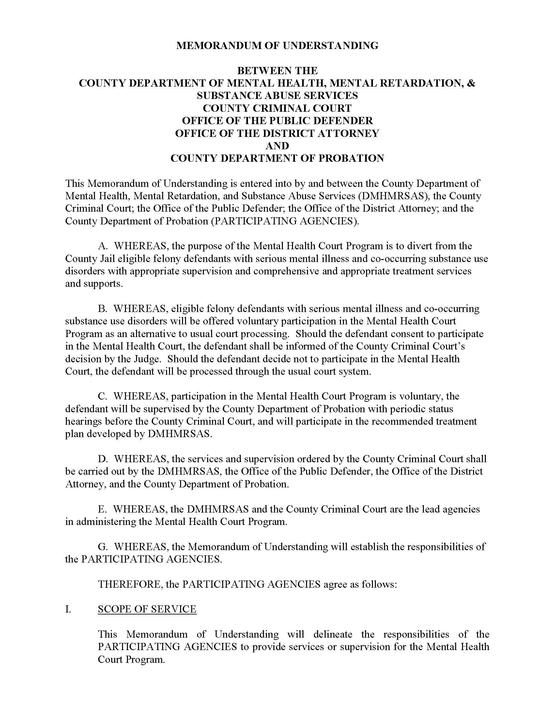




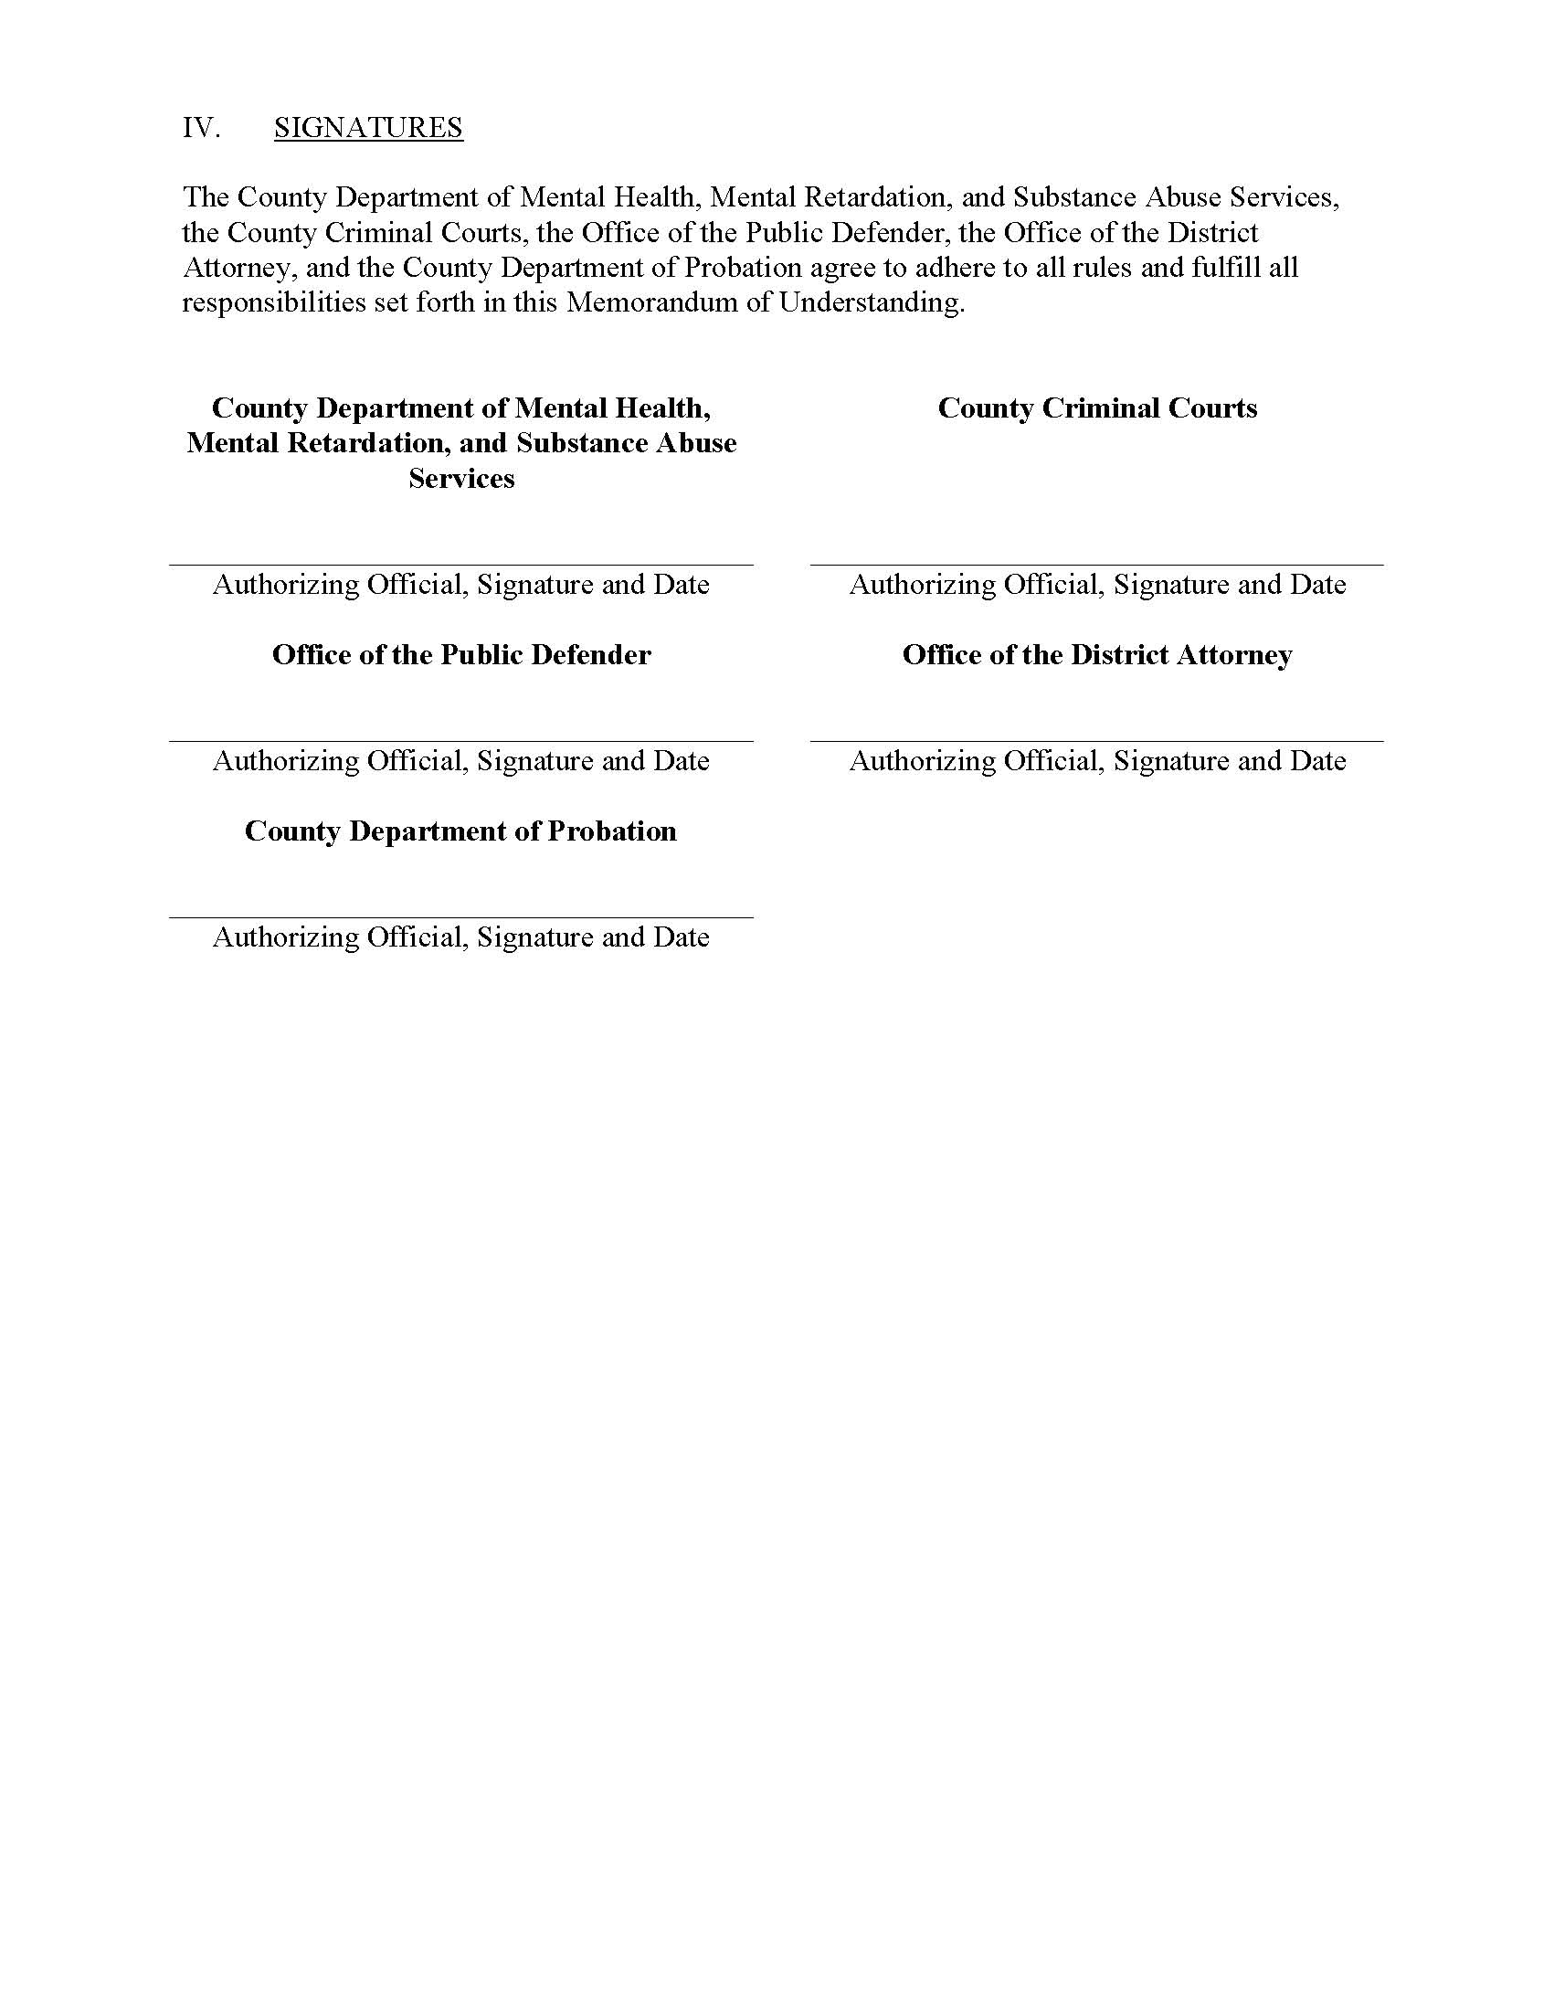

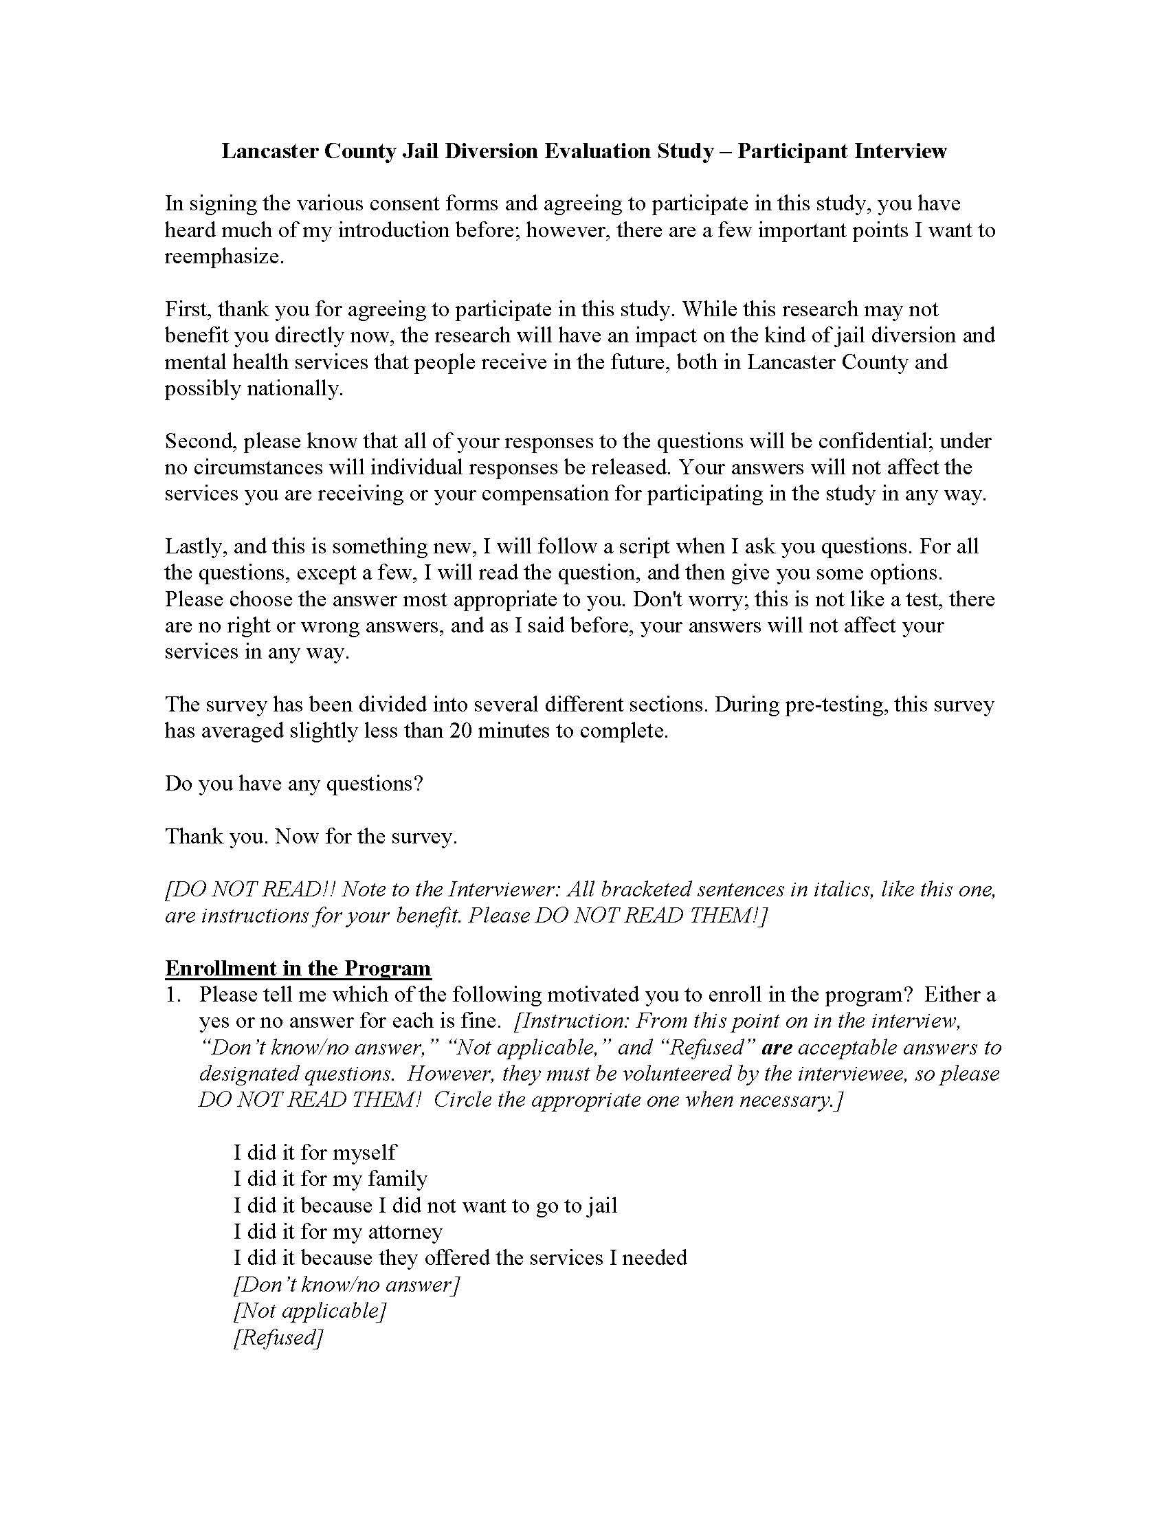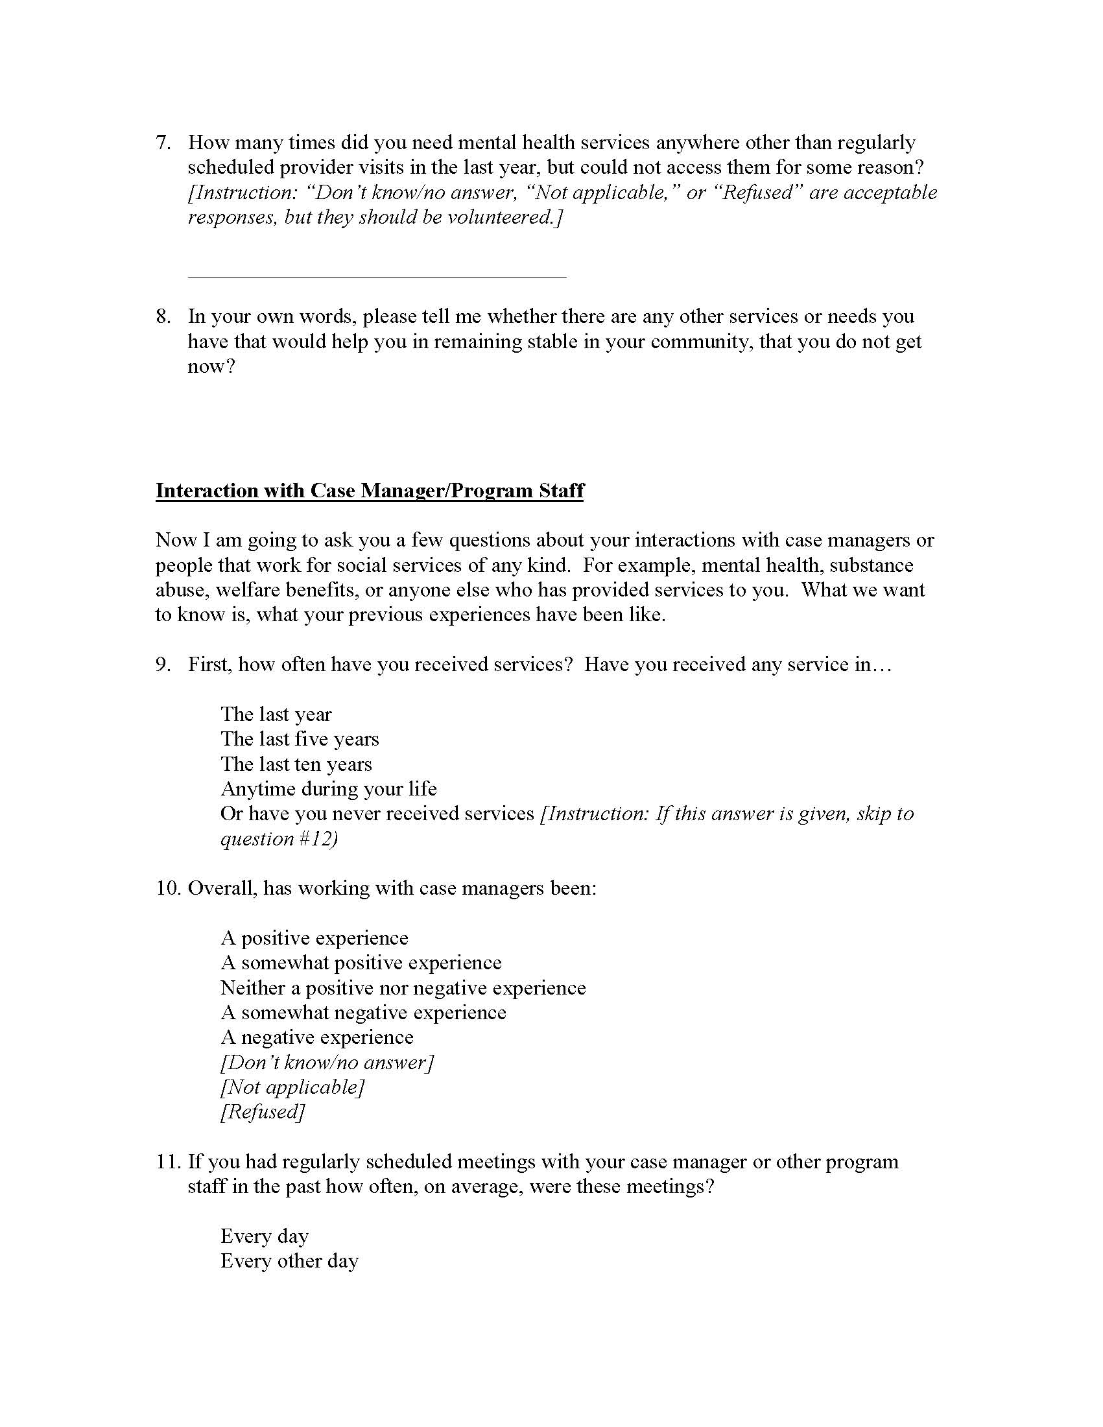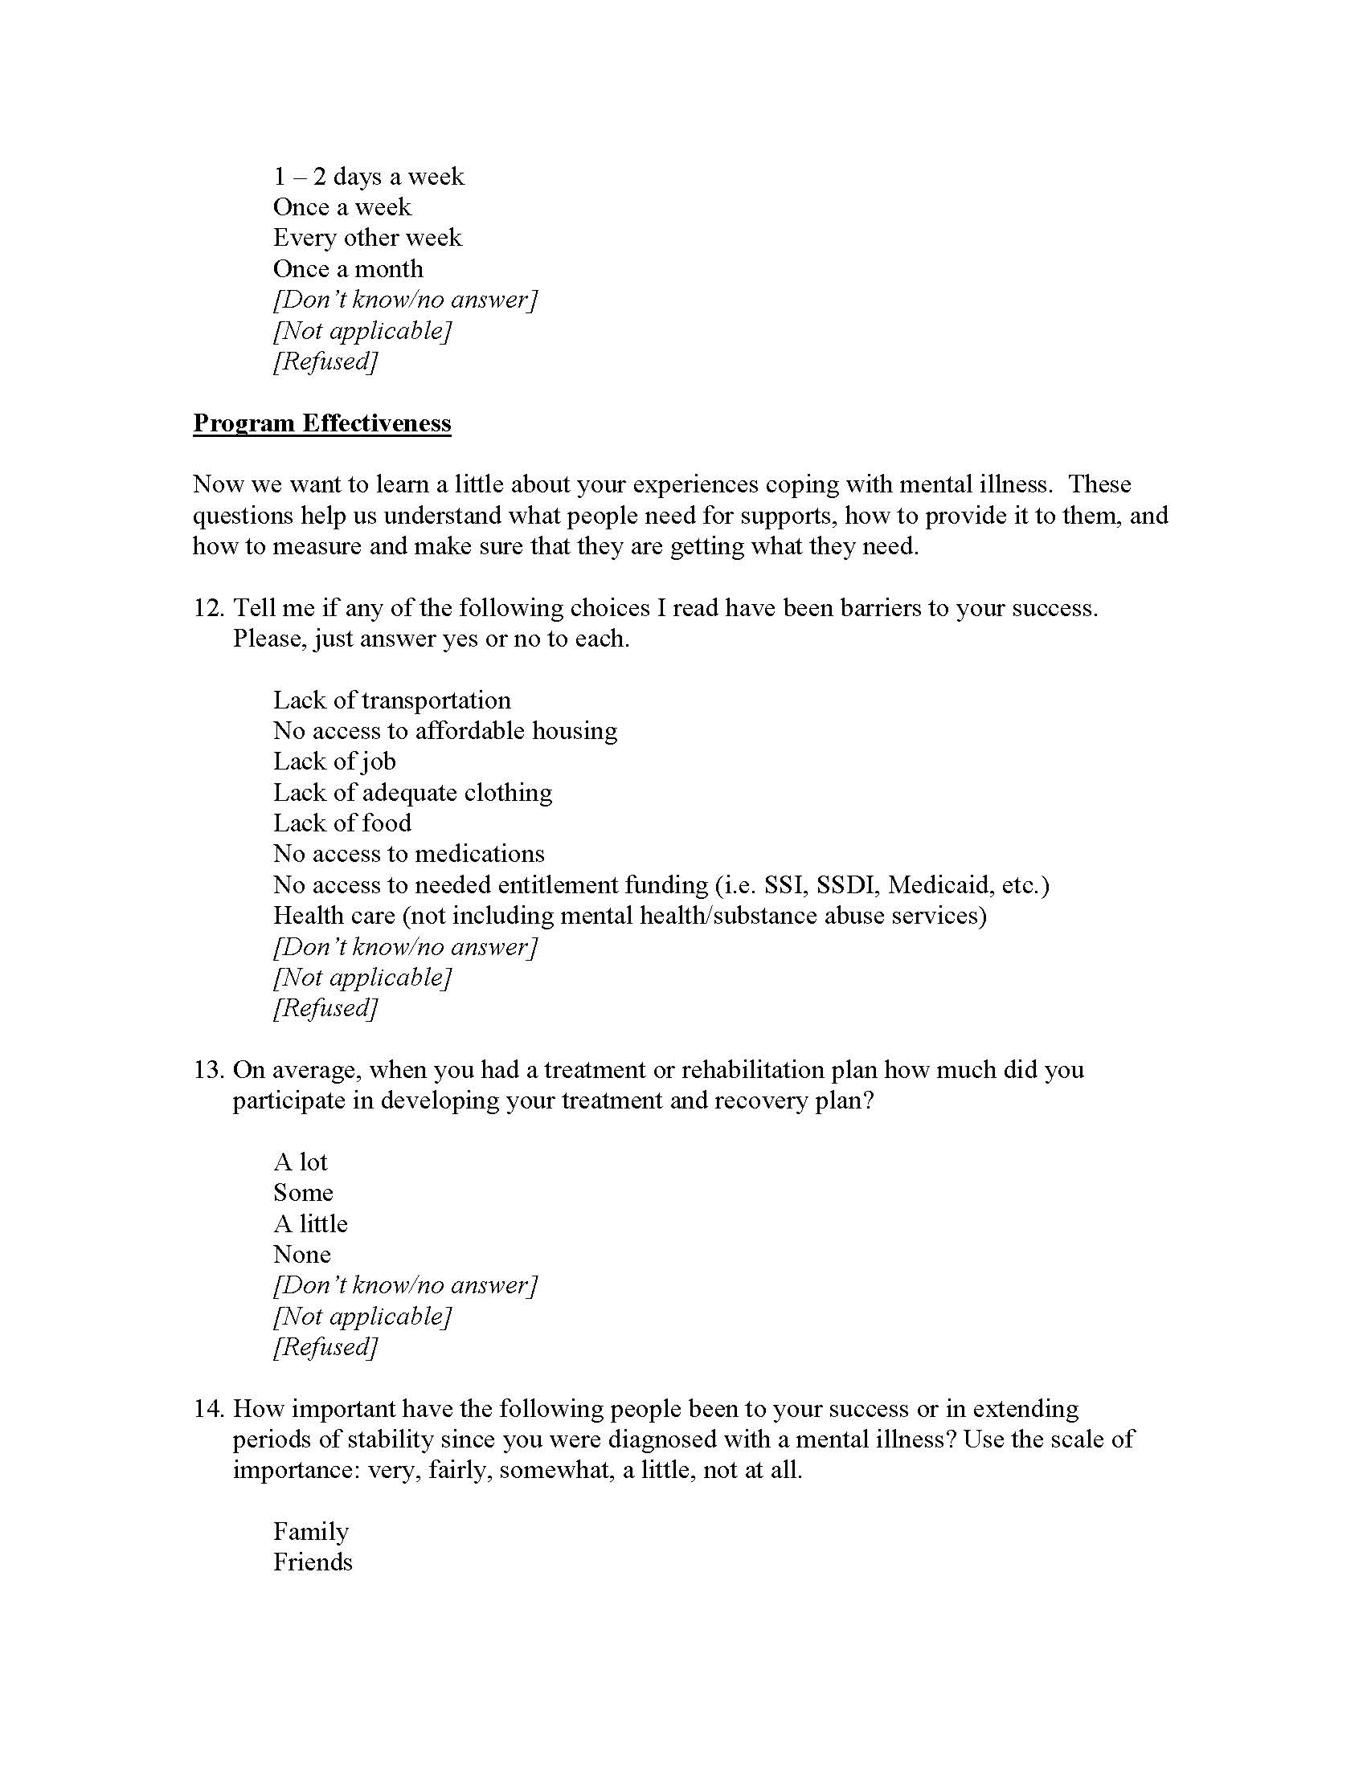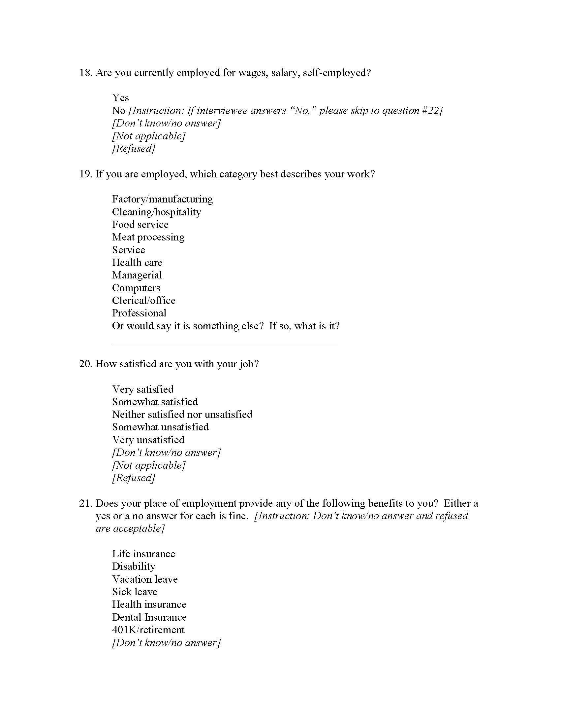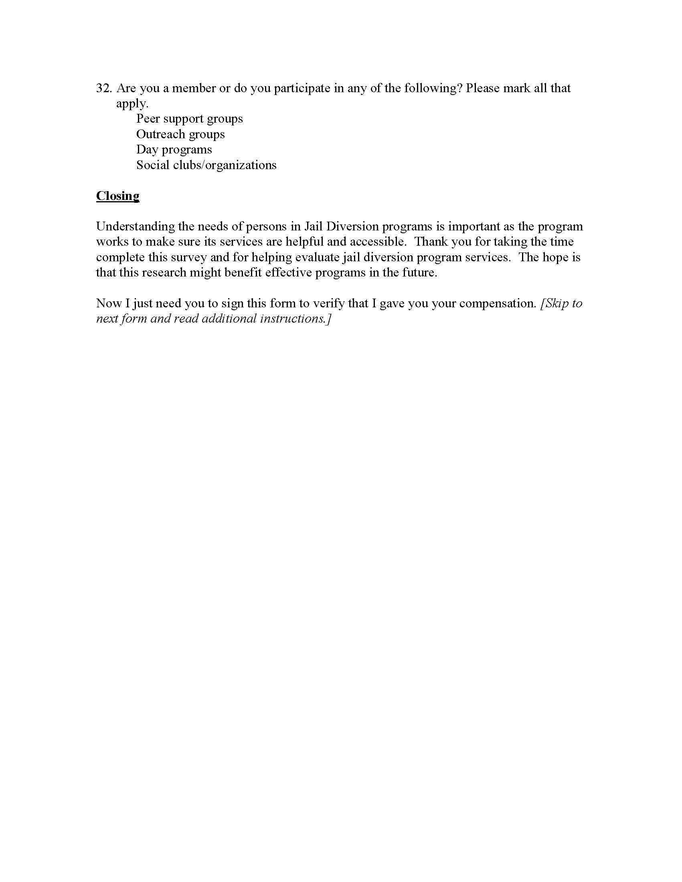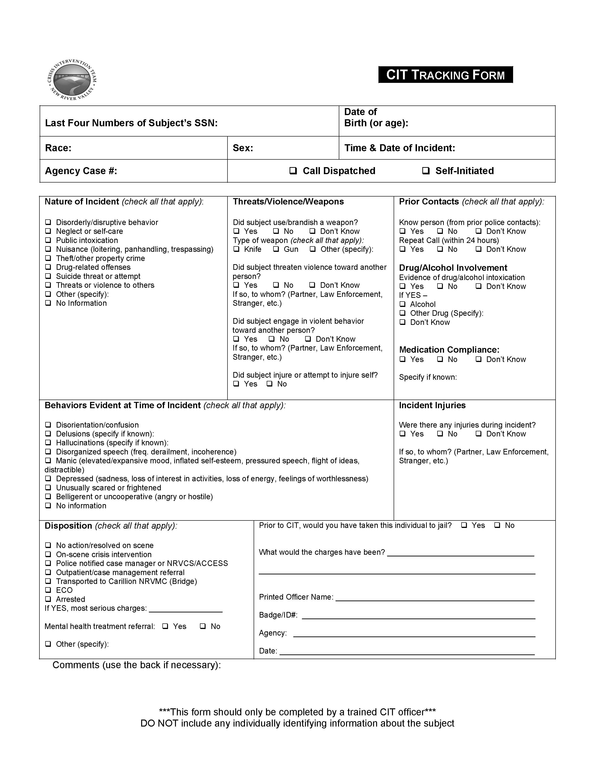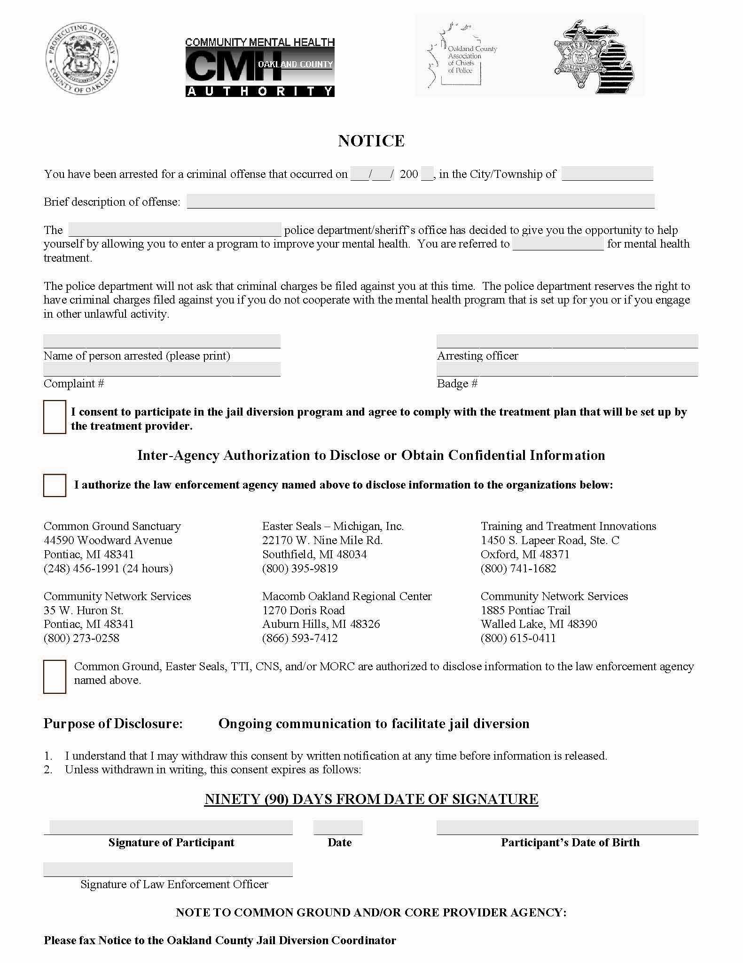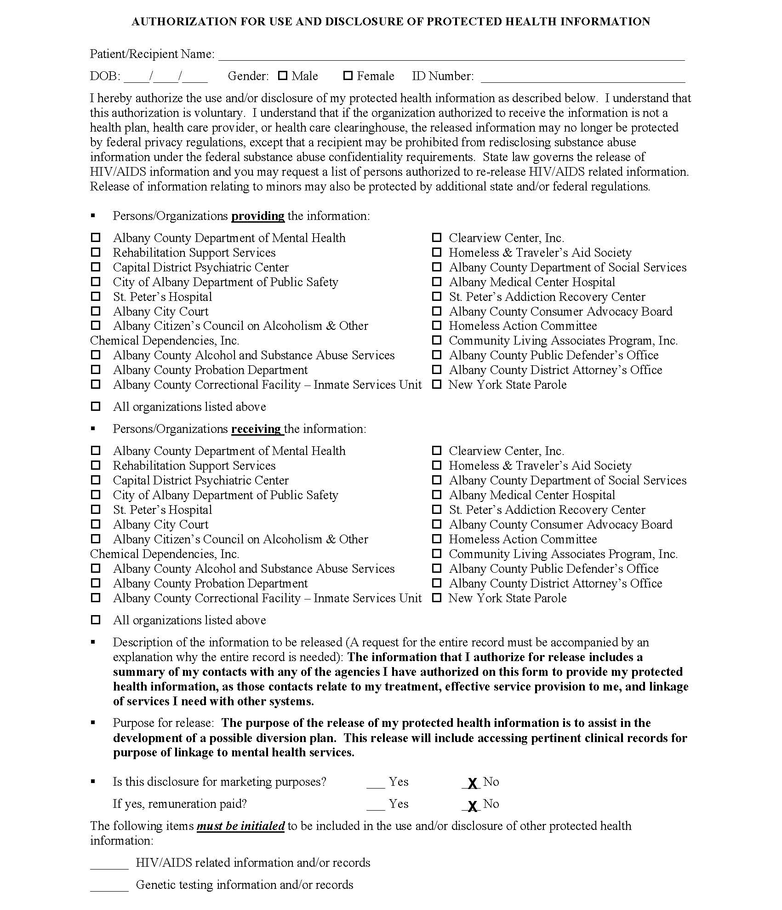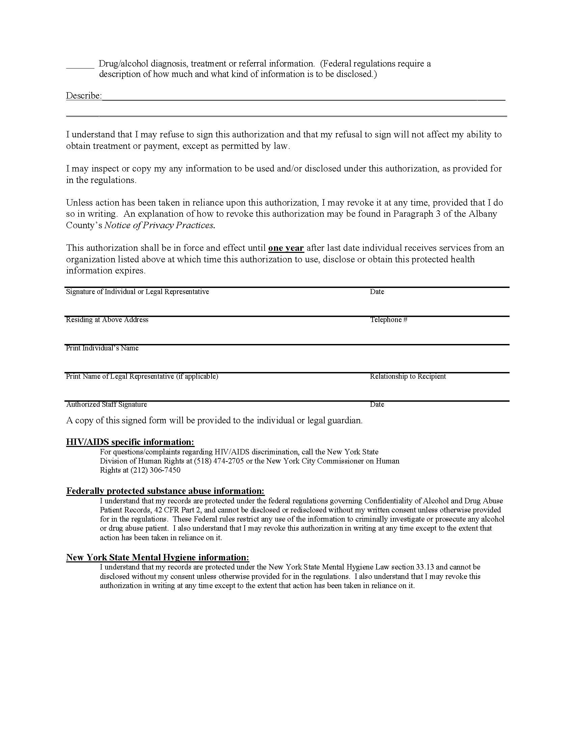
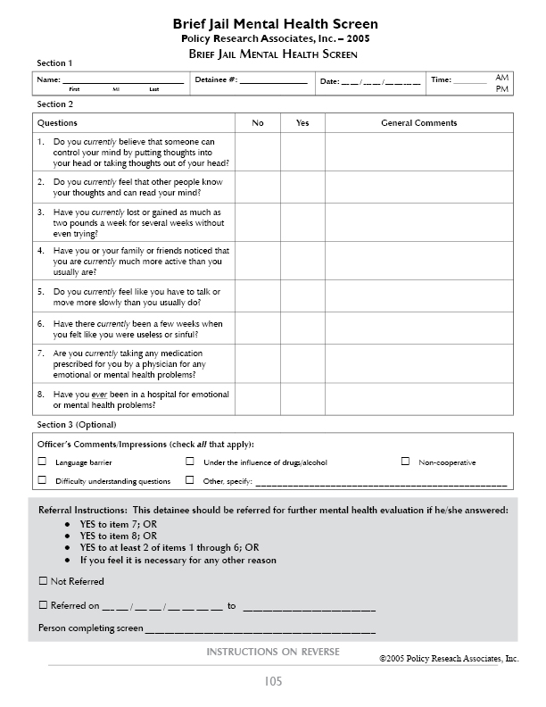
GENERAL INFORMATION:

This Brief Jail Mental Health Screen (BJMHS) was developed by Policy Research Associates, Inc., with a grant from the National Institute of Justice. The BJMHS is an efficient mental health screen that will aid in the early identification of severe mental illnesses and other acute psychiatric problems during the intake process.

This screen should be administered by Correctional Officers during the jail’s intake/booking process.

Instructions for Section 1:

NAME: Enter detainees name — first, middle initial, and last
DETAINEE#: Enter detainee number.
DATE: Enter today’s month, day, and year.
TIME: Enter the current time and circle AM or PM.

INSTRUCTIONS FOR Section 2:

ITEMS 1-6:

Place a check mark in the appropriate column (for “NO” or “YES” response).

If the detainee REFUSES to answer the question or says that he/she DOES NOT KNOW the answer to the question, do not check “NO” or “YES.” Instead, in the General Comments section, indicate REFUSED or DON’T KNOW and include information explaining why the detainee did not answer the question.

ITEMS 7-8:

ITEM 7: This refers to any prescribed medication for any emotional or mental health problems.

ITEM 8: Include any stay of one night or longer. Do NOT include contact with an Emergency Room if it did not lead to an admission to the hospital

If the detainee REFUSES to answer the question or says that he/she DOES NOT KNOW the answer to the question, do not check “NO” or “YES.” Instead, in the General Comments section, indicate REFUSED or DON’T KNOW and include information explaining why the detainee did not answer the question.

General Comments Column:

As indicated above, if the detainee REFUSES to answer the question or says that he/she DOES NOT KNOW the answer to the question, do not check “NO” or “YES.” Instead, in the General Comments section, indicate REFUSED or DON’T KNOW and include information explaining why the detainee did not answer the question.

All “YES” responses require a note in the General Comments section to document:
(1) Information about the detainee that the officer feels relevant and important
(2) Information specifically requested in question

If at any point during administration of the BJMHS the detainee experiences distress, he/she should follow the jails procedure for referral services.

INSTRUCTIONS FOR SECTION 3:

OFFICER’S COMMENTS: Check any one or more of the four problems listed if applicable to this screening. If any other problem(s) occurred, please check OTHER, and note what it was.

REFERRAL INSTRUCTIONS:

Any detainee answering YES to Item 7 or YES to Item 8 or YES to at least two of Items 1-6 should be referred for further mental health evaluation. If there is any other information or reason why the officer feels it is necessary for the detainee to have a mental health evaluation, the detainee should be referred. Please indicate whether or not the detainee was referred.

APPENDIX B: Program Examples
San Francisco’s Behavioral Health Court: Helping the Underserved
San Francisco Behavioral Health Court Judge Mary Morgan wears a black robe and sits on the bench when she meets with court participants every Thursday afternoon. But rather than meting out justice, she talks with men and women about their progress in treatment. Many are doing well; the court reports a low recidivism rate.
Former Behavioral Health Court Judge Herbert Donaldson, a retired jurist who was the driving force behind developing the court, says he enjoyed being able to make a difference in people’s lives. “Many of these people have no homes, they have no skills,” Judge Donaldson says. “They have mental illness and we don’t have treatment facilities to treat them. And sometimes terrible things happen to them” (Koopman, 2006).
On Thursday mornings, Judge Morgan meets with representatives from the public defender’s office and the district attorney’s office, along with staff from the county jail and various mental health programs to discuss the cases that will come before them that day. Typically, clients are accepted into the court from the county jail, where jail staff or the person’s attorney makes a referral. The person has to have a serious mental illness and can’t be accused of arson, sex crimes, domestic violence, or assault resulting in great bodily injury. People with developmental disabilities and mental retardation are also accepted into the court (Johnson, 2004).
Members of the court team create a treatment plan that includes access to intensive case management, counseling, medication, and housing. Clients are monitored by the court and are encouraged, but not forced, to comply with treatment. There are three characteristics that distinguish San Francisco’s Court from similar programs (Donaldson and Johnson, n.d.):
- Behavioral Health Court is a pre-plea court; clients are not required to enter a guilty plea to participate.
- The court looks at the client’s mental health diagnosis, and at the connection between the mental illness and the behavior that led to the client’s arrest, rather than simply focusing on the criminal charges. Even individuals with more serious crimes may be considered.
There is no set legal outcome. The better the individual does in treatment, the more favorable the disposition, which might include having a felony charge reduced to a misdemeanor, a grant of probation terminated, or a criminal charge dismissed. he court was chosen to participate in a national evaluation of four mental health courts funded by the John D. and Catherine T. MacArthur Foundation. “What started as a pilot project is now viewed by many in the justice system as a necessary component of the city’s approach to some of its more vulnerable citizens,” Judge Donaldson concludes.⁶
For more information, contact:
Lisa Lightman, Director of Collaborative Justice Courts, San Francisco Superior Court, (415) 553-9855, llightman@sftc.org
Dallas County, TX: Using Real-time Internet Technology
In 2003, roughly 20 percent of the inmates in the Dallas County jail were seriously mentally ill. In fact, in one 6-week period that summer, 5 percent of the people booked into the jail were clients of the local mental health authority, the Dallas Area NorthSTAR Authority (DANSA).
To respond to the needs of these individuals for treatment and services, DANSA collaborated with a broad range of stakeholders—including the sheriff’s department, the jail mental health provider, the district attorney’s office, the public defender’s office, judges, the felony and misdemeanor courts, and the probation department, among others—to develop the Dallas County Mental Health Diversion Program. The project is funded by a grant through the Texas Correctional Office for Offenders with Medical and Mental Impairments and Dallas County.
The original Mental Health Diversion Program targets offenders charged with misdemeanor offenses. Successful completion of this 6-month program results in the offender’s criminal charge being dismissed. A companion program, the ATLAS (Achieving True Liberty and Success) Mental Health Diversion Program, targets offenders on probation for felony offenses with pending motions to revoke their probation. Upon successful completion of this 1-year program, the motion is withdrawn and the individual is continued on probation. In both programs, participants have severe mental illnesses and are enrolled in NorthSTAR for services. Candidates for diversion are identified and initially screened through the jail or are referred from the original court of jurisdiction for some felony candidates. Participants are served by a team that includes the judge, a psychologist, a public defender, a specially trained probation officer, and a case manager who brokers or provides services that include crisis housing, medication management, and psychiatric rehabilitation.
One of the most unique aspects of the Dallas County program is the Jail Diversion Instant Messaging (JDIM) system developed in collaboration with HarrisLogic of St. Louis. Initiated by the Central Intake Unit at the jail when a person is arrested, the JDIM searches the NorthSTAR database and when it finds a match, notifies the DANSA jail diversion coordinator that a NorthSTAR client has been booked into the county jail. After the person is determined eligible for diversion based on criminal charges, the supervisor can use the JDIM to inform the courts, the district attorney, and the public defender’s office that a diversion case is in the pipeline. The JDIM also alerts the behavioral healthcare organization when a client has agreed to participate and been released by the judge.
The use of instant messaging allows for early identification of offenders with mental illnesses and their expedited release from jail, which may promote better mental health and criminal justice outcomes. It also reduces time spent tracking people down, replying to e-mails, and responding to voicemails. The JDIM is hosted in a secure environment that supports HIPAA compliance and maximum privacy; data are encrypted and made available to individuals on a “need to know” basis only. The system is based on the widely understood Internet chat paradigm and takes about 15 minutes to learn.
For more information, contact:
V.J. Lair, (214) 653-5300, VJLair@dallascounty.org
New York’s EXIT Program: A Unique “Sanction to Services” Approach
The EXIT program is a post-booking diversion program for mentally ill, nonviolent, repeat misdemeanants in the Manhattan Criminal Court (arraignment court). EXIT is a unique public-private partnership between the Mayor’s Office of the Criminal Justice Coordinator and the Center for Alternate Sentencing and Employment Services (CASES) that offers a mandated 3-hour treatment assessment session followed by 6 months of voluntary case management services in lieu of jail time to people who agree to participate. The majority of EXIT clients (90 percent) have substance use disorders, and more than half are homeless at the time of intake.
Defense attorneys and other courtroom personnel refer potential clients, and a clinical social worker provided by EXIT conducts in-court screenings to determine eligibility. Following the recommendation of the program, judges may sentence defendants to a 3-hour assessment session, with the understanding that the program will continue to extend services to defendants for up to 6 months. This “sanction to services” model is designed to feature high engagement and low coercion; the program is not obligated to report to the court beyond the participant’s completion of the initial mandated treatment assessment session.
The treatment assessment session inquires about the client’s needs and supports in the areas of mental health and substance abuse treatment, housing, education, employment, entitlements, food, clothing, and medical care. The aim of the session is to develop a preliminary service plan based on the client’s stated goals and to form a relationship with the client that will encourage him/her to continue to pursue services with the program.
Clients have access to a social worker, psychiatrist, and peer specialist at the program who assist them in meeting goals related to managing mental illness, maintaining sobriety, and achieving stability in the community. EXIT provides supportive case management, escorts clients to housing and service appointments, and helps them create a network of community-based providers from whom they can receive appropriate long-term care and support after leaving the program. Case managers both broker and provide services, which helps sustain clients’ engagement. Client contact varies from once per month to several times per week based on the person’s needs.
Since the program’s inception, more than 60 percent of clients released to the program have taken part in some or all of these voluntary services. During the program’s second year of operation, more than a third of all clients who accepted case management services remained engaged in the program for at least 6 months, despite the lack of a criminal justice mandate enforcing case management services and the propensity for transient service engagement among the target population. Some clients remained engaged with the program for as long as 1 year or more. Finally, the program has demonstrated a correlation between a high level of engagement in its case management component and reduced recidivism, with the cohort of participants who were most engaged constituting the largest proportion of defendants with no convictions one year post-sentence.
For more information, contact:
Gerald Foley, Project Director, (212) 788-6833, GFoley@cityhall.nyc.gov.
New River Valley, VA: The First Rural CIT Program
The New River Valley covers 1,458 square miles in southwest Virginia along the I-81 corridor. It encompasses four counties and one small city, with a total population of 165,000. Across the New River Valley there are 14 law enforcement agencies ranging in size from two officers to more than 100. This appears to be an unlikely place to implement a Crisis Intervention Team (CIT) model of pre-booking diversion, which has been replicated in numerous metropolitan areas nationwide, but that’s exactly what the community has done. The New River Valley established the nation’s first rural, multi-jurisdictional CIT program.
The New River Valley CIT project began in April 2002 with a SAMHSA Community Action Grant (CAG). The first 18 months were spent building consensus among a broad range of stakeholders—including leaders from law enforcement and government agencies; consumers, family members, and advocates; public and private mental health care providers; local magistrates; and community organizations. In March 2004, with the aid of another CAG, the community sent 10 law enforcement officers and 10 civilians to Memphis, TN, to be trained by the creators of the CIT program. These 20 people became the inaugural core faculty for the New River Valley’s CIT program.
CIT officers in the New River Valley receive 40 hours of specialized training that includes 9 hours of role playing exercises based on real-life scenarios. As part of their training, they also spend an entire day visiting the region’s mental health and substance abuse inpatient and outpatient treatment facilities where they speak one-on-one to mental health consumers and familiarize themselves with the programs and staffing available in the community.
To date, the New River Valley CIT program has exceeded the community’s goal of having at least 20 percent of all uniformed patrol officers and deputies trained in CIT; 62 officers representing 13 law enforcement agencies were trained as of May 2005. In addition, nearly 100 percent of dispatchers attended a 4-hour training designed to help them be part of the team effort. Beginning in the fall of 2005, the CIT training was opened to all Virginia law enforcement officers. New River Valley officers attend the training for free, while those from other jurisdictions pay a fee that is put toward continued administrative support of the CIT program.
The New River Valley CIT program includes several important adaptations. Because it takes in 14 separate law enforcement agencies, the program is coordinated by a neutral organization, the local Mental Health Association. However, each law enforcement agency establishes its own CIT policies regarding, for example, whether CIT officers receive extra pay for this assignment. Also, the chiefs and sheriffs meet quarterly to discuss CIT issues. Finally, since there is no public mental health hospital in the New River Valley, a private medical center serves as the central triage facility, called “The Bridge.” At the Bridge, emergency assessment personnel use video technology to speed the process of civil commitment, where this is deemed appropriate, by linking to the local magistrates’ offices rather than requiring the parties to appear in person.
For more information, contact:
Dana Lebowitz, Jail Diversion Coordinator, Mental Health Association of the New River Valley, (540) 953-4990, dlebowitz@mhanrv.org
Shelby County’s Jericho Project: Bringing Down Barriers to Recovery
Among people familiar with jail diversion projects, Shelby County, TN, is perhaps best known for its CIT program. But CIT is only the first line of defense for the metropolitan Memphis area, which also has a court liaison program run by its pretrial services agency. For those people with serious mental disorders who can’t be diverted at either of these points, Shelby County developed the Jericho Project, a non-specialty court post-booking program that relies on conditional release strategies. All three jail diversion initiatives are supported by Mayor A.C. Wharton’s Jail Diversion Committee.
“Ours is a different take on a post-booking program,” says Stephen C. Bush, J.D., Coordinator of Mental Health Systems for the Shelby County Public Defender’s Office. Here’s how the process works:
The Jericho Roundtable, which is composed of the project’s key partners—including pretrial services, the jail medical provider, community agencies, and boundary spanners—meets twice weekly to discuss potential clients and create transition plans tailored to the needs of the individual. People can be referred to the Roundtable by any of the partners or other community stakeholders. The Roundtable members meet with the consumer and develop a community linkage plan based on the APIC model of transition planning, which focuses on assessing the client’s needs, planning for treatment and services, identifying community resources, and coordinating the transition from jail to the community (Osher et al, 2002).
When the plan is ready and the client is clinically stable, defense counsel enters into the negotiating process with the prosecutor and the judge for a conditional order of release. The use of conditional release taps the natural leverage of the criminal justice system to encourage treatment engagement, Bush notes (Bush, 2002). If the individual does well with the treatment plan, this can have a dramatic impact on his/her case. Often charges are dismissed or reduced, and frequently the individual receives probation.
That’s how it works, but Bush is especially enthusiastic about why it works. Because the Jericho Project doesn’t depend on pre-approval by the prosecutor, the staff doesn’t have to screen out those who are most difficult to serve. While in most cases prosecutors and defense counsel are able to negotiate outcomes that result in a supervised release to treatment, the Jericho Project approach respects the traditional adversarial process and invites prosecutors to argue against planning they believe is inadequate. Ultimately, of course, the final decision is up to the court, which can always reject a plan it feels is not appropriate, Bush says.
However, he reports, “Every one of our 18 judges has approved conditional releases based on Jericho community linkage plans, and courts routinely approve them 95 percent of the time, even for individuals with a history of violence and prior arrest who wouldn’t be eligible for consideration in many mental health courts.”
For more information, contact:
Stephen Bush, (901) 545-5835, stephen.bush@shelbycountytn.gov
APPENDIX C: Glossary
Assertive Community Treatment (ACT)
A service-delivery model that provides comprehensive, community-based treatment to people with serious mental illness. ACT provides individualized services directly to consumers through a team which provides treatment and supports in their own home and other non-clinical community settings. Team members are trained in the psychiatry, social work, nursing, substance abuse, and vocational rehabilitation. These services are available every hour of every day.
Boundary Spanner
A boundary spanner provides coordination across multiple organizations or systems. In jail diversion programs, a boundary spanner may be employed by the local mental health agency yet his or her office is located in the county jail or courts. This person’s role may be to coordinate the approval of treatment and supervision plans by the mental health agency and the courts, or to coordinate the systems at an administrative level.
Case Management
A means of coordinating the services available in a community to ensure continuity of mental health care across a non-integrated service system. While some models of case management provide the services directly to an individual with mental illness, most case management programs act as brokers by developing service plans, linking people to services, monitoring those services, and determining additional areas of need.
Community-Based Treatment
Treatment which takes place in community settings, as opposed to treatment in an inpatient setting, a State hospital, or in correctional settings. Community-based treatment may take place at the offices of services providers or in vivo, such as in an individual’s home or workplace.
Consumer
Any individual who does or could receive mental health and other related services, such as substance abuse treatment or supported employment services.
Co-Occurring Disorders (COD)
An individual with co-occurring disorders (COD) has both a mental illness and a substance use disorder. From a treatment perspective, both disorders are primary. Although the disorders may impact each other, neither are merely symptoms of the other.
Consumer-Operated Services
Mental health treatment or support services that are provided by consumers, such as clubhouses and peer support groups.
Crisis Intervention Team (CIT)
A law enforcement-based model of specialized response to people experiencing a mental health crisis in the community. Crisis Intervention Team (CIT) programs are comprised of a volunteer cadre of officers who have completed a 40-hour training on recognizing the signs and symptoms of mental illness, identifying a mental health crisis situation, and de-escalation techniques. Crisis Intervention Team (CIT) programs are a form of community partnership between local law enforcement agencies, local mental health agencies, mental health advocacy groups, mental health consumers, and families.
Cultural Competence
The set of attitudes, skills, behaviors, and policies that enable effective interactions in cross-cultural situations.
Detainee
An unsentenced individual held in pre-trial custody.
Evidence-Based Practice (EBP)
An intervention which, through research, has been found to be beneficial, effective, and replicable for people with serious mental illness. The Center for Mental Health Services (CMHS) of the Federal Substance Abuse and Mental Health Services Administration (SAMHSA) has designated the following interventions as evidence-based practices:
- Assertive Community Treatment (ACT)
- Family Psychoeducation
- Illness Management and Recovery (IMR)
- Integrated Dual Disorders Treatment (IDDT)
- Medication Management Approaches in Psychiatry (MedMAP)
- Supported Employment
Forensic Assertive Community Treatment (FACT)
An adaptation of Assertive Community Treatment (ACT) which addresses an individual’s risk for arrest and incarceration in addition to the model’s public health goals.
Family Psychoeducation
The practice of working in partnership with families to help them develop positive coping skills for handling problems posed by mental illness in their family and skills for supporting the recovery process. The Center for Mental Health Services (CMHS) has designated family psychoeducation as an evidence-based practice (EBP).
Gender-Specific Services
Services that are of or for individuals of one gender to the exclusion of the other.
Health Information Portability and Accountability Act (HIPAA)
The Federal Health Information Portability and Accountability Act (HIPAA) provides protections for the privacy of an individual’s health care information. To comply with HIPAA, covered entities such as hospitals, primary care providers, and mental health service providers must obtain permission from an individual prior to sharing health care information with other service providers. State and local laws may demand stricter standards for the sharing of health care information than are required for a service provider to comply with HIPAA.
Homeless Management Information System (HMIS)
A Homeless Management Information System (HMIS) is a software application designed to record and store client-level information on the characteristics and service needs of homeless persons. An HMIS is typically a web-based software application that homeless assistance providers use to coordinate care, manage their operations, and improve services. All government and nonprofit agencies that receive homeless assistance funds from the U.S. Department of Housing and Urban Development are required to maintain an HMIS.
Housing First
A housing approach that relies on providing people who are homeless with quick access to supportive housing for people who are homeless. Support services are provided following the housing placement to meet housing stability and individual needs. Housing is contingent only upon meeting the terms of a lease rather than with treatment compliance.
Illness Management and Recovery (IMR)
Illness Management and Recovery (IMR) is a set of practices which provides people with serious mental illness skills to manage their illness in order to achieve personal recovery goals. Practices include psychoeducation, relapse prevention skills, and the development of coping strategies. Illness Management and Recovery is often referred to as Wellness Management and Recovery (WMR) and Symptom Self-Management.
Inmate
A sentenced or unsentenced individual involuntarily confined in a jail, prison, or other correctional facility.
Integrated Dual Disorders Treatment (IDDT)
Treatment of co-occurring disorders is integrated when mental health and substance use treatment takes place in the same service setting with cross-trained staff.
Institutional Review Board (IRB)
A group of at least five individuals who are knowledgeable and not directly involved in the research whose job it is to review and approve, require modifications, or disapprove research involving human subjects. The group must include at least one scientist, one non-scientist, and in the case of research involving prisoners, a prisoner or prisoner representative with appropriate background and experience. Institutional Review Boards (IRB) are registered through the U.S. Department of Health and Human Services, Office of Human Research Protections.
Jail Diversion
The avoidance or radical reduction in jail time by using community-based treatment as an alternative.
Medication Management Approaches in Psychiatry (MedMAP)
An EBP in the use of medications for the treatment of schizophrenia. Medication Management Approaches in Psychiatry (MedMAP) is based on four principles: a systematic approach in the selection of medication, measurement of key outcomes, documentation of treatment and outcomes, and use of approaches that promote adherence to treatment.
Memorandum of Understanding (MOU)
A document outlining the terms and details of an agreement between parties, including each party’s requirements and responsibilities.
Management Information System (MIS)
An information collection and analysis system, usually computerized, that facilitates access to program and participant information. It is usually designed and used for administrative purposes.
Post-Booking
A designation for jail diversion programs which divert people after booking into the jail. Post-booking jail diversion programs may be court-based or jail-based.
Pre-Booking
Jail diversion programs that divert people to services in the community as an alternative to arrest.
Psychiatric Advance Directive (PAD)
A legal instrument which may be used to document an individual’s specific instructions or preferences regarding future mental health treatment, as preparation for the possibility that the person may lose capacity to give or withhold informed consent to treatment during acute episodes of mental illness.
Recidivism
In terms of mental health and criminal justice, recidivism is examined in different ways. Mental health recidivism is the use of emergency services or hospitalization for mental illness following a period of mental health services. Criminal recidivism is measured by reoffense, rearrest, reconviction, or technical violation following a period of incarceration.
Re-Entry
A term that covers issues relating to the transition of individuals from correctional settings into the community.
Sequential Intercept Model
A strategic model which identifies points where communities can implement interventions to prevent further criminal justice involvement of people with mental illness. There are five intercept points: law enforcement and emergency services, initial detention and initial court hearings, jails and courts, re-entry, and community corrections and community supports.
Supported Employment
A set of supportive services, including follow-along support, for people with mental illness who want to pursue and maintain competitive employment.
Supportive Housing
Affordable rental housing with support services. Support services, such as case management or vocational training, may be offered on-site or at locations in the community.
Therapeutic Jurisprudence
Approaches which are concerned with the impact of the law on an individual’s emotional and psychological well-being.
Transition Planning
Often called discharge planning, transition planning from jail to community-based services entails assessment of an individual’s service needs, development of a comprehensive service plan, identification of agencies responsible for treatment and supervision, and effective linkages to those services and supports.
Trauma-Informed Services
Services that may be offered or modified to be responsive to the needs of people with histories of trauma.
Trauma-Specific Services
Interventions that address the behavioral, psychological, and social consequences of sexual, physical, and emotional abuse.

References
The Bazelon Center for Mental Health Law. (n.d.). Fact sheets on the criminalization of people with mental illness. Fact sheet #11: Resource issues. Washington, DC: Author. www.bazelon.org/issues/criminalization/factsheets/criminal11.htm
The Bazelon Center for Mental Health Law. (2001). Finding the key to successful transition from jail to community. Washington, DC: Author. www.bazelon.org/issues/criminalization/findingthekey.html
Broner, N., Lattimore, P.K., Cowell, A.J., & Schlenger, W.E. (2004). Effects of diversion on adults with co-occurring mental illness and substance use: Outcomes from a national multi-site study. Behavioral Sciences and the Law, 22(4), 519-541.
Bureau of Justice Statistics. (2006). Drug and crime facts: Drug law violations: Enforcement. Retrieved November 10, 2006 from http://www.ojp.usdoj.gov/bjs/dcf/enforce.htm#arrests
Bush, S.C. (2002). Using conditional release as a strategy for effective linkage to community mental health services: The Memphis Public Defenders Office model. Community Mental Health Report, 2(6), 81.
Clark, J. (2004). Non-specialty first appearance court models for diverting persons with mental illness: Alternatives to mental health courts. Delmar, NY: The TAPA Center for Jail Diversion.
Copeland, M.E. (2000). Wellness recovery action plan (Rev. ed.). West Dummerston, VT: Peach Press.
Council of State Governments. (2002). Criminal justice/mental health consensus project. New York: Author.
Dennis, D., Cocozza, J., & Steadman. H. (1999). What do we know about systems integration and homelessness? In L. Fosburg & D. Dennis (Eds.), Practical lessons: The 1998 national symposium on homelessness research. Washington, DC: U.S. Department of Health and Human Services, U.S. Department of Housing and Urban Development, & Interagency Council on the Homeless.
Donaldson, H., & Johnson, J. (n.d.) San Francisco’s Behavioral Health Court: On the cutting edge. San Francisco Medicine, 78(8), 24-25. www.sfms.org
Draine, J., & Solomon, P. (1999). Describing and evaluating jail diversion services for persons with serious mental illness. Psychiatric Services, 50(1), 56-61.
Drake, R.E., Essock, S.M., Shaner, A., Carey, K.B., Minkoff, K., Kola, L., et al. (2001). Implementing dual diagnosis services for consumers with severe mental illness. Psychiatric Services, 52(4), 469-476.
Drake, R.E., Mercer-McFadden, C., Mueser, K.T., McHugo, G.J., & Bond, G.R. (1998). Review of integrated mental health and substance abuse treatment for patients with dual disorders. Schizophrenia Bulletin, 24(4), 589-608.
Dubuque Jail Diversion Program. (2004). Dubuque jail diversion program: Position description. Dubuque, IA: Author.
Dvoskin, J.A., & Steadman, H.J. (1994). Using intensive case management to reduce violence by mentally ill persons in the community. Hospital and Community Psychiatry, 45, 679-684.
Fallot, R. (2006, May). Trauma-related services for persons in the justice system. Presentation at the Jail Diversion TCE Initiative Grantee Orientation Meeting.
Feldman, S. (1976). Mental health under the umbrella. Hospital and Community Psychiatry, 27(1), 25-29.
Fisher, R., Ury, W., & Patton, B. (1991). Getting to yes (2nd ed.) New York: Penguin Books. Florida Mental Health Institute. (2001, Feb.). Jail diversion strategies for misdemeanor offenders with mental illness. Policy brief #9. Tampa, FL: University of South Florida, Louis de la Parte Florida Mental Health Institute.
Gladwell, M. (2006, February 13/20). Million-dollar Murray. The New Yorker. www.newyorker.com/printables/fact/060213fa_fact
Greenfeld, L.A., & Snell, T.L. (1999). Women offenders. Washington, DC: U.S. Department of Justice, Office of Justice Programs.
Griffin, P.A., Steadman, H.J., & Petrila, J. (2002). The use of criminal charges and sanctions in mental health courts. Psychiatric Services, 53(10), 1285-1289.
Herinckx, H., Swart, S., Ama, S., Dolezal, C., King. S. (2005). Rearrest and linkage to mental health services among client of the Clark County Mental Health Court Program. Psychiatric Services, 56¸853–857.
Institute of Medicine. (2000). Protecting data privacy in health services research. Washington, DC: National Academy Press.
Institute of Medicine. (2006). Improving the quality of health care for mental and substance-use conditions: Quality chasm series. Washington, DC: National Academies Press.
Johnson, J. (2004). San Francisco’s new Behavioral Health Court – One solution to helping the underserved. San Francisco Medicine, 77(6). www.sfms.org
Konrad, E. (1996). A multidimensional framework for conceptualizing human services integration initiatives. In J. Marquart & E. Konrad (Eds.), Evaluating initiatives to integrate human services. New Directions for Evaluation, 69, 5-19. San Francisco: Jossey-Bass.
Koopman, J. (2006, Jan. 23). An alternative to incarceration. San Francisco Chronicle. www.sfgate.com.
Kraybill, K. (2002). Outreach to people experiencing homelessness: A curriculum for training Health Care for the Homeless workers. Nashville, TN: National Health Care for the Homeless Council.
Lamberti, J.S., Weisman, R., & Faden, D.I. (2004). Forensic assertive community treatment: Preventing incarceration of adults with severe mental illness. Psychiatric Services, 55(11), 1285-1293.
Lattimore, P.K., Broner, N., Sherman, R., Frisman, L., & Shafer, M.S. (2003). A comparison of prebooking and postbooking diversion programs for mentally ill substance-using individuals with justice involvement. Journal of Contemporary Criminal Justice, 19(1), 30-64.
Leutz, W.N. (1999). Five laws for integrating medical and social services: Lessons from the United States and the United Kingdom. The Milbank Quarterly, 77(1), 77-110.
Massaro, J. (2004). Working with people with mental illness involved in the criminal justice system: What mental health service providers need to know (2nd ed.). Delmar, NY: The TAPA Center for Jail Diversion.
Massaro, J. (2005). Overview of the mental health service system for criminal justice professionals. Delmar, NY: TAPA Center for Jail Diversion.
Morrissey, J., & Meyer, P. (2005). Extending assertive community treatment to criminal justice settings. Delmar, NY: The National GAINS Center for Evidence-Based Programs in the Justice System.
Munetz, M.R., & Griffin, P.A. (2006). Use of the sequential intercept model as an approach to decriminalization of people with serious mental illness. Psychiatric Services, 57(4), 544-549.
Naples, M., & Steadman, H.J. (2003). Can persons with co-occurring disorders and violent charges be successfully diverted? International Journal of Forensic Mental Health, 2(2), 137-143.
The National GAINS Center. (1999a). The courage to change: A guide for communities to create integrated services for people with co-occurring disorders in the justice system. Delmar, NY: Author.
The National GAINS Center. (1999b). Blending funds to pay for criminal justice diversion for people with co-occurring disorders. Fact Sheet Series. Delmar, NY: Author.
The National GAINS Center. (2002). The Nathaniel Project: An alternative to incarceration for people with serious mental illness who have committed felony offenses. Program Brief Series. Delmar, NY: Author.
The National GAINS Center. (2004). The prevalence of co-occurring mental illness and substance use disorders in jails. Delmar, NY: Author.
National Mental Health Association. (2003). Jail diversion for people with mental illness: Developing supportive community coalitions. Delmar, NY: The TAPA Center for Jail Diversion.
New Freedom Commission on Mental Health, Subcommittee on Criminal Justice. (2004). Background paper. DHHS Pub. No. SMA-04-3880. Rockville, MD.
Noether, C., & Louison, A. (2005). Creating boundary spanners: Navigating across the mental health, substance abuse and criminal justice systems for people involved in the justice system. NIMH SBIR Adult Cross-Training Curriculum (AXT) Project. Presentation at the Penobscot County, ME, AXT site.
North Carolina Jail Diversion Program. (n.d.). What are the steps to developing a jail diversion program? www.dhhs.state.nc.us/mhddsas/justice/jaildiversion/faq7.htm
O’Hara, A., & Cooper, E. (2005). Priced out in 2004. Technical Assistance Collaborative (Boston) and Consortium for Citizens with Disabilities Housing Task Force (Washington, DC).
Osher, F., Steadman, H.J., & Barr, H. (2002). A best practice approach to community re-entry from jails for inmates with co-occurring disorders: The APIC model. Delmar, NY: The National GAINS Center for People with Co-Occurring Disorders in the Justice System.
Petrila, J. (2007). Dispelling the myths about information sharing between the mental health and criminal justice systems. Delmar, NY: CMHS National GAINS Center.
Redlich, A.D., Steadman, H.J., Monahan, J., Petrila, J., & Griffin, P.A. (2005). The second generation of mental health courts. Psychology, Public Policy, and Law, 11(4), 527-538.
Reuland, M. (2004). A guide to implementing police-based diversion programs for people with mental illness. Delmar, NY: The TAPA Center for Jail Diversion.
Reuland, M., & Cheney, J. (2005). Enhancing success of police-based diversion programs for people with mental illness. Delmar, NY: The TAPA Center for Jail Diversion.
Routh, A. (2005, Nov. 16). Human subjects’ protection. Presentation at The TAPA Center Annual Grantee Meeting.
Sacks, S., Sacks, J., McKendrick, K., Banks, S., & Stommel, J. (2004). Modified therapeutic community for MICA offenders: Crime outcomes. Behavioral Sciences and the Law, 22, 477-501.
Skeem, J.L., & Louden, J.E. (2006). Toward evidence-based practice for probationers and parolees mandated to mental health treatment. Psychiatric Services, 57(3), 333-342
Steadman, H.J. (1992). Boundary spanners: A key component for the effective interactions of the justice and mental health systems. Law and Human Behavior, 16(1), 75-87.
Steadman, H.J., & Leifman, S. (2005, Feb. 22). Evaluating jail diversion outcomes: Making the case for jail diversion. GAINS Center Net/Teleconference.
Steadman, H.J., & Naples, M. (2005). Assessing the effectiveness of jail diversion programs for persons with serious mental illness and co-occurring substance use disorders. Behavioral Sciences and the Law, 23(2), 163-170.
Steadman, H.J., Davidson, S., & Brown, C. (2001). Mental health courts: Their promise and unanswered questions. Psychiatric Services, 52(4), 457-458.
Steadman, H.J., Morris, S.M., & Dennis, D.L. (1995). The diversion of mentally ill persons from jails to community-based services: A profile of programs. American Journal of Public Health, 85(12), 1630-1635.
Steadman, H.J., Deane, M.W., Borum, R., & Morrissey, J.P. (2000). Comparing outcomes of major models of police responses to mental health emergencies. Psychiatric Services, 51(5), 645-649.
Steadman, H.J., Mulvey, E.P., Monahan, J., Robbins, P.C., Appelbaum, P. S., Grisso, T., et al. (1998). Violence by people discharged from acute psychiatric inpatient facilities and others in the same neighborhoods. Archives of General Psychiatry, 55, 393–401.
Substance Abuse and Mental Health Services Administration. (2002). Report to Congress on the prevention and treatment of co-occurring substance abuse disorders and mental disorders. Rockville, MD: Author.
Substance Abuse and Mental Health Services Administration. (2003). Blueprint for change: Ending chronic homelessness for persons with serious mental illness and/or co-occurring substance use disorders. Rockville, MD: Author.
Substance Abuse and Mental Health Services Administration. (In press). Expediting access to SSA disability benefits: Promising practices for people who are homeless. Rockville, MD: Author.
The TAPA Center for Jail Diversion. (2004). What can we say about the effectiveness of jail diversion programs for persons with co-occurring disorders? Delmar, NY: Author.
U.S. Department of Health and Human Services. (2001). Mental health: Culture, race, and ethnicity: A report of the Surgeon General. Washington, DC: Author.

Except where noted, information in this section is derived from two key resources: Massaro, J. (2004). Working with people with mental illness involved in the criminal justice system: What mental health service providers need to know (2nd ed.). Delmar, NY: The TAPA Center for Jail Diversion. Massaro, J. (2005). Overview of the mental health service system for criminal justice professionals. Delmar, NY: The TAPA Center for Jail Diversion. Both are available at www.gainscenter.samhsa.gov.
Significant portions of this section are derived from two key sources: 1) The National GAINS Center. (1999a). The courage to change: A guide for communities to create integrated services for people with co-occurring disorders in the justice system. Delmar, NY: Author. 2) The National GAINS Center. (1999b). Blending funds to pay for criminal justice diversion for people with co-occurring disorders. Fact Sheet Series. Delmar, NY: Author. Both are available at www.gainscenter.samhsa.gov.
Information in this section was derived from key sources: 1) Massaro, J. (2005). Overview of the mental health service system for criminal justice professionals. Delmar, NY: TAPA Center for Jail Diversion. www.gainscenter.samhsa.gov 2) Petrila, J. (2007). Dispelling the myths about information sharing between the mental health and criminal justice systems. Delmar, NY: CMHS National GAINS Center. www.gainscenter.samhsa.gov
The information in this section and the one that follows was provided by Travis Parker, Director of the Lancaster County Mental Health Jail Diversion Project in Lincoln, NE.
Though 12 months is the standard length of time to measure, other units of time—6 months, 9 months, 18 months, or 2 years—are equally appropriate depending on how long your program is funded and whether your primary funder has specific reporting requirements.
Portions of this section are derived from Routh, A. (2005). Human subjects’ protection. Presentation for TCE Site Evaluators Human Subjects Training.
Portions of this write-up appeared in the May 2005 issue of Mental Health Matters, the newsletter of the Mental Health Association of the New River Valley, Inc., and on the association’s Web site at www.mhanrv.org. Additional material is from a TAPA Center Net/Teleconference on “Making Jail Diversion Work in Rural Communities.” An audio replay and PowerPoint slides are available on the GAINS Center Web site at www.gainscenter.samhsa.gov (click on the “Presentations” link under the “Resources” tab).

